

LEADER OVERVIEW
Overview—Deck the Halls
As we prepare for Christmas, things begin to look a little different. We see Christmas trees, lights strung around homes and stores, and big inflatables. These things are fun and exciting, but as we “Deck the Halls,” it’s important to remember the real reason we celebrate Christmas! Many things we decorate with can point us back to the Christmas story and be good reminders about the One we are celebrating.

Each week, we’ll talk about a different Christmas decoration and discover how each one can remind us of Scripture as we see them during the holidays. Each week, your stage design can grow as the piece being talked about is placed on the stage, adding to the ones before.

SESSION 1: Born with Purpose—Genesis 3:1–6, 13–15, 23; Matthew 1:20–21;  1 Corinthians 15:3–4; Revelation 22:14  Faith Fact: Jesus came to save us from our sins. | SESSION 2: The True Light of Christmas—  John 1:1–5, 9–14; 8:12  Faith Fact: Jesus is the Light of the world.
SESSION 3: The Cast of Characters—  Matthew 1:18–24; Luke 1:28–38; 2:8–18  Faith Fact: God always has a plan. | SESSION 4: The Best Gift—Matthew 1:23; 2:1–11; Luke 2:11; 1 John 4:14–16  Faith Fact: Jesus is King, God, and Savior.
SESSION 5: A Joyful Christmas Review—
Proverbs 3:5–6; Matthew 1:21; 2:1–2, 10–11; John 8:12
Faith Fact: My joy is found in Jesus.

SESSION OVERVIEW


The Christmas Tree—The need for Christmas started with a tree back in Genesis. When sin entered the world through Adam and Eve’s disobedience, it involved a tree and God’s promise of a Savior. Jesus came as a baby and grew up to show us what love is. He was hung on another tree, a cross, when He died for us. Thankfully, He rose again so that our relationship with God could be restored. In this session, kids will discover that Jesus came with purpose, knew what He was going to do, and He did it all because of His great love for us!

Bible Lesson | Faith Fact
Adam, Eve, and Christmas  Genesis 3:1–6, 13–15, 23; Matthew 1:20–21;  1 Corinthians 15:3–4; Revelation 22:14 | Jesus came to save us from our sins.
Faith Verse
John 1:14 (NLT)
The Word became human and made his home among us. He was full of unfailing love
and faithfulness.

This series is part of an entire kids’ discipleship strategy. Get access at KidminRoadmap.com.

PREPARING FOR THE SESSION
You Will Need | Getting Ready
Preservice Activities  - Toys  - Soft ball  - Christmas ornaments, 1 per kid  - Christmas tree  - Pretzel sticks  - Grapes, red or green  - Paper plates  Large Group  - Bible  - Worship songs (Song suggestions: “Whoa, I Have Life” Lyric Video by Yancy and Little Praise Party; “Superhero” Lyric Video by Hillsong Kids; “What a Beautiful Name” Lyric Video by Hillsong Kids)  - For groups not using a phone or tablet only, add:  - Projector or TV  - Laptop  - Countdown 5-Minute Video  - Theme Intro Video  - Faith Fact Slide or Motion Graphic  - Bible Lesson Video  - Faith Verse Slide or Motion Graphic  - Small plastic tree  - Scissors  - Bag  - Card stock, 1 sheet per 4 kids  - Paper, ½ sheet per kid  - Crayons  - Pages to Print:  - Introduction Christmas Tree Page  - Bible Time Signs 1–7  - Theme Bookmark, 1 sheet per 4 kids  - Optional: Newsletter Template  - Optional: Advent Countdown to Christmas Ornaments, 1 set per kid  - Optional: White card stock for Advent Countdown to Christmas Ornaments  Small Group  - Red and green gumdrops, several per kid  - Toothpicks, several per kid  - Green crepe paper  - Christmas bows  - Tinsel or ribbon  - Scissors  - Smartphone or timer  - Paper plates, 1 per kid  - Crayons or markers  - Pages to Print:  - Small Group Activity Page, 1 per kid  - Small Group Feet-to-Floor Game Time Page, 1 per small group | Preservice Activities  - Set up a Christmas tree in room.  - Hide the ornaments around the room.  - Set out toys and snacks.  Large Group  - Download videos and slides if needed.  - Select worship song(s) and have them ready to play.  - Print the Bible Time Signs.  - Place the signs in the bag.  - Print the Theme Bookmark on card stock, 1 sheet per 4 kids, and cut apart.  - Optional: Download and customize the Newsletter Template, if using.  - Optional: Print copies of the Advent Countdown to Christmas Ornaments,  1 set per kid.  Small Group  - Print the Small Group Activity Page, 1 per kid  - Print the Small Group Feet-to-Floor Game Time Page and cut out the star, 1 per small group.  Don’t miss the fun Advent Countdown to Christmas Ornaments, a family-centered daily focus for December. Download with the printables for this session or from KidminRoadmap.com.

Check out all the promotional and extra media files available for this theme. To access the Bible Engagement project from the computer, visit App.BibleEngagementProject.com

PRESERVICE ACTIVITIES
See what’s needed at the beginning of the session.

Bible Story Warm-Up | Find the Ornaments
Today we’ll play a fun game. Our Bible story talks about some special trees, like the one Adam and Eve weren’t supposed to eat from and the cross where Jesus gave His life for us. We’ll also hear about how Christmas trees remind us of Jesus and why He came. Let’s play a game where we go on a hunt for Christmas tree decorations!

I’ve hidden some Christmas ornaments around the room. When I say, “Go,” I want you to walk around carefully and try to find one ornament. Once you find one, bring it back and place it on our Christmas tree. Are you ready to play?
- Make sure that everyone has a turn. Allow the kids to help decorate the tree when they find an ornament.
- After the game, bring the kids together and ask these questions:
- What kind of ornament did you find?
- Was it easy or hard to find it?
- Why do we put ornaments on a Christmas tree?
- What are some ways a Christmas tree can remind us of Jesus?

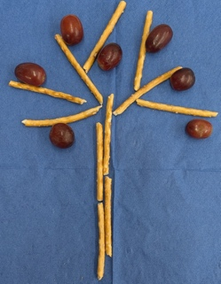
Snack: Pretzel Tree
A tree is a very important part of our Bible story today, so let’s make one for our snack. I’ll give you some pretzel sticks to make the trunk and branches of your tree. After you’ve done that, use some grapes to add to your tree. Let’s see your best trees!
• Give kids time to make and eat their snack.

Free Play
Any extra time can be spent playing with toys.

LARGE GROUP (25 Minutes)
See what’s needed at the beginning of the session.

INTRODUCTION
- Optional: Play the Countdown 5-Minute Video.
- Use this time to pick up toys and transition to the large group area.


Welcome
Hi, everyone! I’m so glad you’re here today! Can you give me a big wave if you’re happy to be here? (Group response) I have a question for you . . . who loves Christmas trees? (Group response) Me too! I love how they sparkle and have all the lights. I especially love all the pretty ornaments.

How many of you already have your Christmas tree up at home? Raise your hand if you do! Does your tree have lights? (Group response) Do you have a favorite ornament on your tree? What does it look like? (Group response)

Christmas trees are so beautiful, but guess what? They can help us remember something even
more beautiful—the greatest gift ever, Jesus!
- Play the Theme Intro Video.



Faith Fact
Today we’ll talk about some really special trees in the Bible. Can you hold your arms up so they look like the branches of a Christmas tree? (Group response)

There was a tree in a beautiful garden and there was another tree shaped like a cross. We even use Christmas trees now to help us remember all of it!
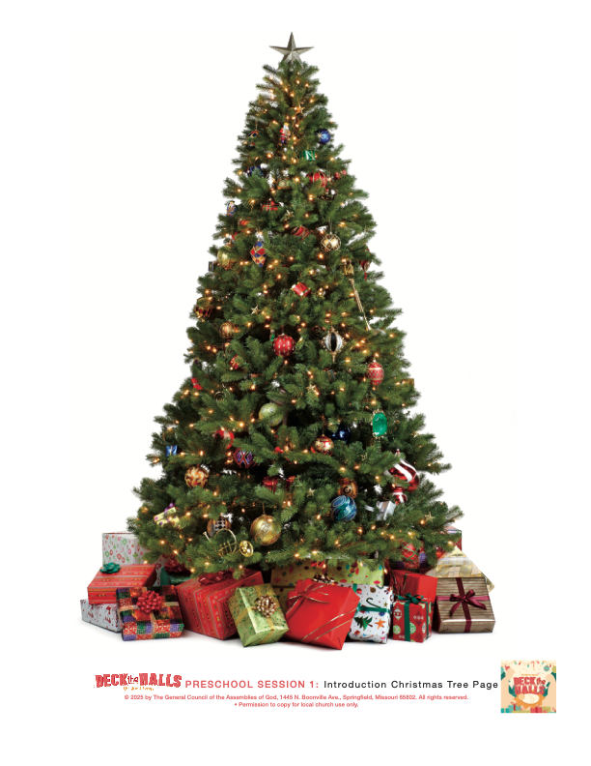
(Hold up the Introduction Christmas Tree Page or point to a Christmas tree that’s in the room.) This tree can remind us that Jesus came for a very special reason. Jesus came to save us from our sins.
- Show the Faith Fact Slide or Motion Graphic.

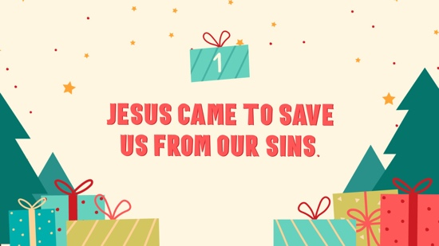

Let’s do some fun motions to help us remember our Faith Fact. When we say, “Jesus came”, we’ll put our hands together and raise them above our heads like a Christmas tree. And when we say “to save us from our sins,” we’ll stretch our arms out wide like a cross. Let’s put it all together and try it a couple of times. Jesus came to save us from our sins.

Great job friends! Jesus loves you so much. I can’t wait for you to hear the Bible story and learn more about these trees and how much Jesus loves you!

WORSHIP
Today we’re learning that a Christmas tree can remind us of something very, very special—Jesus! Jesus didn’t just come to be a baby in a manger—He came because He loves you and wants to be your Friend forever. Jesus came to save us from our sins. One way we can show Jesus we love Him is by worshipping Him!

Praise
Let’s get our hearts ready to worship Jesus!

If you’re thankful that Jesus was born, raise your hands high like a tall Christmas tree. (Group response)
If you’re glad Jesus came to save us from our sins, make your arms into a big cross! (Group response)
If you want to say, “I love you Jesus,” hug yourself really tight! (Group response)
Now can you whisper to Him that you love Him? “I love you, Jesus!” (Group response)

Sing
Now, it’s time to worship Jesus in a different way. Let’s show Jesus how much we love Him by singing together.
- Lead the kids in singing one or two praise songs. See suggestions at the beginning of the session.

Prayer
Now let’s bow our heads and pray.

Dear Jesus, thank You for coming to earth. Thank You for loving me and for taking my sins away. I love You so much. Amen.

BIBLE TIME | Adam, Eve, and Christmas (Genesis 3:1–6, 13–15, 23; Matthew 1:20–21;
1 Corinthians 15:3–4; Revelation 22:14)
You Will Need | Getting Ready
- Bible  - Bible Time Signs 1–7  - Scissors  - Bag  - Theme Bookmark, 1 sheet per 4 kids  - Card stock, 1 sheet per 4 kids | - Print the Bible Time Signs.  - Place the signs in the bag.  - Print the Theme Bookmark on card stock, 1 sheet per 4 kids, and cut apart.

I want to know Jesus more. How about you? (Group response) The Bible tells us a lot about Jesus. (Hold up the Bible.) We have some special friends who will help us learn a little bit more about what we’re talking about today! Let’s meet them now.

Video Intro
- Play the Bible Lesson Video.

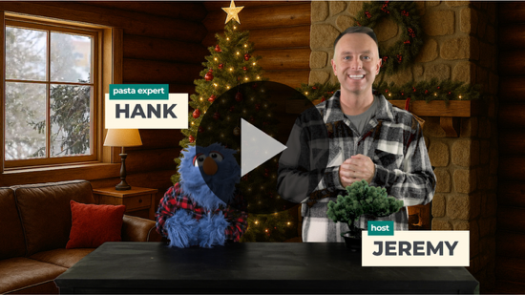

Teaching Time
That Hank is pretty silly isn’t he? Let’s take a look into God’s Word to see what it has to say about these special trees we’ve been talking about today!
- As you tell this Bible Story, make sure to hold an open Bible or have one close to you to make sure the kids understand that this is a true story from God’s Word.
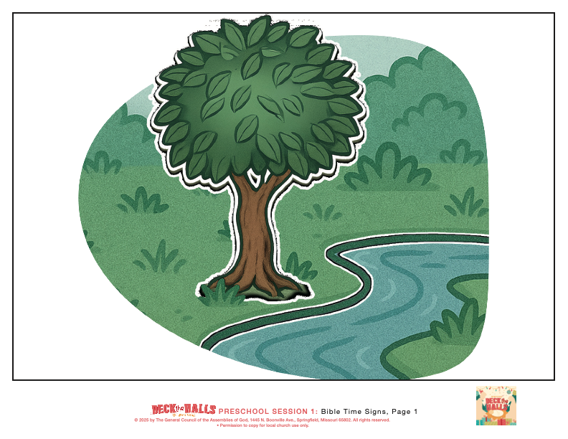
I want to tell you a true story from God’s Word from the very beginning of the Bible. Can everyone say, “In the beginning?” (Group response) A long time ago, God made a beautiful garden. It was perfect in every way. (Pull out the Bible Time Sign 1 from the bag to show the kids.) It was filled with beautiful things, like flowers and trees.

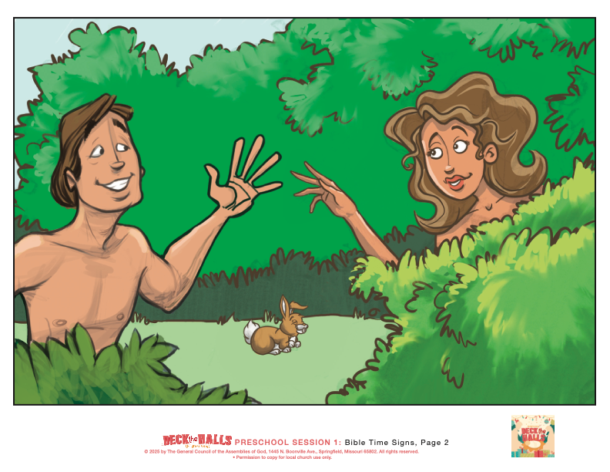
Then, God made two people named Adam and Eve. (Pull out the Bible Time Sign 2 from the bag.) They loved God and God loved them. God told them that they could eat from any tree in the garden, but there was one rule. He said, “You can’t eat from this one tree.”

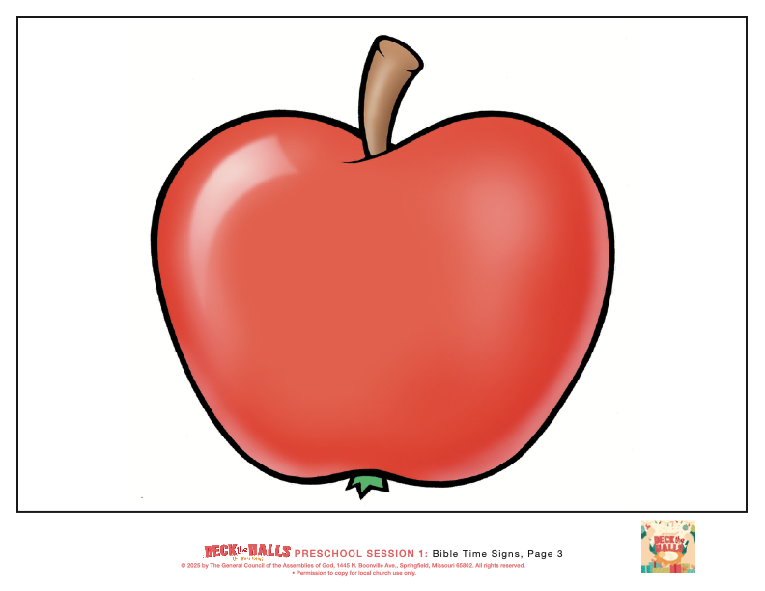
(Pull out the Bible Time Sign 3 from the bag.) One day, Adam and Eve chose to not listen to God and disobeyed Him. They ate the fruit from the one tree that God had told them not to. Uh-oh! Can you say, “uh-oh” with me? (Group response) That was called sin—doing something that God says not to do.

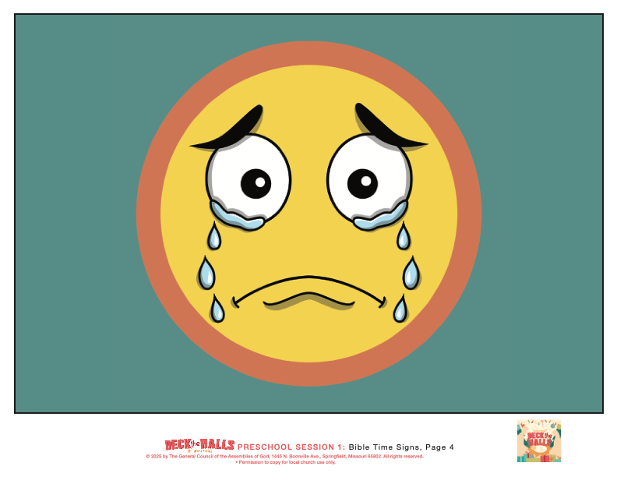
(Pull out the Bible Time Sign 4 from the bag.) Sin made everything messy and it made God very sad. Because of sin, people couldn’t be close to God like before. That’s why we needed someone to come and help us!

Can we try saying our Faith Fact together? Jesus came (hands up like a Christmas tree) to save us from our sins (arms out like a cross).
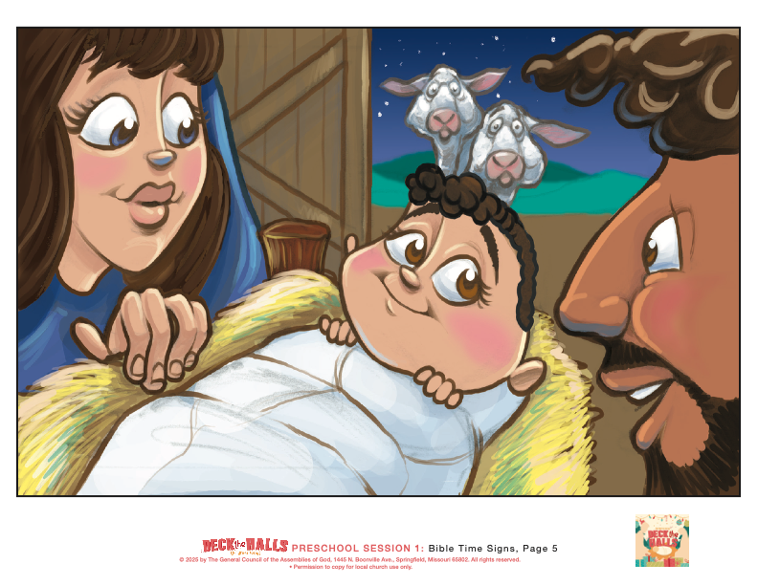
After sin came into the world, God had a rescue plan. His plan was to send Jesus as a tiny baby! (Pull out the Bible Time Sign 5 from the bag.) Jesus grew up and never ever sinned. He always listened to God. When He was older, He gave up His life on a tree that had been made into a cross.
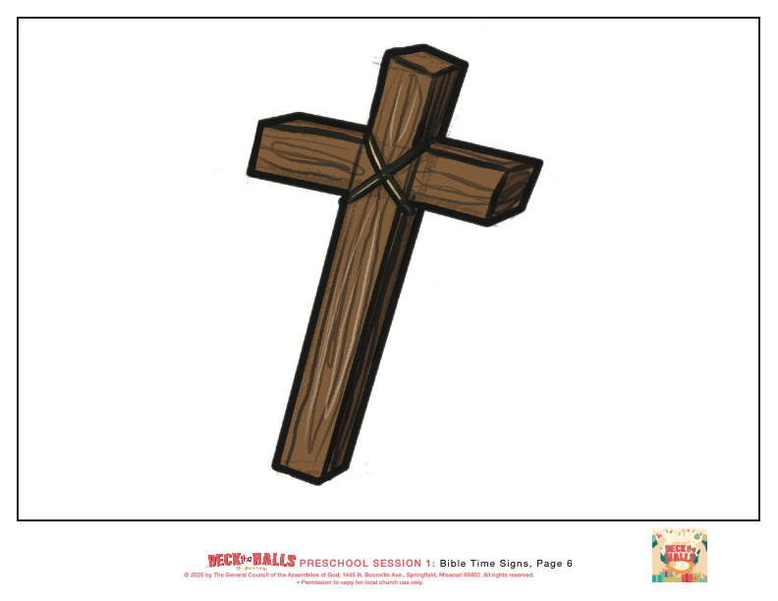
(Pull out the Bible Time Sign 6 from the bag.) Jesus died on the cross because He loves you and wanted to take away your sins. But guess what? Jesus didn’t stay dead—He came back to life!

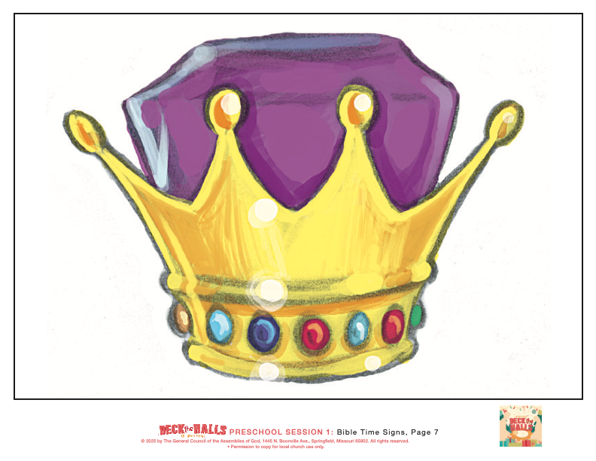
(Pull out the Bible Time Sign 7 from the bag.) Now, we can be with God forever in a beautiful place with no more sin and no more sadness. This place is called Heaven. Heaven is filled with love and joy and Jesus.

Let’s say our Faith Fact again. Jesus came to save us from our sins.

RESPONSE TIME
You Will Need | Getting Ready
- Paper, ½ sheet per kid  - Crayons | No prep is needed for this activity.

- Consider playing a worship song softly in the background while kids pray.

Let’s take a quiet moment. Put your hands in your lap and close your eyes. Think about Jesus. He came because He loves you!

I’ll give each of you a piece of paper and a crayon. I want you to listen to my instructions because I’ll tell you what to draw. As we draw, we’ll think about Jesus.

First, remember how we talked about how Adam and Eve didn’t listen to God and sinned? All of us have sinned. Take a minute to draw a sad face or something we do that’s not right. (Allow kids time to draw.)

Remember how we talked about Jesus coming as a baby? He came for us! Take a moment to draw baby Jesus. (Allow kids a moment to draw.)

Jesus came to save us from our sins. He gave up His life on the cross and came back to life so we could be forgiven and spend forever with Him in Heaven. Draw a heart to say, “Thank you Jesus!” (Allow kids time to draw.)

Now, I want you to put your crayon down and fold your hands in your lap. We’ll pray together.

Prayer
Optional: Have the kids repeat phrases of the prayer after you.

Dear Jesus, thank You for coming. Thank You for loving me. Thank You for the cross. Amen.

Faith Verse
When we remember Bible verses, Jesus can use them to change us. Let’s discover our new Faith Verse.
- Show the Faith Verse Slide or Motion Graphic.

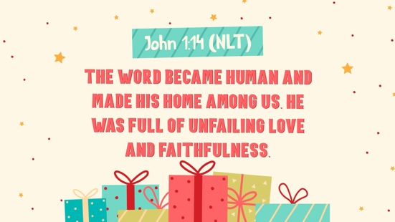

John 1:14 (NLT)
The Word became human and made his home among us. He was full of unfailing love and faithfulness.

Let’s learn the motions for our Faith Verse.

John (Hands at waist, spread apart, palms up and out.)
1: (Hands together like a clap.)
14 (Hands opened to “book.”)
The Word (Hold your hands together like an open book.)
became human, (Point to yourself with both hands.)
and made his home (Make a roof shape over your head with your hands.)
among us. (Spread your arms out wide around to the group.)
He was full (Pretend to scoop and fill your arms like you’re gathering something big.)
of unfailing love (Make a big heart with your hands in front of your chest.)
and faithfulness. (Stand up tall with your hands at your sides like a soldier.)

Wow, great job, friends! Keep practicing the Faith Verse at home, and we’ll say it again when we’re together.

Closing
What a great time we’ve had together! When we see a Christmas tree this week, let’s remember what Jesus did for us.

Faith Fact

Before we move on, let’s review our Faith Fact.
- Show the Faith Fact Slide or Motion Graphic.

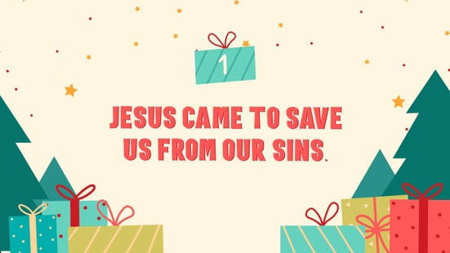

Let’s say it together 3 more times: Jesus came to save us from our sins. (Repeat 2 more times.)

Dismissal to Small Groups
Now it’s time to head to small group with your friends and do some more fun activities.
- Dismiss the kids by groups.

Leader Tip: This can be done by assigning colors to teams or by age groups. Note that some preschoolers may not know their age. Using a colored sticker, jersey, or wristband will help separate the kids and help identify their small groups.

SMALL GROUP
See supplies and prep instructions at beginning of session or in each activity below.

Leader Tip: All groups can do each activity at the same time. If you choose to rotate, you will need at least one leader per group.

Circle 1
GROUP CONNECTION | Gumdrop Christmas Trees
You Will Need | Getting Ready
- Red and green gumdrops, several per kid  - Toothpicks, several per kid | No prep is needed for this activity.

A long time ago, people made some wrong choices. God had a special plan to help us. He promised to send Jesus. Jesus came to the rescue and made it so we could be friends with God forever. God’s plan came together perfectly, kind of like how we’re going to build something special together.

Today, we’ll build some Christmas trees using gumdrops and toothpicks. You’ll each get some and can work together with a few friends at your table.
- Hand out a tray with gumdrops and toothpicks to each small group of 2–3 kids.
- Show them how to carefully stick toothpicks into gumdrops to make a little tree shape.

Wow! I love how you are working together. That’s such a strong tree! You’re using all your pieces just right!

Just like your trees needed all the gumdrops and toothpicks, God’s plan needed every part too! He planned all along to send Jesus to be our Savior. And He did exactly that! Because of Jesus, we can be forgiven and be with God forever! That is for sure a reason to celebrate Christmas!

Circle 2
ACTIVITY PAGE TIME | Color and Trace
You Will Need | Getting Ready
- Activity Page, 1 per kid  - Crayons or markers | - Print the Activity Page, 1 per kid.

Let’s do a fun activity page to help us remember our Bible story!
- Hand out an Activity Page and crayons to each kid.

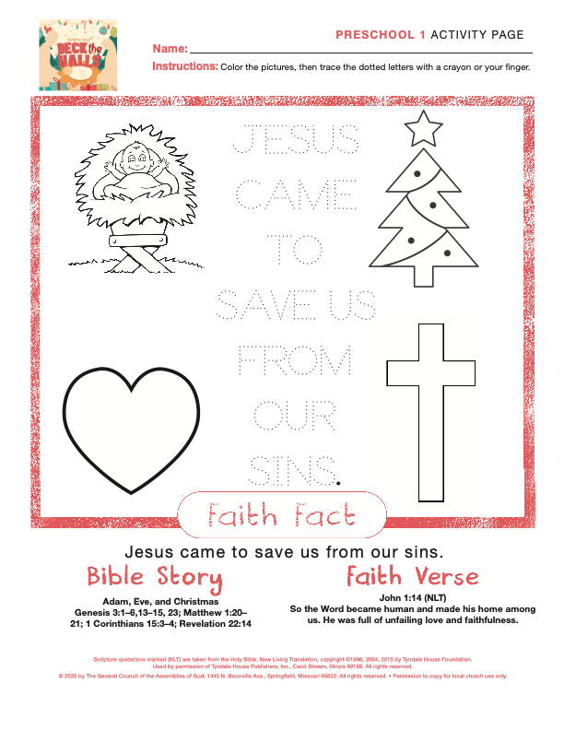
Okay friends, do you remember what we heard about today? Yes! Jesus came to save us from our sins. Look at the pictures on your page. Can you find the baby Jesus? What about the tree, the heart, and the cross? Let’s color each picture that helps us remember our story.
- Allow kids time to color the pictures. Help as needed.
- Engage the kids in conversation as they color: Jesus came as a baby, He loves us so much, the cross reminds us that He gave His life for us, etc.

Now, let’s say something really important together. It’s our Faith Fact! Jesus came to save us from our sins. Can you trace the words with your crayon or your finger? As you trace each word, say it with me. Jesus . . . came . . . to . . . save . . . us . . . from . . . our . . . sins.

Circle 3
FEET-TO-FLOOR GAME TIME | Christmas Tree Dress-Up
You Will Need | Getting Ready
- Green crepe paper  - Christmas bows  - Tinsel or ribbon  - Scissors  - Feet-to-Floor Game Time Page, 1 per group  - Smartphone or timer | - Print the Feet-to-Floor Game Time Page and cut out the star, 1 per group.


Who’s ready to have some Christmas fun? Today, we’ll make our very own Christmas trees, but not the kind that you can hang lights on or put presents under. Instead, we’ll decorate each other like trees!
- Divide kids into small groups with a leader helper for each group.
- Give each group green crepe paper, Christmas bows, tinsel or ribbon and a star cutout to place on top.

One kid in each group will be the tree and the others will help decorate.
• Set a timer for 2–3 minutes and help as needed.

The Bible talks about trees too. A long time ago, there was a tree in a garden where people made a very sad choice. But God had a plan! He sent Jesus to save us from our sins.

Circle 4
HANDS-ON LEARNING | Silly Christmas Plate Drawing
You Will Need | Getting Ready
- Paper plates, 1 per kid  - Crayons | No prep is needed for this activity.

Today we’ll play a silly drawing game. Here’s the silly part: You won’t be able to see what you’re drawing. You’ll hold your paper plate on your head and draw on it. That sounds pretty silly, doesn't it?
- Hand out a paper plate and crayon to each kid. Show them how to gently hold the plate on their head with one hand and use the other hand to draw.

Hold your plate on top of your head with one hand and use your other hand to draw. Listen carefully to my instructions and I’ll tell you step-by-step what to draw. Remember, no peeking!
Here we go. Let’s draw together!

- Draw a big circle in the middle of your plate. This will be the face.
- Inside the circle, draw two eyes. Make sure they’re even.
- Put a nose right in the center of the face.
- Draw a smiley mouth.
- On the top of the head, draw some hair. It can be curly, straight, or spiky. It’s up to you.
- Make sure to draw the ears on each side of the head.
- Now, on top of the head, draw a Christmas tree hat.
- Last, draw some stars around the head for decoration.

Now, take your plate off your head and let’s see your drawing! Wow! Those are some silly and fun Christmas faces! Did it turn out the way you thought it would? (Let kids laugh at their pictures and take a look at each other’s pictures.)

You know what? Even when we can’t see the whole picture, God always can. God had a plan from the very beginning to send Jesus. And guess what? Jesus followed God’s plan perfectly! He came as a baby, lived a perfect life, and gave His life for us because He loves us so much.

FAITH FACT RECAP
- Display the Faith Fact Slide or Motion Graphic as parents are coming into the room.
- Maximize the time you have with your kids, so that parents see what their kids have learned. Have the kids repeat the Faith Fact, and then dismiss them to their parents.

What an awesome time we had together today! Before we go, let’s say the Faith Fact one more time. Jesus came to save us from our sins. (Group response) Great job, everyone! See you next time!

DISMISSAL
- Send home the paper from Response Time, Activity Page, Hands-on Learning plate, and the Theme Bookmark.
- Remind parents that there are Family Devotions available on the app to do with their kid.
- Optional: Send home the Advent Countdown to Christmas Ornaments, one set per kid.
- Tell everyone the date and time for the next session.

