

LEADER OVERVIEW
Overview—Deck the Halls
As we prepare for Christmas, things begin to look a little different. We see Christmas trees, lights strung around homes and stores, and big inflatables. These things are fun and exciting, but as we “Deck the Halls,” it’s important to remember the real reason we celebrate Christmas! Many things we decorate with can point us back to the Christmas story and be good reminders about the One we are celebrating.

Each week, we’ll talk about a different Christmas decoration and discover how each one can remind us of Scripture as we see them during the holidays. Each week, your stage design can grow as the piece being talked about is placed on the stage, adding to the ones before.

SESSION 1: Born with Purpose—Genesis 3:1–6, 13–15, 23; Matthew 1:20–21;  1 Corinthians 15:3–4; Revelation 22:14  Faith Fact: Jesus came to save us from our sins. | SESSION 2: The True Light of Christmas—  John 1:1–5, 9–14; 8:12  Faith Fact: Jesus is the Light of the world.
SESSION 3: The Cast of Characters—  Matthew 1:18–24; Luke 1:28–38; 2:8–18  Faith Fact: God always has a plan. | SESSION 4: The Best Gift—Matthew 1:23; 2:1–11; Luke 2:11; 1 John 4:14–16  Faith Fact: Jesus is King, God, and Savior.
SESSION 5: A Joyful Christmas Review—
Proverbs 3:5–6; Matthew 1:21; 2:1–2, 10–11; John 8:12
Faith Fact: My joy is found in Jesus.

SESSION OVERVIEW

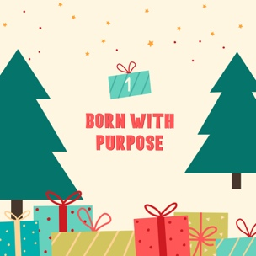
The Christmas Tree—The need for Christmas started with a tree back in Genesis. When sin entered the world through Adam and Eve’s disobedience, it involved a tree and God’s promise of a Savior. Jesus came as a baby and grew up to show us what love is. He was hung on another tree, a cross, when He died for us. Thankfully, He rose again so that our relationship with God could be restored. In this session, kids will discover that Jesus came with purpose, knew what He was going to do, and He did it all because of His great love for us!

Bible Lesson | Faith Fact
Adam, Eve, and Christmas  Genesis 3:1–6, 13–15, 23; Matthew 1:20–21;  1 Corinthians 15:3–4; Revelation 22:14 | Jesus came to save us from our sins.
Faith Verse
John 1:14 (NLT)
The Word became human and made his home among us. He was full of unfailing love
and faithfulness.

This series is part of an entire kids’ discipleship strategy. Get access at KidminRoadmap.com.

PREPARING FOR THE SESSION
You Will Need | Getting Ready
Large Group  - Bible  - Worship songs (Song suggestions: “Star of the Morning” Lyric Video by Hillsong Kids, “Light Has Come” Lyrics Video by River Valley Go Kids, “Gratitude” by Brandon Lake)  - For groups not using a phone or tablet only, add:  - Projector or TV  - Laptop  - Countdown 5-Minute Video  - Theme Intro Video  - Faith Fact Slide or Motion Graphic  - Game Slide or Motion Graphic  - Bible Lesson Video  - Teaching Point Slides 1–3  - Faith Verse Slide or Motion Graphic  - Green crepe paper  - Christmas wrapping bows  - Tinsel  - String or strand of Christmas lights  - Clothespins  - Card stock  - Scissors  - Christmas tree stand with only four legs  - Pencils or pens, one per kid  - Pages to Print:  - Theme Bookmark, one per four kids  - Bible Lesson Timeline Pictures 1–9  - Prayer Response Page, one per kid  - Optional: Advent Countdown to Christmas Ornaments, one set per kid  - Optional: Newsletter Template  - Optional: White card stock for Advent Countdown to Christmas Ornaments  Small Group  - Red and green gumdrops  - Toothpicks  - Measuring tape or ruler  - Paper plates, one per kid  - Pencils or crayons, one per kid  - Bibles, one per kid  - Scissors  - Tape  - Green or red plastic cups, ten cups per group  - Pencils or pens, per kid  - Bibles  - Crayons or markers  - Pencils, pens, or markers  - Pages to Print:  - Small Group Faith Verse Review Page, one per group  - Small Group Faith Fact Journal Page, one per kid  - Small Group Activity Page A, one per kid  - Small Group Activity Page A Answer Page  - Small Group Activity Page B, one per kid  - Small Group Activity Page B Answer Page  - Family Devotion Week 1, one per kid | Large Group  - Download videos and slides if needed.  - Select worship song(s) and have them ready to play.  - Decide if the Game will be played by just a few kids in front of the group or if everyone will participate.  - Print the Theme Bookmark on card stock, one per four kids, and cut apart.  - Print the Bible Lesson Timeline Pictures 1–9.  - Hang the string or strand of Christmas lights so it’s hung like a clothesline.  - Optional: Have kid volunteers hold up the signs one at a time.  - Print the Prayer Response Page, one per kid.  - Optional: Download and customize the Newsletter Template, if using.  Small Group  - Print the Faith Verse Review Page and cut apart the slips.  - Tape each slip to one of the ten cups.  - Print the Faith Journal Page, one per kid.  Note: Decide how you will use this page. Options include: Send home for kid’s personal devotions or use during Prayer and Response time, in small groups, or as stations around the room with kids completing a different section of the page at each station.  - Print the Small Group Activity Page A and/or Small Group Activity Page B, combined total printed one per kid.  - Print the Family Devotion Week 1 to give to the parents, one per kid.  - Optional: Print copies of the Advent Countdown to Christmas Ornaments, one set per kid.  Don’t miss the fun Advent Countdown to Christmas Ornaments, a family-centered daily focus for December. Download with the printables for this session or from KidminRoadmap.com

Check out all the promotional and extra media files available for this theme. To access the Bible Engagement project from the computer, visit App.BibleEngagementProject.com

LARGE GROUP (30 Minutes)
See what’s needed at the beginning of the session.

INTRODUCTION
- Optional: Play the Countdown 5-Minute Video.


Welcome

Hi, everyone! Who loves Christmas trees? Does anyone already have their Christmas tree put up? (Group response) They’re so beautiful, aren't they? Did you know that a Christmas tree can remind us of the greatest Gift ever? Jesus!
- Play the Theme Intro Video.



Faith Fact
Today we’ll talk about a few different trees that we find in the Bible and how they can remind us of why we really celebrate Christmas. The most special tree for us, the tree that Jesus died on, is a cross. Jesus was born for a very special purpose. That’s what our Faith Fact today is about: Jesus came to save us from our sins.
- Show the Faith Fact Slide or Motion Graphic.

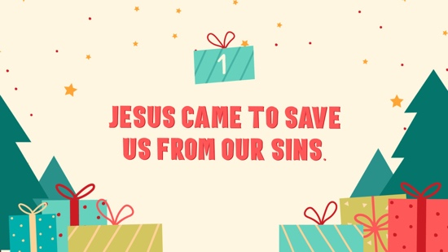

Let’s add some actions to this Faith Fact to help us remember it. (Demonstrate actions as you do them.) Let’s try this: When we say, “Jesus came,” we’re going to put our hands together over our heads like we’re making the top point of a Christmas tree. When we say, “to save us from our sins,” we’re going to stretch our arms out wide to make the shape of a cross. Let’s try it!
- Give kids an opportunity to try the actions a few times.

Let’s say the Faith Fact together one more time. Jesus came to save us from our sins. One more time and just a little bit louder! Jesus came to save us from our sins. Great job!

GAME | Human Christmas Trees
You Will Need | Getting Ready
- Green crepe paper  - Christmas wrapping bows  - Tinsel | - Decide if this will be played by just a few kids in front of the group or if everyone will participate.

- Show the Game Slide or Motion Graphic.


Today, we’re going to make our own Christmas trees. But instead of using a Christmas tree from the store or one made of construction paper, we’re going to make trees out of people! We are going to divide into groups and each group will choose one person to become the tree. Then, your group will have 3 minutes to decorate your tree as best as you can.
- Hand out decorations to each group.
- Give groups 3–5 minutes to decorate their tree.

Wow! Your Christmas trees look fantastic! Today we are talking about some trees in the Bible that played a really big part in God’s story. Our need for Jesus started all the way back at the beginning of the Bible with the tree of the knowledge of good and evil in the Garden of Eden. Then it led to another tree that Jesus faced—the cross.

WORSHIP

When we look at a Christmas tree, it almost looks like an arrow pointing up. It can remind us of what Jesus did for us. That’s the real reason we celebrate Christmas. We’re going to spend some time worshipping Jesus today. We can worship Him by raising our hands and focusing our hearts and our words, like an arrow, on how awesome He is.
- Lead the kids in singing one or two praise songs. See suggestions at the beginning of the session.

BIBLE LESSON | Adam, Eve, and Christmas
(Genesis 3:1–6, 13–15, 23; Matthew 1:20–21; 1 Corinthians 15:3–4; Revelation 22:14)
You Will Need | Getting Ready
- Bible Lesson Timeline Pictures 1–9  - String or strand of Christmas lights to hang the pictures from  - Clothespins  - Theme Bookmark, one per kid  - Card stock  - Scissors | - Print the Bible Lesson Timeline Pictures.  - Hang the string or strand of Christmas lights so it’s hung like a clothesline.  - Optional: Have kid volunteers hold up the signs one at a time.  - Print the Theme Bookmark on card stock, one per four kids, and cut apart.

I’m so glad we get to worship God together! Now it’s almost time to learn something amazing from God’s Word. Do you remember what our Faith Fact is today? (Group response) Yes! We’re talking about how Jesus came to save us from our sins. But before we do any of that, let’s pray.

Prayer
Dear God, thank You for sending Jesus. We love You so much! Amen.

Video Intro

Just before we look at the Bible story, let’s watch this video.
- Play the Bible Lesson Video.

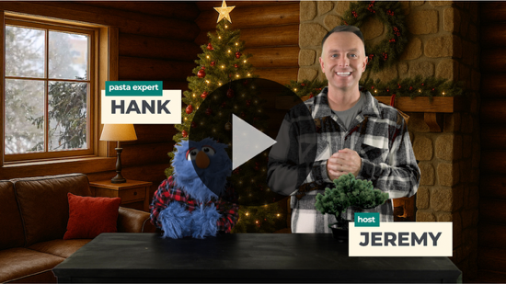

That video was such a great lead-in to our story today! How many of you have a fake or artificial Christmas tree? (Group response) How many of you have a real Christmas tree? (Group response) Today we’re learning about some very real trees that the Bible talks about and how they play a huge part in our lives!

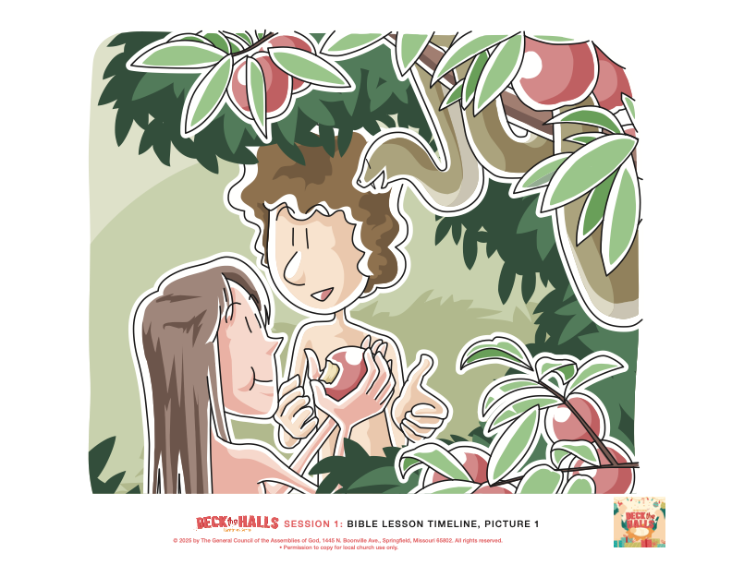
Teaching Time

A long time ago, all the way back in the beginning of the Bible, the Book of Genesis talks about a beautiful and perfect garden that God created. He also created the first two people to live there. Do you know their names? (Allow responses.) Right! We call them Adam and Eve.
- Hang Timeline Picture 1: Adam and Eve.

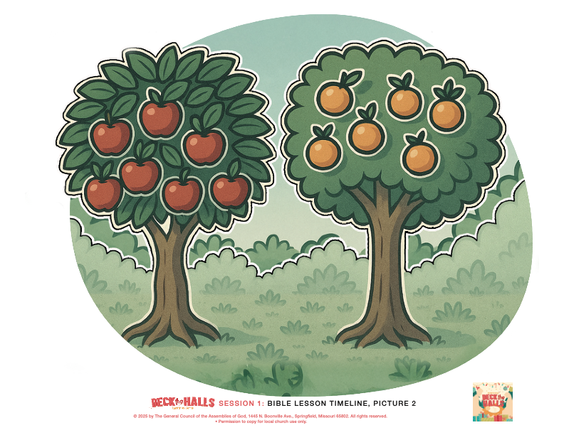
Optional: Have a kid hold up each Timeline Picture.

In that perfect garden, God placed two very special trees—the tree of life and the tree of the knowledge of good and evil.
- Hang Timeline Picture 2: Garden of Eden/Two Special Trees.

God gave Adam and Eve very specific instructions. He told them that they could eat from any tree in the Garden except one—they weren’t supposed to eat the fruit from the tree of the knowledge of good and evil. The serpent came to Eve and tempted her to eat from the tree that God told them not to. Let’s see what happened! Grab your Bible and turn to Genesis 3.
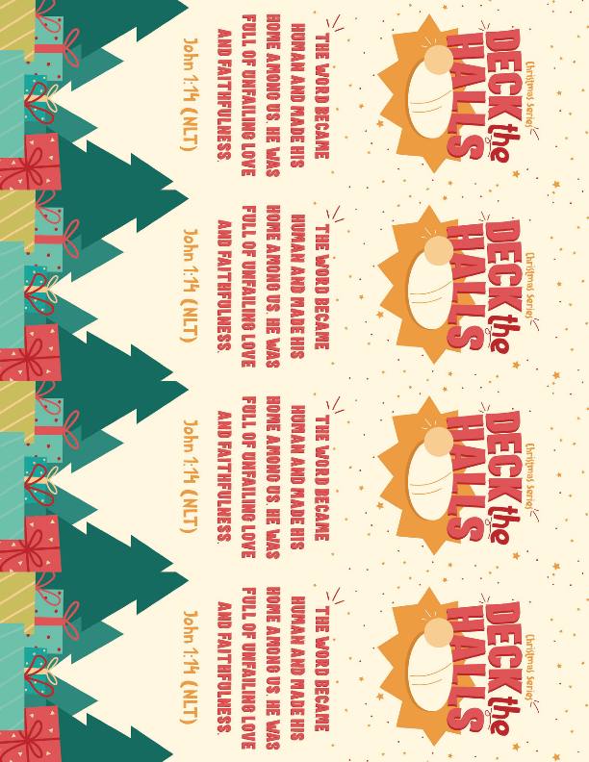
- Read the Bible story Genesis 3:1–6 aloud to the group.
- To keep Large Group time moving along, we don’t recommend having the kids read.
- Give a Theme Bookmark to each kid. Tell the kids to mark this place in their Bible with the Theme Bookmark, so they can read it on their own at home.

1. Sin entered the world.
- Show the Teaching Point 1 Slide.

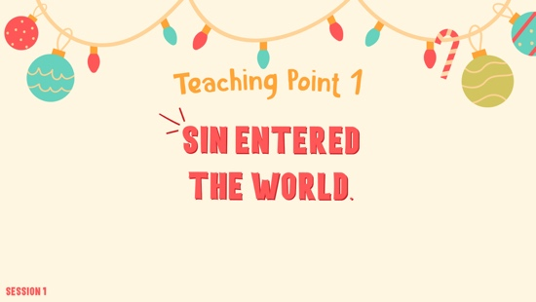

Adam and Eve disobeyed God when they ate from the tree that God had specifically told them not to eat from. When they disobeyed, sin entered God’s perfect world. Their sin left all people in need of a Savior.
- Read Genesis 3:13–15, 23.

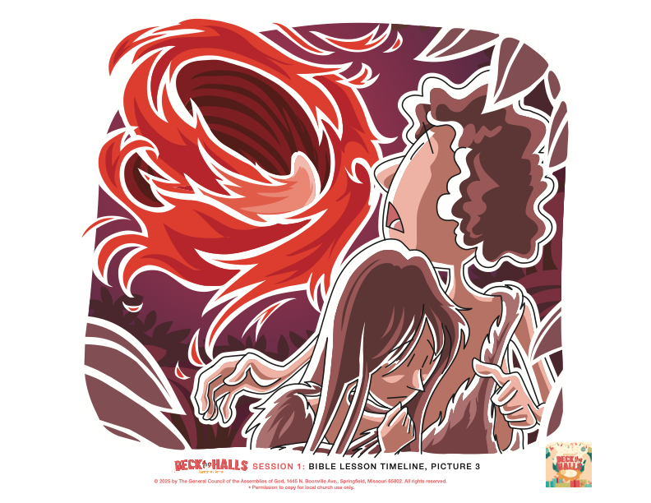
How many of you have been punished when you did something wrong? Raise your hand. (Group response) Me, too! The same is true when we sin. Sin requires a punishment, too. God made Adam and Eve leave the perfect garden, and life was difficult for them. Not only could they not live in the Garden anymore, but they also couldn’t see or eat from the tree of life.
- Hang Timeline Picture 3: Adam and Eve Leave the Garden.

But, God also punished the serpent. God said that He was going to send Someone who would defeat the serpent. This was God’s first promise to send a Savior.

Let’s fast-forward a little to the very first Christmas. Thousands of years after all this happened, God kept His promise to send a Savior. He sent Jesus!

2. Jesus came to earth as a baby.
- Show the Teaching Point 2 Slide.

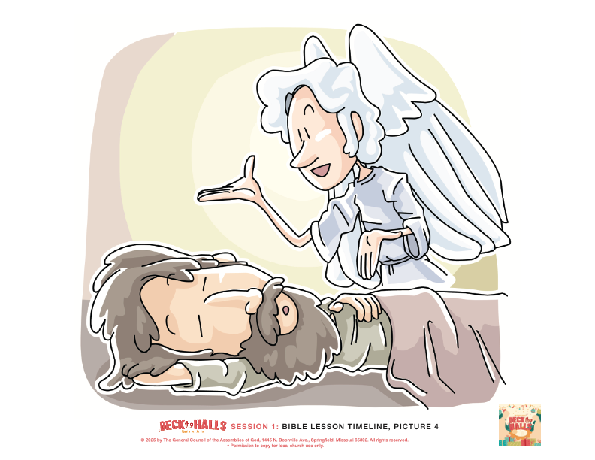
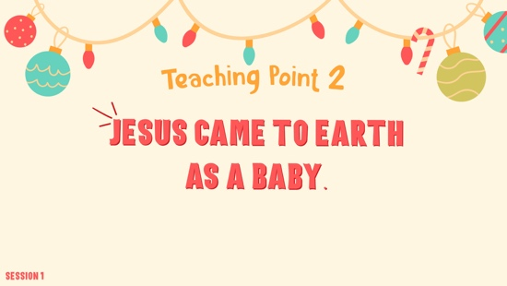

- Read Matthew 1:20–21.
- Hang Timeline Picture 4: Angel Appears to Joseph in a Dream.

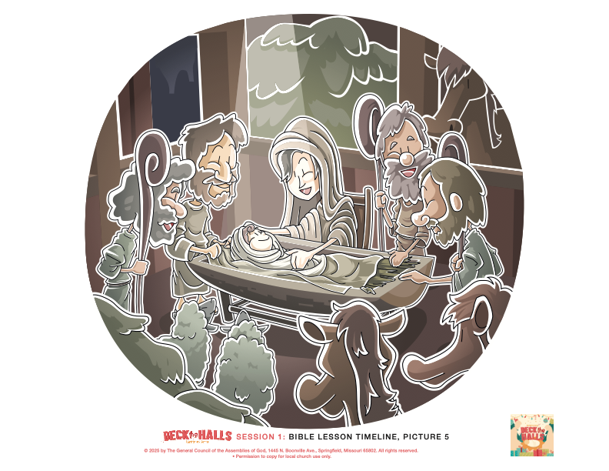
The angel Gabriel appeared to Joseph in a dream and told him that Mary was going to have a baby. The angel said they were to name Him Jesus because He would save His people from their sins. Does anyone know what town Jesus was born in? (Allow responses.) Bethlehem! Mary and Joseph traveled to Bethlehem. When the Baby was born, they named Him Jesus just as they had been told.
- Hang Timeline Picture 5: Jesus Is Born/Nativity Scene.
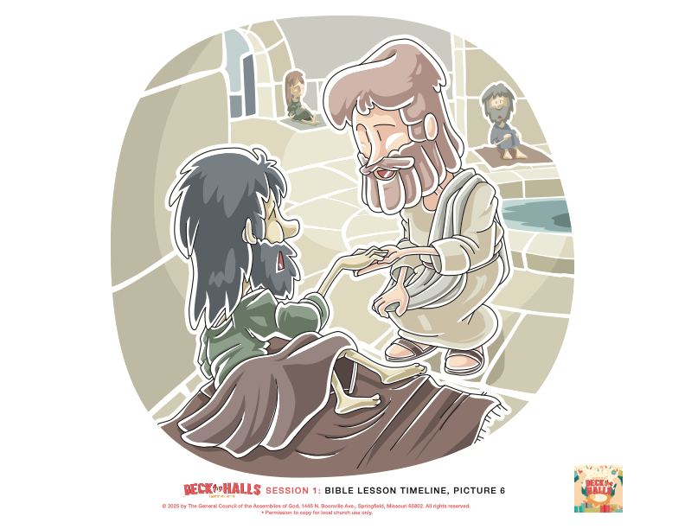

Jesus didn’t stay a baby though! He grew up just like you’re growing up. He wasn’t here on earth just to be a baby.
- Hang Timeline Picture 6: Jesus Doing Ministry.

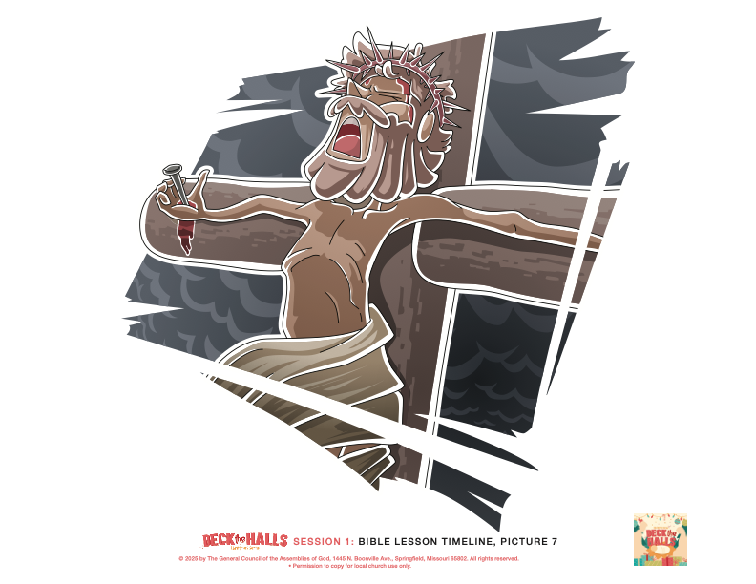
Jesus was born with a purpose, just like what our Faith Fact says. What’s our Faith Fact? Jesus came to save us from our sins. His life led to another kind of tree, one that wasn’t filled with lights or ornaments. It was a tree that had been made into a cross.
- Hang Timeline Picture 7: Jesus on the Cross.

3. Jesus died on a cross and rose again for us.
- Show the Teaching Point 3 Slide.

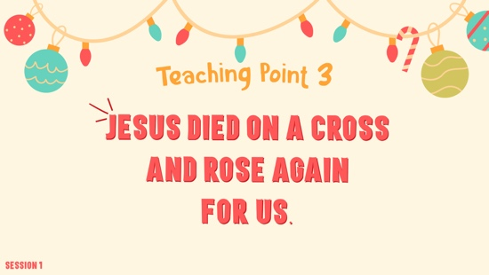

- Read 1 Corinthians 15:3–4.
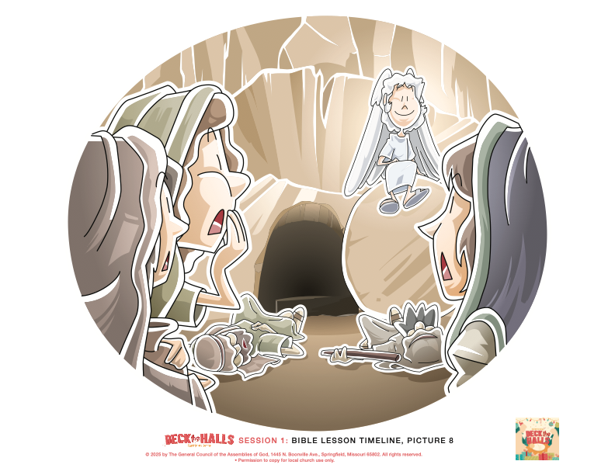

Jesus came to earth, lived a perfect life, and died on the Cross. Then He came back to life and defeated death. Through His death on that tree, the Cross, He paid the price for our sins. We can have a relationship with God if we choose to accept Jesus as our Savior and live to follow Him. Jesus’ resurrection is the promise that we can also live with Him forever one day.
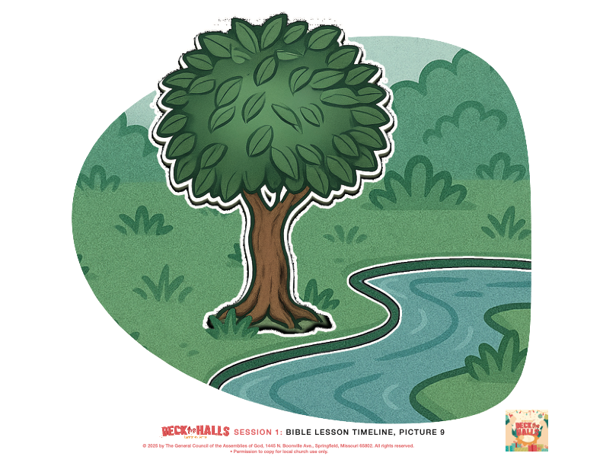
- Hang Timeline Picture 8: Jesus Is Alive.

One day, we will have access to the tree of life again that people lost at the Garden of Eden.
- Hang Timeline Picture 9: New Earth and the Tree of Life.

Jesus is building the most incredible city for those who follow Him! In that city, there is a river that carries the purest, most life-giving water you could ever imagine. The river is lined with the tree of life, offering healing and food for Jesus’ friends. Just imagine a tree that bears a different kind of delicious fruit every single month! This city is a place where God’s light shines endlessly. Only those who have asked Jesus to be their Savior can enter. There we’ll find eternal joy, peace, and friendship with Jesus in the presence of God forever!
- Read Revelation 22:14.

OBJECT LESSON | Christmas Tree Stand
You Will Need | Getting Ready
- Christmas tree stand with only four legs | No prep is needed for this activity.

- Hold up the tree stand for the kids to see.

Thinking about Christmas trees, does anyone know what this is? (Group response) It’s a Christmas tree stand. You put the trunk of your tree in this stand so the tree will stand up nice and tall. If you tried to put a Christmas tree up in your house without this base, it couldn’t stand up. It would fall over, breaking all the lights and ornaments and creating a giant mess. It’s only possible for the Christmas tree to stand up because of the base.

Does the shape of these legs make you think of anything that we’ve talked about today? (Group response) I think it looks a little like a cross. Without Jesus’ cross, we wouldn’t be able to celebrate Christmas. If we reject what Jesus did for us on the cross, we miss out on the main point of Christmas—the gift of a Savior.

PRAYER AND RESPONSE
You Will Need | Getting Ready
- Prayer Response Page, one per kid  - Pencils or pens, one per kid | - Print the Prayer Response Page, one per kid.

- Consider playing a worship song softly in the background while kids pray.

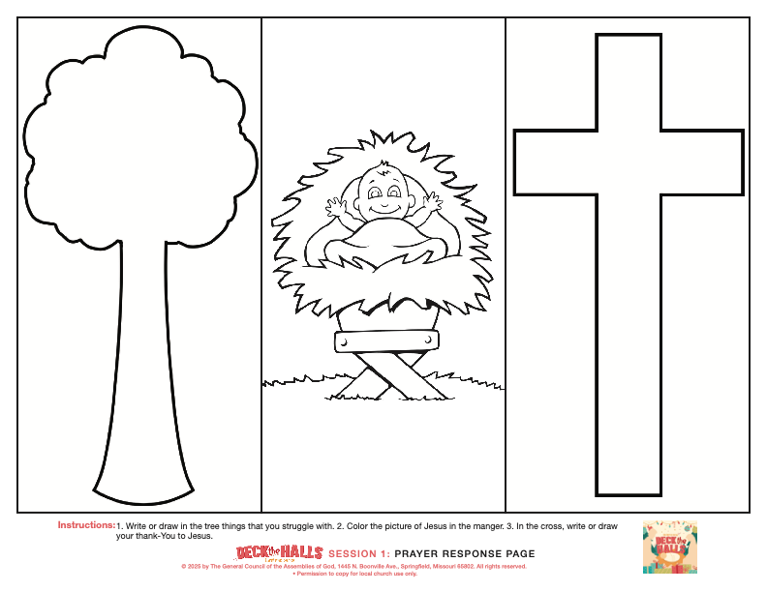
Let’s respond to what we read in God’s Word. Sin separates us from God. Jesus came to save us from our sins. And because of what Jesus did for us on the cross, our sin problem can be fixed. We can go to Him, ask for forgiveness, and ask Him to help us live for Him.
- Hand out the Prayer Response Page and a pencil to each kid.
- Encourage the kids to find a place in the room where they can focus and be separated from other kids.

We’re going to spend a minute getting ourselves quiet in God’s presence and ask the Holy Spirit to speak to us. All of us sin, and we know that there are things we struggle with. Ask the Holy Spirit to bring to your mind those areas where you struggle with sin. Take a minute to write or draw about those things in the first tree on your paper that represents the tree in the Garden of Eden where Adam and Eve disobeyed God.
- Allow the kids time to respond to this first section.

Now, look at the picture of Jesus as a baby in the manger. This is why we celebrate Christmas. Jesus was born for a purpose. Take some time to think about how special it is that Jesus was willing to come as a baby for us.
- Allow the kids time to reflect.

Now, let’s look at this last picture—Jesus’ cross. Jesus knew that He was going to grow up and give His life for us because of how much He loves us. Let’s take a minute to tell Him thank You for coming to give His life for our sins and rising again so we could have a friendship with God and live with Him forever. In the cross, you can write or draw your thank-You to Jesus!
- Don’t rush this time in the presence of God. Allow time and space for the Holy Spirit to speak and for kids to listen.
- If time allows, and in the seriousness of the moment, you may allow kids to share what the Holy Spirit may be speaking to them.

Let’s pray together.

Prayer
Optional: Have the kids repeat phrases of the prayer after you.

Dear Jesus, thank You for being willing to come as a baby at Christmas. You knew that You would grow up to give Your life for me. You came to earth anyway. Thank You that I can have a friendship with God forever. Amen.

Optional: Salvation Prayer
We can have a relationship with God when we accept Jesus as our Savior and live to follow Him. Maybe you would like to ask Jesus to come and be a part of your life right now. Jesus died on the cross and rose again so that we can be made right with God. He can forgive you of your sins and give you a fresh start. You can do that today and start that friendship with Him. I want to give you an opportunity to do that right now. If you’d like to invite Jesus to be your Lord and Savior, let’s pray together.
- Invite kids to come forward to pray with you or have everyone repeat the prayer after you.

Dear Jesus, I believe You came to earth and died on the Cross so that I can be forgiven. Please forgive my sins and make me a new person. I want to live for You. I also believe You came back to life, and now I can live forever with You. Thank You for coming into my life. Amen.

Faith Verse

Our Faith Verse reminds us of how Jesus came to earth with a purpose because of His incredible love for us. Let’s say our Faith Verse together.
- Show the Faith Verse Slide or Motion Graphic.

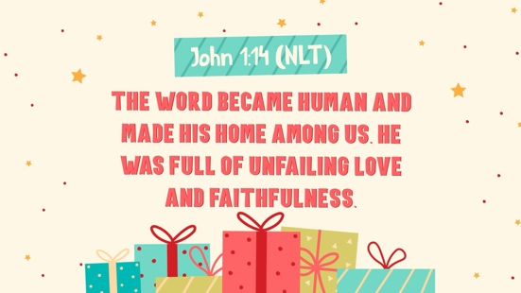

John 1:14 (NLT)
The Word became human and made his home among us. He was full of unfailing love and faithfulness.

It’s so special to think about what Jesus did for us. He loves us so much!

Faith Fact

Before we move on, let’s review our Faith Fact one more time.
- Show the Faith Fact Slide or Motion Graphic.

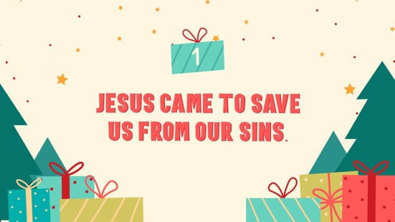

Remember how we said our Faith Fact together earlier by adding the actions? Let’s try that again. Point your hands up together like a Christmas tree when we say, “Jesus came,” and then stretch your arms out wide like a cross when we say, “to save us from our sins.” Let’s say it one more time. Jesus came to save us from our sins.
- Dismiss kids to Small Group time or to go home if your group time ends here.

SMALL GROUP

This section can be done in conjunction with the large group or on its own if you do small groups with your kids. During Small Group time, the goal is to connect kids with the Word of God and to each other. All activities are led by the small group leader.

GROUP CONNECTION | Gum Drop Christmas Trees
You Will Need | Getting Ready
- Red and green gumdrops  - Toothpicks  - Measuring tape or ruler | No prep is needed for this activity.

Even before any of us were born or had done anything wrong, God had a plan in motion to save people. We read about that plan in the Old Testament and can see how everything led to a Savior coming to earth to rescue us. Because Jesus died on the Cross, our sins can be forgiven, and we can spend forever with Him. Each part of God’s plan came together perfectly to give us an amazing life and build a future for us.
- Divide the group into teams.

I’ll give each team a box of toothpicks and a bunch of gumdrops. You are going to work together in your teams to build the tallest and strongest Christmas tree you can.
- Hand out the materials and give kids 5–10 minutes to build their trees.
- Partway through the time, take away one item they are using to build, either a large chunk of the toothpicks or a large handful of the gumdrops. Encourage kids to try to continue building.

Did taking away some of your building materials make it easier or harder to build your trees? (Group response) It made it harder! Why was it harder? (Allow responses.) It’s because every gumdrop and toothpick mattered.

Each piece was important, just like every part of God’s plan is important. God’s plan to save us through Jesus came together perfectly. The best part is that because of Jesus, our sins can be forgiven, and we can spend forever with Him. Isn’t that amazing?
- Measure each of the trees and determine which team was the winner for the tallest tree.

GAME | Christmas Plate Challenge
You Will Need | Getting Ready
- Paper plates, one per kid  - Pencils or crayons, one per kid | No prep is needed for this activity.

We’re going to play a fun game to see how well we can follow a plan. First, you’re going to draw a picture on a plate. Sounds pretty easy, right? (Group response) Here’s the catch: You have to hold the plate on top of your head while you draw and you have to follow my instructions. The part that makes it even trickier is, you can’t look at your drawing until the end. Are you ready to play? (Group response)
- Hand out a paper plate and pencil to each kid.

Hold your plate on top of your head with one hand and use your other hand to draw. Listen carefully to my instructions and I’ll tell you step by step what to draw. Remember, no peeking!

Here we go.

- Draw a big circle in the middle of your plate. This will be the face.
- Inside the circle, draw two eyes. Make sure they’re even.
- Put a nose right in the center of the face.
- Draw a smiley mouth.
- On the top of the head, draw some hair. It can be curly, straight, or spiky. It’s up to you.
- Make sure to draw the ears on each side of the head.
- Now, on top of the head, draw a Christmas tree hat.
- Last, draw some stars around the head for decoration.

- Make sure kids have time to finish their drawings.

Now, take your plate off your head and let’s see your drawing!
- Allow a moment for the kids to laugh and react to their drawing and share their pictures with those around them.

Let’s see how many points you got for following my instructions. Give yourself a point for each of these.
- A complete circle for the face
- Two eyes inside the circle
- A nose in the center of the face
- A smiley mouth
- Hair on top of the head
- Ears on the sides of the head
- A Christmas tree hat on top of the head
- Decorations around the head

How many points did you get? (Allow responses.) Great job everyone!

Let’s take a minute to think about what we just did. Our pictures didn’t turn out exactly how we thought they would, did they? You see, Jesus always knew the plan, and He followed it exactly. He came to earth as a baby, lived a perfect life, grew up, gave His life on the cross to save us from our sins, and rose again. Unlike our drawings, which turned out pretty silly, Jesus followed the plan perfectly so that we could be forgiven and have a relationship with Him. Everything He did was on purpose. Jesus came to save us from our sins.

BIBLE LESSON RECAP | Adam, Eve, and Christmas
(Genesis 3:1–6, 13–15, 23; Matthew 1:20–21; 1 Corinthians 15:3–4; Revelation 22:14)
You Will Need | Getting Ready
- Bibles, 1 per kid | No prep is needed for this activity.

Optional: If small group does not immediately follow large group time, you may want to read the Bible story passage together before the discussion (Genesis 3:1–6, 13–15, 23; Matthew 1:20–21).

At the very beginning of the Bible, sin entered the world when Adam and Eve chose to disobey God. They ate from the tree that He gave them specific instructions not to eat from. Because of their disobedience, they had to leave the Garden, and life became really hard for them. At this time, God first promised to send a Savior to save people from their sins.

Thousands of years later, God kept His promise to send a Savior, and He sent His Son Jesus to earth to be born as a baby. An angel appeared to Joseph and told him to name the baby Jesus, because He would save His people from their sins.

Jesus didn’t stay a baby, though. He grew up and lived a perfect life by never sinning, not even once! His life led Him to another tree, the Cross, where He died to pay the punishment for our sin. Then He rose from the dead three days later! Because of His death and resurrection, we can now have a relationship with God. We can live with Him forever.

Faith Fact
- Show the Faith Fact Slide or Motion Graphic.

Do you remember our Faith Fact? Say it with me: Jesus came to save us from our sins.

GROUP DISCUSSION

Feel free to use all or just a few questions for good discussion that reinforces the Faith Fact and Bible Lesson. Questions marked with * are designed for more conversation. Adjust the questions based on the age or maturity of your group.

Let’s take a few minutes to talk about the Bible story we heard today and how we can apply it to our life.

Questions

- What three main trees did our Bible story talk about?

- How do you think Adam and Eve felt after they disobeyed God?

- Why do you think God promised to send a Savior after Adam and Eve sinned?

- *How does it make you feel knowing that God had a plan from the beginning to send a Savior who would save us from our sins?

- *What do you think it was like for Jesus as a baby and growing up?
- Why do you think Jesus was willing to die on the cross for us?

- How can Christmas trees remind us of what Jesus did for us?

- *What do you think it will be like living with God forever?

For additional questions, see the Bible Fact-Pak questions 29, 30, 220, 320, 321, 329, and 330. Bible Fact-Pak resources are available from MyHealthyChurch.com.

Live it Challenge

Christmas trees can remind us of the incredible love of Jesus and what He did for us. Jesus came to save us from our sins. Every day this week, take time to sit in front of your Christmas tree at home when it’s quiet or with soft worship music playing. If you don’t have a Christmas tree, keep your eyes open for Christmas trees around town. Spend a couple of minutes each day thanking Jesus for giving His life to save you from your sins. Tell Him how you feel, knowing that you get to spend forever with Him.

Prayer

Finish group discussion by sharing prayer requests and praise reports. Keep track of your small group’s prayer requests and review them each time you meet.
- Have kids share and pray for each other’s prayer requests.

Dear God, thank You for loving us enough to have a perfect rescue plan in place to save us from our sins. Thank You for sending Jesus and for making a way for us to spend forever with You. Amen.

FAITH VERSE REVIEW
You Will Need | Getting Ready
- Faith Verse Review, one per group  - Scissors  - Green or red plastic cups, ten cups per group  - Tape | - Print the Faith Verse Review Page and cut apart the slips.  - Tape each slip to one of the ten cups.

Our Faith Verse is John 1:14. It reminds us of exactly what Jesus did because of His great love for us. Let’s review it now.
- Show the Faith Verse Slide or Motion Graphic.

John 1:14 (NLT)
The Word became human and made his home among us. He was full of unfailing love and faithfulness.

Let’s review our Faith Verse as a group again, so you’ll know it for our next activity.
- Say the verse as a group a couple of times.

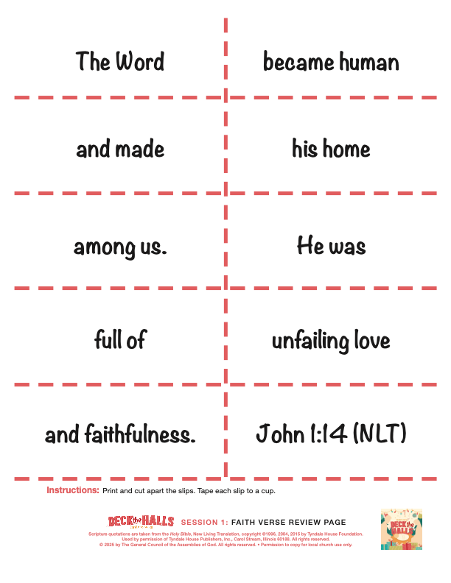
Faith Verse Fun | Cup Stacking Christmas Tree

Let’s play a game to help us remember our Faith Verse. We’re going to see if we can make a Christmas tree by stacking these cups in order of the words of our Faith Verse. You can start with the first part of the verse on the bottom. If you stack your cups so that there four cups on the bottom row, it will look like a Christmas tree when it’s finished.
- Allow kids to work together to put the verse together.
- Play multiple rounds as time allows.
- Optional: Have kids compete against each other to see who can put it together first or have them work as a group to see if they can beat their time.

There were a few trees that we talked about in our Bible story today. The need for Christmas started with a tree all the way back in Genesis. Sin entered the world through Adam and Eve’s disobedience involving a tree. But then God promised a Savior. Jesus came as a baby and grew up to show us what love is. But then He was hung on another tree, the cross. He died for us and rose again so that our relationship with God could be restored. That meant that people can one day eat from the tree of life again! Jesus came with purpose, knowing what He was going to do, and it showed His great love for us!

FAITH FACT JOURNAL
You Will Need | Getting Ready
- Faith Fact Journal Page, 1 per kid  - Pencils or pens, 1 per kid  - Bibles  - Crayons or markers | - Print the Faith Fact Journal Page, one per kid.
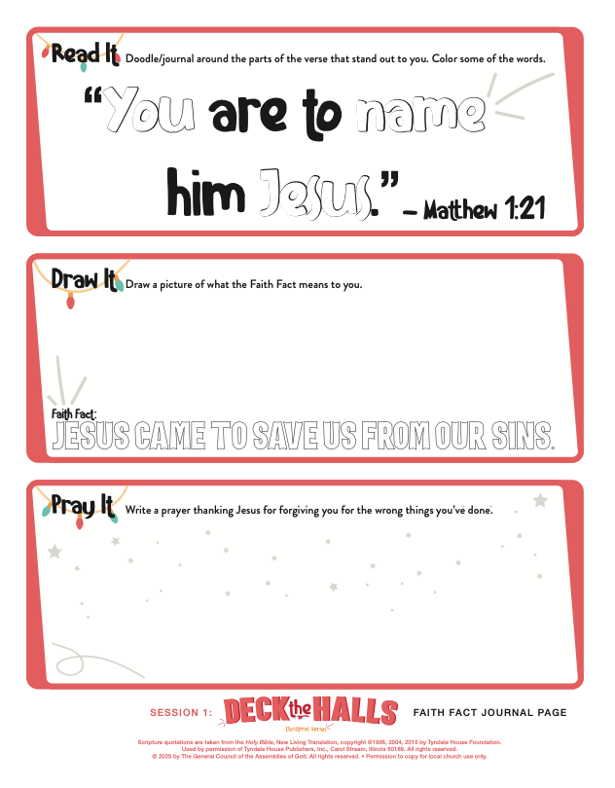
We’ve got a journal page that will help us dig a little deeper into God’s Word and our Faith Fact today.
- Hand out a Faith Fact Journal Page and a pencil to each kid.
- Place Bibles on the table for kids to use.
- Provide crayons or markers for kids to share.
- Guide the kids through the page as needed.

ACTIVITY PAGE A | Christmas Tree Word Search (An activity for younger kids)
You Will Need | Getting Ready
- Activity Page A, one per kid  - Activity Page A Answer Page  - Pencils, pens, or markers | - Print Activity Page A, one per kid.
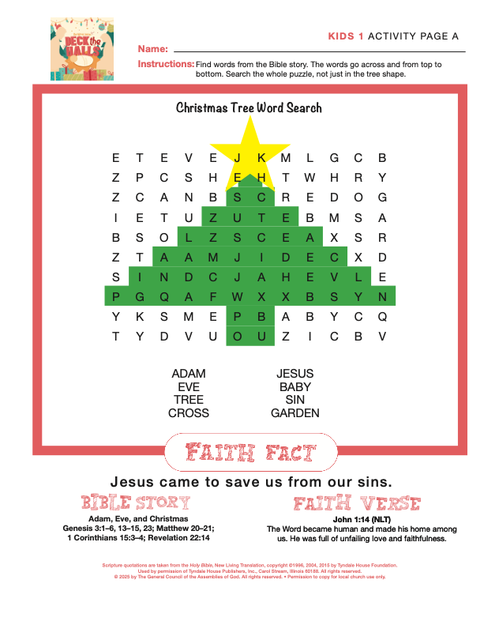

We’ve got a fun page to do today. This word search has words from the Bible story today. Let’s try to find each word and see if we can remember what that word has to do with our Bible story.
- Hand out an Activity Page A and a pencil to each kid.
- Give kids time to complete the Activity Page.

Isn’t it incredible to think about what Jesus did for us? Jesus came to save us from our sins.

ACTIVITY PAGE B | Christmas Tree Word Search (An activity for older kids)
You Will Need | Getting Ready
- Activity Page B, one per kid  - Activity Page B Answer Page  - Pencils, pens, or markers | - Print Activity Page B, one per kid.
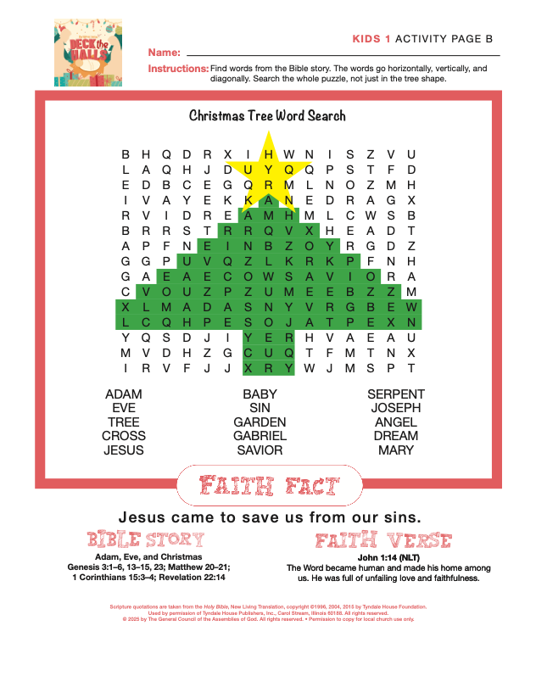

We’ve got a fun page to do today. This word search has words from the Bible story today. Let’s try to find each word and see if we can remember what that word has to do with our Bible story.
- Hand out an Activity Page B and a pencil to each kid.
- Give kids time to complete the Activity Page.

Isn’t it incredible to think about what Jesus did for us? Jesus came to save us from our sins.

DISMISSAL

As we get ready for Christmas and set up fun things like our Christmas tree, let’s remember the other special trees from our Bible story today and why we really celebrate Christmas. Jesus came and saved us from our sins. Let’s pray.

Prayer
Dear God, thank You for loving us so much that You sent Your Son Jesus to save us from our sins. We are so thankful for the new life that You give and for the promise of living forever with You. Amen.

Faith Fact Recap
- Show the Faith Fact Slide or Motion Graphic.

Something very important I want you to remember from today is our Faith Fact. Let’s say it together one more time. Jesus came to save us from our sins. When you go home, tell that to someone who needs to hear this good news today. I’m so glad you came today. I can’t wait to see you next time.
- Send home the Activity Page, the Prayer and Response Page, the Faith Fact Journal Page, and the Family Devotion Week 1.
- Remind parents that there is a Family Devotion to do with their kid.
- Optional: Send home the Advent Countdown to Christmas Ornaments, one set per kid.
- Tell everyone the date and time for the next session.

