

LEADER OVERVIEW

Volume Overview—Run the Race
In these sessions, kids will discover that God has a plan for each one of them and the importance of listening to and doing what God says. They will also learn about the hope of Jesus’ return and what it will be like to live with God forever.

SESSION 1: Timothy Learns from Paul—  2 Timothy 3:10–17  Faith Fact: God has a plan for me. | SESSION 2: Faith and Works—James 1:19–27; 2:14–26  Faith Fact: God wants me to take action.
SESSION 3: Jesus Is Coming Back—  1 Thessalonians 4:13–18; 5:1–11  Faith Fact: Jesus is coming back. | SESSION 4: New Heaven and New Earth— Revelation 21:1–10, 21–27  Faith Fact: I can live with God forever.

SESSION OVERVIEW

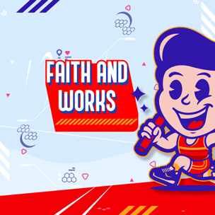

In this session, kids will learn that it’s important to listen and to do what God says. Our faith journey doesn’t stop when we become a Christian. God wants us to put our faith in action and serve Him.

Bible Lesson | Faith Fact
Faith and Works  James 1:19–27; 2:14–26 | God wants me to take action.
Faith Verse
Philippians 3:14 (NLT)
I press on to reach the end of the race and receive the heavenly prize
for which God, through Christ Jesus, is calling us.

Listen Kids is part of an entire kids’ discipleship strategy. Get access at KidminRoadmap.com.
PREPARING FOR THE SESSION
You Will Need | Getting Ready
Large Group  - Bible  - Worship songs (Song suggestions: “Zeal” by The Belonging Co; “Way Maker” by Hillsong; “See a Victory” by Elevation Worship; “Yes and Amen” by Chris Tomlin)  - Small prizes or candy  - Handheld mirror or full-length mirror  - Poster board  - Marker  - For groups not using a phone or tablet only, add:  - Projector or TV  - Laptop  - Countdown 5-Minute Video  - Theme Intro Video  - Faith Fact Slide or Motion Graphic  - Game Time Slide or Motion Graphic  - Bible Lesson Video A  - Bible Lesson Video B  - Faith Verse Video or Slide  Small Group  - Small prizes or candy, one per kid  - Bibles, one per kid  - Small Group Activity Page 1, one per kid  - Small Group Activity Page 2, one per two kids  - Strips of colored paper, seven per kid  - Scissors  - Glue or tape  - Pencils or pens, one per kid | Large Group  - Download videos and slides if needed.  - Select worship song(s) and have them ready to play.  - Write one phrase on each side of the poster board: “Listening is not enough” and “Faith without good deeds is dead.”  Small Group  - Print the Small Group Activity Page 1, one per kid.  - Print the Small Group Activity Page 2, one per two kids.  - Cut the colored paper into strips.  - Cut out the Action Pouch rectangles from Small Group Activity Page 2, one per kid.
Check out all the promotional and extra media files available for this theme. To access the Bible Engagement Project from a computer, visit App.BibleEngagementProject.com.

Find the corresponding Bible Fact-Pak® question numbers for this session in the Volume Additional Assets on the mobile or Web app.

LARGE GROUP (30 Minutes)
See what’s needed at the beginning of the session.

INTRODUCTION

- Optional: Play the Countdown 5-Minute Video.

Welcome

Welcome! I’m so glad you’re here! Last time we talked about Paul and how he discipled other people like Timothy who were then able to train others. Today, we’ll be looking at some practical life advice from the Book of James. Let’s watch this video, and then we’ll get started.

- Play Theme Intro Video.

James is a book of the Bible near the end of the New Testament. It’s not a long book. You can read all five chapters on your own or read them with your family. One of the things the Book of James talks about is how our actions should go along with our faith. We can’t just say that we love Jesus and not show that we do by our actions.

Faith Fact
- Show the Faith Fact Slide or Motion Graphic.


Let’s learn today’s Faith Fact. It goes along with what we’ll see in James. God wants me to take action. That tells me that our God is a God of action.

We have to stand up and move while we say a Faith Fact like this. Say the Faith Fact with me while running in place. God wants me to take action. That was great! Let’s say it a couple more times. (Pause for kids to say the Faith Fact.)

GAME | Think It, Do It
You Will Need | Getting Ready
- Small prizes or candy | No prep is needed for this activity.


- Show the Game Time Slide or Motion Graphic.

Do you trust me? (Group response) Do you trust me enough to do anything I say? (Group response) That’s what we are going to do today. I will think of something for you to do or say, and if you are chosen, you have to do it. If you do it, I have a prize for you. If you choose to pass, you will go back to your seat without a prize. Let’s play!
- Choose one or two kids to come up at a time.
- Give kids an action to do like skip around the room, shake hands with everyone in the front row, make a silly face, act like a monkey for 10 seconds, sing a song, eat something without using your hands, peel a banana with your teeth, or say the Faith Fact/Faith Verse with your tongue sticking out. Use your imagination.
- Give the kid(s) the option to do it or pass.
- Play as many rounds as time allows.
I was surprised by who decided to do those crazy things. If you can give that much energy to game time, I know you are ready to move during worship.

WORSHIP

Worship is a great way to put our faith in action and show others that we love God. It is a physical example of how much we love God when we worship Him by singing.
- Lead the kids in singing one or two praise songs. See suggestions at the beginning of the session.

BIBLE LESSON | Faith and Works (James 1:19–27; 2:14–26)

- See Preparing for the Session on page 2 for items needed here.

There is something so freeing and fun about singing and worshipping God with all your heart. Let’s pray and ask God to challenge us to take even more action as we explore today’s Bible lesson.

Prayer

Dear God, thank You for an amazing time of worship. Help us to examine our life and see the areas where we need to take more action for You. Amen.

Video Intro

Before we start the Bible story, let’s check in with Dash and Austin and see what they’re up to.
- Play Bible Lesson Video A.

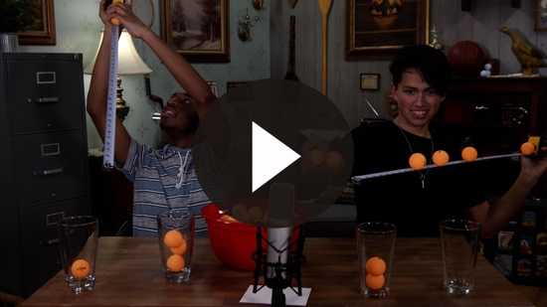

Wow! Would you try that challenge? (Group response) How can rolling balls along a tape measure tie into a Bible story?

Teaching Time
If you have your Bible, turn with me to James 1:19–27. (Allow time for the kids to turn to the passage in their Bible.)

We are going to read two passages out of James today because they go together. Let’s start with James 1:19–21.
- Read James 1:19–21.

Stop there for a moment. The first verse has some really helpful advice that deserves repeating. “You all must be quick to listen, slow to speak, and slow to get angry.” Why do you think that the Bible tells us to do those things? (Allow responses.)

“Be quick to listen.” Why is that important? (Allow responses.) James is telling us that it is important to listen to what other people have to say.

Be “slow to speak.” Why do you think that is in there? (Allow responses.) Sometimes we want to do all the talking, but we have to remember to slow down, listen to others, and wait for our turn to speak.

The last part of this verse says, “slow to get angry.” Why do you think that it says that? (Allow responses.) People tend to get offended, or get angry, too easily. The Bible is telling us that we do not need to get angry so quickly. Try to understand other people’s perspective, and maybe you won’t get so angry.

These verses in James are super important to remember. In fact, let’s repeat them together a few times to make it really stick. I will say, “Be quick to,” and you will say, “Listen.” I will say, “Slow to,” and you will say, “Speak.” Then I will say, “Slow to get,” and you will say, “Angry.” Let’s practice that a few times.
- Say the verse a few times the way it was explained with the kids before moving on.

Great job! Let’s continue reading in James 1:22–25.
- Read James 1:22–25.

How many of you look at yourself in the mirror every day? (Group response) Would you say that you are familiar with what your face looks like? (Group response)
- Hold up the mirror while you talk about it.

What if you didn’t look at your face in a mirror for a year? Do you think you’d look exactly the same? (Group response) Of course not. You’re growing. The same is true when we read God’s Word. God wants to use it to help us grow. We need to look at it every single day, soak it in, and actually do what it says. It’s not enough just to know what the Bible says; we have to put it into action. Remember, God wants me to take action.

Let’s turn to James 2:14–17. (Allow kids time to find the new Scripture passage.)
- Read James 2:14–17.

James goes on to write several examples of how faith without good deeds is completely useless. When we have faith, it simply means we put our trust in God. If our trust in God is real, then that should show in our actions! It’s not enough to just say we trust God; we must act like we trust God!
- Insert an example from someone in your life whom you trust. Explain to the kids how that person’s actions show they can be trusted.

It’s pretty useless to say you trust someone, but then not show it in your actions. Let’s take your parents as an example. If you trust your parents to keep you safe, then you would be willing to let them drive you to school, or you would be happy for them to cook your food. It would be a little strange if you said you trusted them but refused to let them do those things for you.

It’s the same way with God! If we really have faith in God and trust Him, then our lives should show that. James mentioned two people from the Old Testament who were great examples of putting their faith into action. He wrote about how Abraham was willing to give up his son Isaac, his son of God’s promise. James also mentioned Rahab risking her life to hide the Israelite men who were scouting out the land. Those were big acts of faith that showed they trusted God!

It’s not enough for us to have faith; people need to see our faith in action. How do these two passages of Scripture go together? What are the similarities between the two messages? (Group response) The first passage’s main point was listening to God’s Word is not enough. We need to listen to God’s Word and then do what it says.
- Hold up the first side of the poster board.

The second passage’s main point was faith without good deeds is completely useless and dead. If we have faith in God, people should be able to see it by what we say and do.
- Flip the poster board and show the second sentence.

Faith Verse
Our Faith Verse reminds us that our lives on earth are like running a race. If you sat down on the track and didn’t finish the race, could you win? (Group response) Of course not! You have to run. We have to put our faith in action to “run our race” here on earth as well. Let’s take time now to work on learning the Faith Verse with actions.
- Show the Faith Verse Video or Slide.

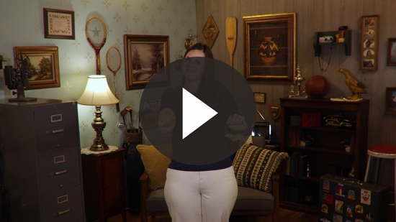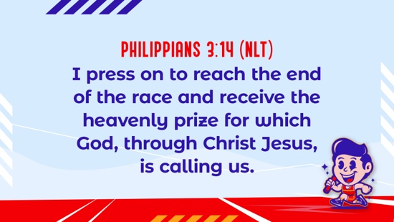

Philippians 3:14 (NLT)
I press on to reach the end of the race and receive the heavenly prize for which God, through Christ Jesus, is calling us.

There are times when it might seem easier to hide your faith or do nothing, but that’s not what God has told us to do. He wants us to take action and let everyone know that we love and believe in Him.

How can you do that? What are some ways that you can show others that you are a Christian and that you live for Jesus? (Allow responses.) It is important that we make good choices. Don’t do or say things that you shouldn’t do or say. Don’t be afraid to talk about God and tell others how much He loves them. Help others who need a friend or have a need.

PRAYER AND RESPONSE
You Will Need | Getting Ready
No supplies are needed for this activity. | No prep is needed for this activity.

Consider playing a worship song softly in the background while kids pray.

God wants us to be Christians who take action. He doesn’t want us to just read our Bible at home and church and then go out and act like we’re not Christians. He doesn’t want us to believe in Him but not let anyone else know about it. People should know that we are followers of Jesus by our actions, the way we live, and the choices that we make. How can you put your faith into action this week? Let’s pray and ask God. Then, let’s listen to what He is saying to us today.
- Give kids time to pray.
- Lead them in a salvation prayer.
- Then introduce the worship song. This could play in the background while kids pray or could be a worship song to sing together.

Worship Song
Play one or two worship songs.

Video Wrap-Up

Before we go to our small group activities, let’s see how the Challenge Accepted team is doing with their challenge.
• Play Bible Lesson Video B.

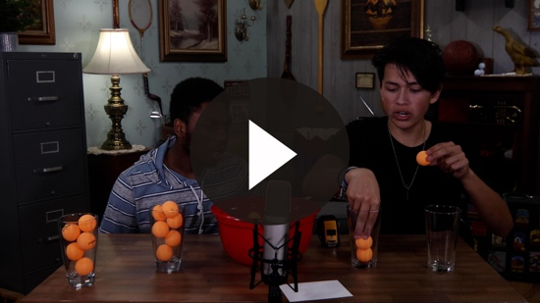

Let’s all accept the challenge that Austin gave us. Spend time asking God to show you what action you need to take and then do it.
- Show the Faith Fact Slide or Motion Graphic.



Let’s say our Faith Fact together. Say it with me. God wants me to take action. I hope our Faith Fact helps us all get out there and live out our faith this week. See you next time.
- Dismiss kids to Small Group time or to go home if your group time ends here.

SMALL GROUP (30 Minutes)
This section can be done in conjunction with the large group, or on its own if you do small groups with your kids. During Small Group time, the goal is to connect the kids with the Word of God and to each other. All activities are led by the small group leader.

GROUP CONNECTION | Listen Carefully
You Will Need | Getting Ready
- Small prizes or candy, one per kid | No prep is needed for this activity.

How well do you listen? We are about to find out! I am going to whisper something for the whole group to do in one person’s ear. They will pass what I said on to the next person and so on. You must whisper in their ear quietly so no one else can hear. When everyone has been told what to do, the group will do it. If the group successfully listens and does what I said to do, you will get a point. If you receive three points, I have a prize for the whole group.
- Have the kids sit in a circle or line up in a line.
- When the whole group knows what they are supposed to do, tell them to do it.
- Play as many rounds as you like or play until kids get three points. If they get three points, give each kid a small prize or piece of candy.

BIBLE LESSON RECAP | Faith and Works (James 1:19–27; 2:14–26)
You Will Need | Getting Ready
- Bibles, one per kid | No prep is needed for this activity.

Today we looked at the Book of James. There is so much wisdom in these five short chapters, but we looked at only two sections of the book today. Let’s read the two passages that have similar lessons for us to learn from. Turn with me to James 1:19–27 to get started. Next, we’ll turn to James 2:14–24.
- Divide the reading into four segments and have kids read each segment.

James 1:19–22

James 1:23–27

James 2:14–18

James 2:19–24

What is one thing that you remember from our Bible verses? (Allow responses.)

We talked about some of these verses in James that are super important to remember. Let’s review them together. I will say, “Be quick to,” and you will say, “Listen.” I will say, “Slow to,” and you will say, “Speak.” Then I will say, “Slow to get,” and you will say, “Angry.” Let’s practice that a few times.
- Say the verse a few times the way it was explained with the kids before moving on.

Faith Fact
- Show the Faith Fact Slide or Motion Graphic.

The Book of James is filled with advice that tells us how to put our faith into action. Our Faith Fact is a great reminder that God is a God of action. Say it with me. God wants me to take action.

GROUP DISCUSSION

Feel free to use all or just a few questions as a jumping-off place for good discussion. Questions marked with * are designed for more conversation. Adjust the questions based on the age or maturity of your group. Typically, older kids will be able to dive a little deeper than younger ones.

Questions

Are you a good listener?

Are you better at listening or talking?

Have your parents ever told you to do something, but you didn’t do it?

* Share about a time when you didn’t do what you were told to do.

Have you ever read something in the Bible and chose to do the opposite?

* Share about a time when you did something you knew the Bible said you shouldn’t do.

Do you show your faith in God to others?

* How do you put your faith in action?

* Share a good deed you plan to do for someone else.

* What is something Jesus did that is an example of faith in action?

APPLICATION AND RESPONSE

How can you put your faith in action this week? Maybe there’s a better question. How does God want you to put your faith in action this week? (Allow responses.) Why don’t we all ask Him that question right now? Now is a great time to practice taking some time to listen to God. We will spend a couple of minutes in complete silence and allow God time to speak to us. Try doing this every day on your own.

Make It a Habit
Select a simple visual reminder of the session’s Faith Fact

Do you remember today’s Faith Fact? Let’s say it together. God wants me to take action. Every day this week, you’ll probably look at yourself in the mirror multiple times. Every time you look in the mirror, remind yourself to read your Bible and find something you can put into action. It could be showing someone God’s love, sharing your faith with a friend, or praying for someone who needs healing. Put your faith in action every day this week. What else could we use to remember?
- Make notes of what the kids share.

Prayer

Let’s pray and ask God to tell us how He wants us to take action this week. Join me in praying this prayer.

Dear God, I’m so thankful that You are a God of action. Help me to follow Your example and live my faith in a way that is obvious to everyone around me. Amen.

FAITH VERSE REVIEW
You Will Need | Getting Ready
No supplies are needed for this activity. | No prep is needed for this activity.

Our Faith Verse is Philippians 3:14. It reminds us that we must get up and take action to follow the plan God has for us. Let’s say the Faith Verse and do the actions for the verse together.
- Show the Faith Verse Video or Slide.

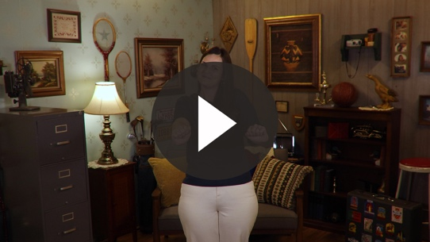

Philippians 3:14 (NLT)
I press on to reach the end of the race and receive the heavenly prize for which God, through Christ Jesus, is calling us.

Faith Verse Fun | Faith Verse in Action

We always say our Faith Verse together, but today, we are going to put it into action. We’ll divide the group into two teams. Each team will have five minutes to come up with their own actions for the Faith Verse. The teams will present the Faith Verse with the actions they came up with.
- Allow each team to teach their Faith Verse actions to the other team.

ACTIVITY PAGE | Action Pouch
You Will Need | Getting Ready
- Activity Page 1, one per kid  - Activity Page 2, one per two kids  - Colored strips of paper, seven per kid  - Scissors  - Glue or tape  - Pencils or pens, one per kid | - Print Activity Page 1, one per kid.  - Print Activity Page 2, one per two kids.  - Cut the colored paper into strips.  - Cut out the Action Pouch rectangles from Activity Page 2, one per kid.

What are some simple ways you can put your faith in action this week? (Allow responses.)
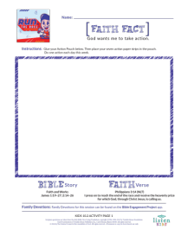
- If kids are struggling with coming up with good options, help them out.

Faith in Action ideas: Tell someone you love them/care about them, do a chore that you aren’t asked to do at home, share something with someone, give up something to spend more time with God, offer to help someone in need, pray for someone, make something or write a note to encourage someone, share something you learned about God’s Word with someone.

Those are some great ideas! I want you to write down seven ways to put your faith in action this week. You have to be willing to actually do them! You can use some of the ideas we all just shared as a group or come up with your own. Write one action on each of your seven strips of paper.

Then you are going to create an Action Pouch. Take the rectangle Action Pouch and glue [or tape] it to the page to create a pouch to put your strips of paper in. You can take this home as a reminder. I challenge you to draw an action out of your Action Pouch every day this week and put your faith in action that day.

Prayer
Say this prayer with me.

Dear God, thank You for giving me so many ideas for how I can put my faith into action. Help me to take this challenge and put my faith into action every day this week. Amen.

FAITH FACT RECAP
- Display the Faith Fact Slide or Motion Graphic as parents are coming into the room.
- Maximize the time you have with your kids, so that parents see what their kids have learned. Have the kids repeat the Faith Fact, and then dismiss them to their parents.

This is the answer to the question your adults are going to ask: “What did you learn today?” Let’s say the Faith Fact together: God wants me to take action.

Remember to pull an action slip out of your Action Pouch every day and put your faith into action!

DISMISSAL
- Send home the Activity Page.
- Remind parents that there are Family Devotions available on the app to do with their kid.
- Tell everyone the date and time for the next session.

