

LEADER OVERVIEW

Volume Overview—Run the Race
In these sessions, kids will discover that God has a plan for each one of them and the importance of listening to and doing what God says. They will also learn about the hope of Jesus’ return and what it will be like to live with God forever.

SESSION 1: Timothy Learns from Paul—  2 Timothy 3:10–17  Faith Fact: God has a plan for me. | SESSION 2: Faith and Works—James 1:19–27; 2:14–26  Faith Fact: God wants me to take action.
SESSION 3: Jesus Is Coming Back—  1 Thessalonians 4:13–18; 5:1–11  Faith Fact: Jesus is coming back. | SESSION 4: New Heaven and New Earth— Revelation 21:1–10, 21–27  Faith Fact: I can live with God forever.

SESSION OVERVIEW
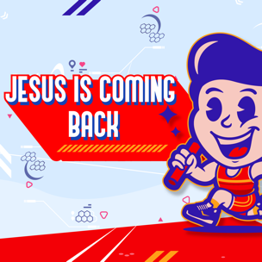

In this session, kids will learn that Christians don’t need to be afraid of the end of our time on earth. Jesus is coming back to take everyone who believes to live forever with Him.

Bible Lesson | Faith Fact
Jesus Is Coming Back  1 Thessalonians 4:13–18; 5:1–11 | Jesus is coming back.
Faith Verse
Philippians 3:14 (NLT)
I press on to reach the end of the race and receive the heavenly prize
for which God, through Christ Jesus, is calling us.

Listen Kids is part of an entire kids’ discipleship strategy. Get access at KidminRoadmap.com.
PREPARING FOR THE SESSION
You Will Need | Getting Ready
Large Group  - Bible  - Worship songs (Song suggestions: “Zeal” by The Belonging Co; “Way Maker” by Hillsong; “See a Victory” by Elevation Worship; “Yes and Amen” by Chris Tomlin)  - For groups not using a phone or tablet only, add:  - Projector or TV  - Laptop  - Countdown 5-Minute Video  - Theme Intro Video  - Faith Fact Slide or Motion Graphic  - Game Time Slide or Motion Graphic  - Bible Lesson Slides 1–2  - Bible Lesson Video A  - Bible Lesson Video B  - Faith Verse Video or Slide  - Trumpet Sound Video  Small Group  - Bibles, one per kid  - Small Group Faith Verse Review (pages 1–3), one set per team  - Smartphone or timer  - Small Group Activity Page, one per kid  - Crayons or colored pencils | Large Group  - Download videos and slides if needed.  - Select worship song(s) and have them ready to play.  - If using the Trumpet Sound Video, download it and have it ready to play for the Large Group Game and Bible Story.  Small Group  - Print the Small Group Faith Verse Review (pages 1–3), one set per team.  - Cut apart the slips and mix up a set for each team.  - Print the Small Group Activity Page, one per kid.
Check out all the promotional and extra media files available for this theme. To access the Bible Engagement Project from a computer, visit App.BibleEngagementProject.com.

Find the corresponding Bible Fact-Pak® question numbers for this session in the Volume Additional Assets on the mobile or Web app.

LARGE GROUP (30 Minutes)
See what’s needed at the beginning of the session.

INTRODUCTION
- Optional: Play the Countdown 5-Minute Video.


Welcome

Welcome! I’m so glad you’re here! Did you know the Bible compares living our life for Jesus to running a race? To do that, we’ve been talking about putting our faith into action. Today, we’ll be looking at a Bible promise that’s still to come. Let’s watch this video, and then we’ll get started.
- Play Theme Intro Video.


The Bible says that one day Jesus is coming back to earth to take us to be with Him forever! That’s what we will hear about today from the Book of 1 Thessalonians. Before we do that, let’s learn today’s Faith Fact together. Our Faith Fact tells us something exciting that we can look forward to. Jesus is coming back. Who is excited for Jesus to come back to earth? (Group response) Me too! I can’t wait!

Faith Fact
- Show the Faith Fact Slide or Motion Graphic.


Let’s say the Faith Fact together and shout a cheer at the end. Jesus is coming back.

GAME | Are You Ready?
You Will Need | Getting Ready
- Trumpet Sound Video | No prep is needed for this activity.

- Show the Game Time Slide or Motion Graphic.


Are you ready for anything? (Group response) We will see! In today’s game, everyone will lay down on the floor faceup and keep their eyes closed. When you hear the horn blow, jump up and do the action I say.
- Play the Trumpet Sound Video for each round. Vary the amount of time before playing the video.

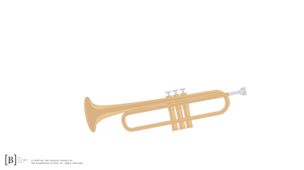

- Optional actions: jump up and down, spin in a circle, push–ups, jumping jacks, hop on one foot, burpees, etc.
- Add your own actions as well to keep it interesting.

You kids did an amazing job staying awake while you lay on the floor for so long. I can tell you are ready for anything! Now, are you ready to worship God? (Group response) Let’s give God even more focus than we had during the game.

WORSHIP

God loves it when we worship Him. How cool would it be if Jesus came back today while we’re singing? We never know when He could return.
- Lead the kids in singing one or two praise songs. See suggestions at the beginning of the session.

BIBLE LESSON | Jesus Is Coming Back (1 Thessalonians 4:13–18; 5:1–11)

- See Preparing for the Session on page 2 for items needed here.

I’m so glad we take the time to worship God and spend time in His presence. Let’s pray and ask God to help us focus and learn something new from His Word during the Bible lesson.

Prayer

Dear God, thank You for giving us the opportunity to spend time in Your presence today. Help us to be ready and prepared for Jesus’ return. Amen.

Video Intro

Before we get started with the Bible lesson, let’s check in with Dash and Austin and see what they’re up to.
- Play Bible Lesson Video A.

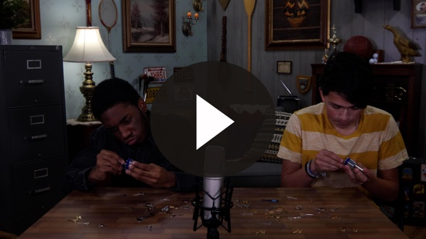

Now that seems like a goofy challenge! Would you like to try it? (Group response) What can a giant spring have to do with our Bible story today? I guess we’ll find out later.

Teaching Time
Open your Bible to 1 Thessalonians 4:13. (Allow time for the kids to turn to the passage in their Bible.) When Jesus left the disciples and was taken up into the clouds, He returned to heaven. But, Jesus promised that He would one day return for His people. Today, we will learn what the Bible says about Jesus coming back to earth.
- Show the Bible Lesson Slide 1.

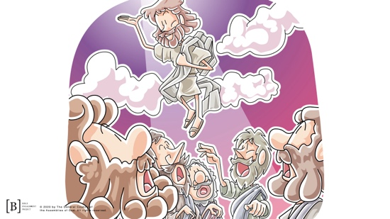

Have you ever thought about what life is like after death? I know that it can be scary to think about death, but the Bible tells us that we don’t have to be afraid at all. When we live for Jesus, we are ready to meet Him one day. Before we begin reading in the Bible, let’s test and see how ready you are. Every time you hear this horn sound, I want you to jump up and say the Faith Fact together. Let’s practice that a couple of times before we begin. Remember, the Faith Fact is Jesus is coming back.
- Play Trumpet Sound Video and say the Faith Fact.

Great! I think you’re ready. We’ll hear the sound effect at different times during the Bible story, so be ready. I hope you found 1 Thessalonians 4 in your Bible. Now, let’s begin by reading verses 13–14.
- Read 1 Thessalonians 4:13–14.
- After the verses are read, play Trumpet Sound Video and say the Faith Fact with the kids.

Great job! Before we continue reading, who are the people who have no hope mentioned in verse 13? (Allow responses.) That’s right! Those who don’t know God don’t have any hope.
When someone who doesn’t know Jesus dies, they do not go to heaven. For those of us who do know Jesus, we don’t have to worry about that. We do have hope that we will get to spend forever with God. These verses tell us that when Jesus comes back to earth, He will take us back to heaven with Him. Isn’t that amazing! Let’s continue reading in verse 15.
- Read 1 Thessalonians 4:15.
- After the verses are read, play Trumpet Sound Video and say the Faith Fact with the kids.
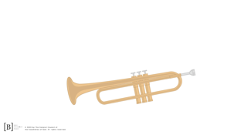

You know, I just had to play the sound effect there. Does anyone know what this verse means? Think about it combined with the other verses we read. (Allow responses.) It means that all the Christians who have already died will rise to meet Jesus in the air before those of us who are alive do. We just have to be patient and wait our turn.
- Show the Bible Lesson Slide 2.

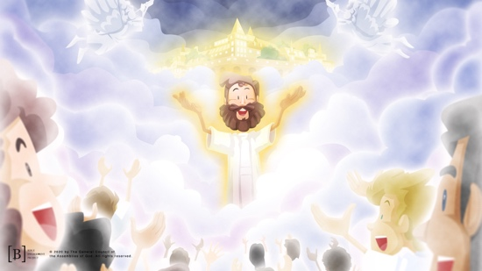

Let’s continue reading about what will happen in verses 16–18.
- Read 1 Thessalonians 4:16–18.

Did you catch what those first two verses said? When Jesus comes back, a bunch of people who have already died will rise up from their graves so they can meet Jesus in the air. Isn’t that cool?

There’s more! After that happens, then it’s our turn. The Christians who are alive will all basically fly up in the air to meet Jesus, and then we get to hang out with Jesus forever. Isn’t that cool? That sounds amazing, and it is not something to be scared of or worried about. But wait. There’s more!
- Play Trumpet Sound Video and say the Faith Fact with the kids.
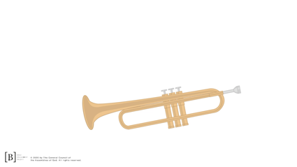

Turn to 1 Thessalonians 5, and we will continue reading about what will happen when Jesus comes back.
- Read 1 Thessalonians 5:1–7.

Do you understand what that means? It means that we don’t know when Jesus will return. Each one of us needs to make sure that we are ready for Him because He could come at any time. People who don’t know Jesus may not know that He is coming back for His people, but we do know that. We won’t be surprised when He returns to take us home to heaven. Remember what our Faith Fact says?
- Play Trumpet Sound Video and say the Faith Fact with the kids.

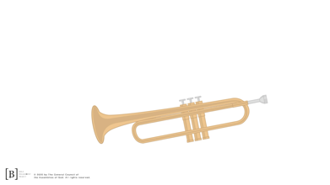

That’s one way to stay alert. We only have a few more verses left to read. Stay with me.
- Read 1 Thessalonians 5:8–11.

Wow! The Bible says that we “live in the light.” That means that because we know the truth, we can see clearly and understand the things that God has planned for us.

Did you hear why we don’t have to be afraid or worried about when Jesus comes back? (Group response) If you have asked Jesus to forgive your sins and made a choice to live for Him, you are saved. Jesus died on the Cross so that we can be forgiven and saved. It is because of what He did and our accepting His forgiveness that we will live with Him forever. It doesn’t matter if we have already died or if we are still alive when He returns. He will come and take us to live with Him forever.

Think about this. Do you like being prepared and knowing the schedule for every day? (Group response) Some people love knowing what to expect, and others love a good surprise. We can’t know the day Jesus will return. Does that bother you or scare you? (Allow responses.) Remember, we don’t need to be scared. We should be excited that we are God’s children, and we have a Blessed Hope that Jesus is coming back.

Faith Verse
Our Faith Verse reminds us to keep our focus on the prize at the end of this life. What is that prize? (Allow responses.) The prize is getting to live forever with God. That’s a pretty amazing prize. Let’s learn the actions to our Faith Verse together.
- Show the Faith Verse Video or Slide.

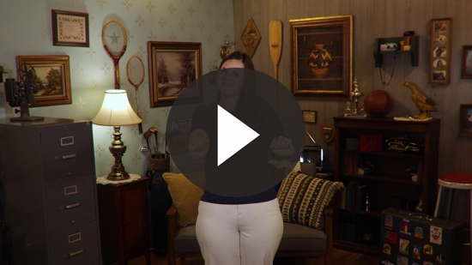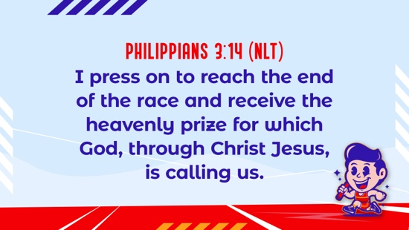

Philippians 3:14 (NLT)
I press on to reach the end of the race and receive the heavenly prize for which God, through Christ Jesus, is calling us.

It’s a lot easier to focus on what is right in front of you instead of focusing on what you can’t see. We may not know when Jesus will return, but we need to spend every day living for Jesus like we know it’s the day He’s coming.

PRAYER AND RESPONSE
You Will Need | Getting Ready
No supplies are needed for this activity. | No prep is needed for this activity.

Consider playing a worship song softly in the background while kids pray.

We have no reason to be afraid about Jesus returning even if we don’t know when that will be. Why? Because God has given us everything we need to know to be prepared. He has given all of us the opportunity to know Him and receive His salvation by asking Him to forgive our sins. Are you ready? Before we pray, I want to make sure everyone in this room has the opportunity to receive salvation and be prepared for Jesus’ return.
- Give kids time to pray.
- Lead them in a salvation prayer.
- Then introduce the worship song. This could play in the background while kids pray or could be a worship song to sing together.

Worship Song
Play one or two worship songs.

Video Wrap-Up

Before we go to our small group activities, let’s see how Dash and Austin’s challenge worked out.
• Play Bible Lesson Video B.
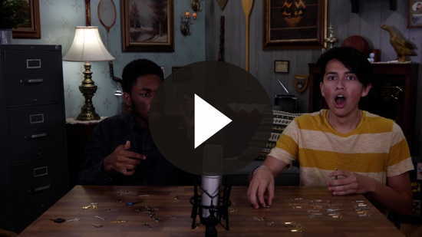

Let’s all accept the challenge that Austin gave us to tell someone about Jesus coming back again.
- Show the Faith Fact Slide or Motion Graphic.


Say it with me. Jesus is coming back. That isn’t a threat or anything to be scared of. When we hear today’s Faith Fact it should remind us of something we can look forward to. Jesus’ return to earth will be the biggest party and family reunion anyone has ever seen. See you next time, that is if Jesus doesn’t come back before then.
- Dismiss kids to Small Group time or to go home if your group time ends here.

SMALL GROUP (30 Minutes)
This section can be done in conjunction with the large group, or on its own if you do small groups with your kids. During Small Group time, the goal is to connect the kids with the Word of God and to each other. All activities are led by the small group leader.

GROUP CONNECTION | Be Prepared
You Will Need | Getting Ready
No supplies are needed for this activity. | No prep is needed for this activity.

When you go on trips or vacations, are you the type of person who is always prepared or do you always forget something super important like toothpaste? (Allow responses.) We are going to see how prepared you would be for different types of trips. Let’s sit in a circle and I will tell you a little about the trip. You will choose the top three things you would pack.
- Have the kids sit in a circle.
- Trip options: beach, overnight train ride, hiking in the mountains, ski trip, amusement park weekend, camping, cruise, visit family out of town.

BIBLE LESSON RECAP | Jesus Is Coming Back (1 Thessalonians 4:13–18; 5:1–11)
You Will Need | Getting Ready
- Bibles, one per kid | No prep is needed for this activity.

I can’t believe we are almost to the end of our look at the Bible. Time has flown by quickly. Speaking of flying, that’s one of the things we have to look forward to when Jesus returns. Well, maybe not flying, but at the very least, levitation is in our future. Jesus is coming back. We may not know when, but we know He is coming.

It’s important to know the facts about His return, but the most important thing is that we know we are ready and prepared for His return. How can we know that for sure? Well, we can read about Jesus’ return in 1 Thessalonians 4:13–18 and 5:1–11. See if you can listen carefully and figure out what we need to do to be ready for Jesus’ return.
- Choose a kid to read 1 Thessalonians 4:13–15, one to read 1 Thessalonians 4:16–18, one to read 1 Thessalonians 5:1–5, and one to read 1 Thessalonians 5:6–11.

What is one thing that you remember about our Bible story? (Allow responses.)

Faith Fact

I’m so glad that we don’t have to be afraid of this life on earth coming to an end. We can look forward to Jesus’ return. Let’s say our Faith Fact with excitement.

- Show the Faith Fact Slide or Motion Graphic.

Say it with me. Jesus is coming back. Now that’s something we can celebrate!

GROUP DISCUSSION

Feel free to use all or just a few questions as a jumping-off place for good discussion. Questions marked with * are designed for more conversation. Adjust the questions based on the age or maturity of your group. Typically, older kids will be able to dive a little deeper than younger ones.

Questions

Do you like to be prepared for something or do you prefer surprises?

* How do you prepare for a trip?

* If you had to leave for a trip and had no clue where you would be going, what are three things you would bring with you?

* What is your favorite memory of being surprised?

What is something you don’t like being a surprise?

Are you scared or excited about Jesus coming back? Why?

* What is something you can do to be prepared for Jesus’ return?

Do you know someone who is not prepared for Jesus to come back?

* How can you help others be prepared for Jesus to come back?

* What is the first thing you want to ask Jesus when you meet Him in person?

APPLICATION AND RESPONSE

Are you sure that you are prepared and ready for Jesus to return? (Group response) If you have asked Jesus to forgive your sins and you believe in Him, then you are saved. You don’t have to worry about what will happen when Jesus comes back. If you have never received the gift of salvation, you can do that right now and make sure you are ready for Jesus’ return.
- Pray a prayer for salvation with the kids.

Make It a Habit
Select a simple visual reminder of the session’s Faith Fact

Remember today’s Faith Fact? Let’s say it together. Jesus is coming back. When you see a clock, a watch, or a calendar this week, be reminded of Jesus’ return. We may not know the time or the date of His return, but we can make sure we are prepared. What else could we use to remember?
- Make notes of what the kids share.

Prayer
Let’s pray and thank God for helping us be prepared for Jesus’ return. Say it with me.

Dear God, thank You for making a way for me to come and live with You forever. Help me to be ready for Jesus’ return. I want to help others be ready for His return too. Amen.

FAITH VERSE REVIEW
You Will Need | Getting Ready
- Smartphone or timer  - Faith Verse Review (pages 1–3), one set per team | - Print copies of the Faith Verse Review (pages 1–3), one set per team.  - Cut apart and mix up a set for each team.

Our Faith Verse is Philippians 3:14. Does anyone know it by memory yet? (Group response) It’s a great reminder that our focus should be on the prize of spending eternity with God. What better prize is there? Let’s say the Faith Verse and do the actions for the verse together.
- Show the Faith Verse Video or Slide.

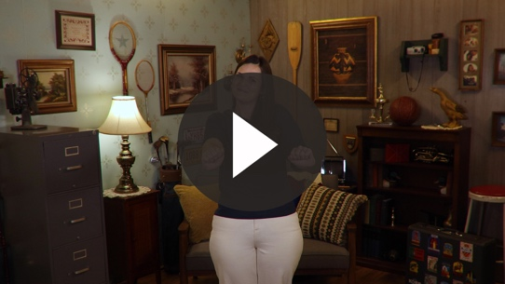

Philippians 3:14 (NLT)
I press on to reach the end of the race and receive the heavenly prize for which God, through Christ Jesus, is calling us.

Faith Verse Fun | Time’s Up!

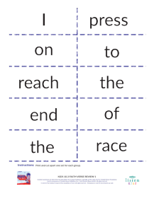
Let’s continue our review of the Faith Verse and say it together one more time. Remember to say it clearly so we can understand each word you say. (Pause for kids to review.)
I think you know the Faith Verse pretty well by now! I’m going to test your memory and see how prepared you are. We’re going to divide into smaller teams. You will have an unknown amount of time to work together to put the verse in the correct order. When you hear me say, “Time’s up,” stop right where you are.

If you didn’t finish the verse, then the team was too slow. We will play several rounds, and the amount of time changes for each round. Let’s see how prepared you are to put the Faith Verse in order.
- Mix up the paper slips of the Faith Verse and give one set to each team.
- Time options: One minute for the first round, 45 seconds for the second round, and 30 seconds for the final round.

ACTIVITY PAGE | Forever with Jesus
You Will Need | Getting Ready
- Activity Page, one per kid  - Crayons or colored pencils | - Print copies of the Activity Page, one per kid.
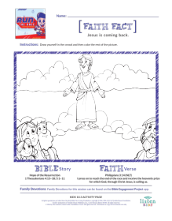

Have you thought what it might be like to rise up and meet Jesus in the air or what it might be like in heaven? (Allow responses.) I want you to think about that now. Draw yourself in the crowd of people meeting Jesus in the air. Then, color the rest of the picture.

Prayer

Dear God, we are so excited for Jesus to come back and take us to be with Him forever! Help us to talk to as many people as possible and make sure they are ready for His return. Amen.

FAITH FACT RECAP
- Display the Faith Fact Slide or Motion Graphic as parents are coming into the room.
- Maximize the time you have with your kids, so that parents see what their kids have learned. Have the kids repeat the Faith Fact, and then dismiss them to their parents.

We can’t possibly know or even guess when Jesus will return, but He is coming back and He wants all of us to be with Him forever!

This is the answer to the question your adults are going to ask: “What did you learn today?” Let’s say the Faith Fact together: Jesus is coming back. See you next time, that is if Jesus doesn’t come back before then.

DISMISSAL
- Send home the Activity Page.
- Remind parents that there are Family Devotions available on the app to do with their kid.
- Tell everyone the date and time for the next session.

