

LEADER OVERVIEW

Volume Overview—Run the Race
In these sessions, kids will discover that God has a plan for each one of them and the importance of listening to and doing what God says. They will also learn about the hope of Jesus’ return and what it will be like to live with God forever.

SESSION 1: Timothy Learns from Paul—  2 Timothy 3:10–17  Faith Fact: God has a plan for me. | SESSION 2: Faith and Works—James 1:19–27; 2:14–26  Faith Fact: God wants me to take action.
SESSION 3: Jesus Is Coming Back—  1 Thessalonians 4:13–18; 5:1–11  Faith Fact: Jesus is coming back. | SESSION 4: New Heaven and New Earth— Revelation 21:1–10, 21–27  Faith Fact: I can live with God forever.

SESSION OVERVIEW
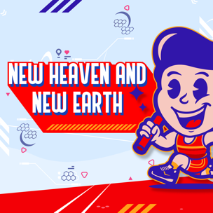
In this session, kids will learn about what the new heaven and new earth will look like. They will get a glimpse of what it will be like to live with God forever.

Bible Lesson | Faith Fact
New Heaven and New Earth  Revelation 21:1–10; 21–27 | I can live with God forever.
Faith Verse
Philippians 3:14 (NLT)
I press on to reach the end of the race and receive the heavenly prize
for which God, through Christ Jesus, is calling us.

Listen Kids is part of an entire kids’ discipleship strategy. Get access at KidminRoadmap.com.
PREPARING FOR THE SESSION
You Will Need | Getting Ready
Large Group  - Bible  - Worship songs (Song suggestions: “Zeal” by The Belonging Co; “Way Maker” by Hillsong; “See a Victory” by Elevation Worship; “Yes and Amen” by Chris Tomlin)  - Whiteboard or poster board  - Whiteboard markers or permanent markers  - For groups not using a phone or tablet only, add:  - Projector or TV  - Laptop  - Countdown 5-Minute Video  - Theme Intro Video  - Faith Fact Slide or Motion Graphic  - Game Time Slide or Motion Graphic  - Large Group Game Slides 1–10  - Bible Lesson Video A  - Bible Lesson Video B  - Faith Verse Video or Slide  - Countdown60 Video  Small Group  - Bibles, one per kid  - Countdown60 Video  - Small Group Activity Page, one per kid  - Crayons or colored pencils | Large Group  - Download videos and slides if needed.  - Select worship song(s) and have them ready to play  - Write, “New Heaven” and “New Earth” at the top of the whiteboard or poster board.  Small Group  - Print the Small Group Activity Page, one per kid.
Check out all the promotional and extra media files available for this theme. To access the Bible Engagement Project from a computer, visit App.BibleEngagementProject.com.

Find the corresponding Bible Fact-Pak® question numbers for this session in the Volume Additional Assets on the mobile or Web app.

LARGE GROUP (30 Minutes)
See what’s needed at the beginning of the session.

INTRODUCTION
- Optional: Play the Countdown 5-Minute Video.



Welcome

Welcome! I’m so glad you’re here! This is a special time together because we are in our last session in the last book of the Bible. I know that we have all learned a lot of new things about God’s Word. Can someone share something new you have learned? (Allow responses.) Those are some awesome takeaways from the Word of God. I hope you have grown to love learning from God’s Word and learned how to listen to God’s voice.

Last time we talked about when Jesus comes back for His followers. Today, we’ll be learning what the Bible says about a time that’s even further in the future. Let’s watch this video, and then we’ll get started.
- Play Theme Intro Video.

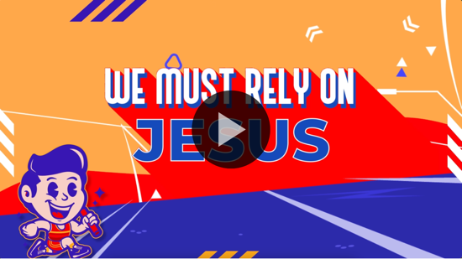

Today, we have one more thing to learn about together. Buckle your seat belt because we are going to be in the last book of the Bible. Does anyone know the name of that last book? (Group response) That’s right, we’re in the Book of Revelation.

Most people don’t spend a lot of time reading the Book of Revelation. Do you? (Group response) Probably not. It’s mostly about the end of the world. Some of the things written in Revelation are tricky to understand. We will focus on one of the best parts of Revelation. It’s about what the new heaven and new earth are going to be like. Are you interested? (Group response) Well, you’re going to have to wait a little longer because we have to learn our Faith Fact first.

Faith Fact
- Show the Faith Fact Slide or Motion Graphic.

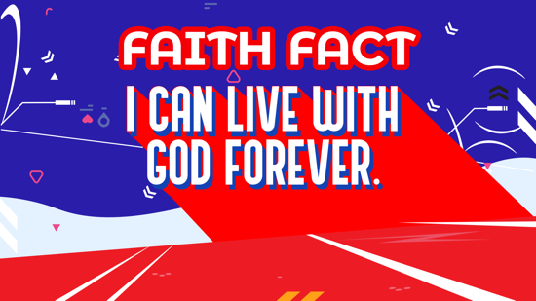

Our Faith Fact tells us something that happens after Jesus returns. I can live with God forever. That sounds amazing! Say the Faith Fact with me while we all spin around in a circle. I can live with God forever. Now that’s a promise to remember!

GAME | What Makes It New?
You Will Need | Getting Ready
- Game Slides 1–10 | No prep is needed for this activity.

- Show the Game Time Slide or Motion Graphic.


What makes new things so awesome? Is it that fresh smell, the shiny finish, or that untouched appearance? How would you describe it? (Allow responses.) That's what we will find out in today's game. I will choose two people for each round. A picture of something new will come up on the screen, and the first person to come up with a word to describe it wins the round. It must be a real word. Let's play!
- Show Game Slides 1–10, one at a time. Allow kids to choose a descriptive word for each slide.
- Choose two new players for each slide.
- Keep playing until you run out of slides.











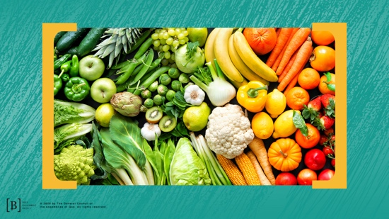



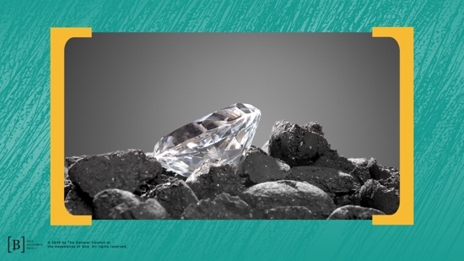



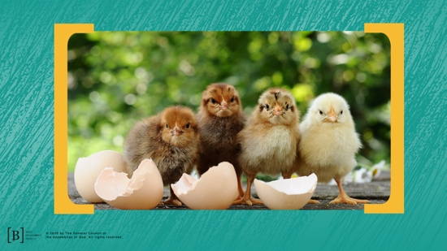

I loved the words you came up with to describe all those new things. Who would love to have any of those new items? (Group response) Getting new stuff is always awesome, but I know something even better. Getting to spend time in God’s presence is way better than new stuff.

WORSHIP

Spending time worshipping God is one of the best things in the world. One way we can do that is by singing. Let’s worship God now and sing our praise to Him.
- Lead the kids in singing one or two praise songs. See suggestions at the beginning of the session.

BIBLE LESSON | New Heaven and New Earth (Revelation 21:1–10; 21–27)

- See Preparing for the Session on page 2 for items needed here.

That was an incredible time of worship. I can only imagine how great it will be to worship God and hang out with Him forever. Someday soon, we won’t have to imagine it. We will be living it. Let’s pray and ask God to teach us something new about how things will look when we spend forever with Him.

Prayer

Dear God, thank You for allowing us to read about some of the things we can look forward to in the new heaven and new earth. Help us to look forward to it and realize that this old earth is not our forever home. Amen.

Video Intro

Before we get started with the Bible story, let’s check in with Dash and Austin and see what they’re up to.
- Play Bible Lesson Video A.

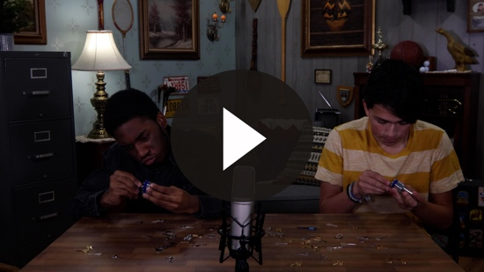

Wow! Do you think you could find the right key in such a short time? (Group response) But what do a key and lock have to do with a new heaven and new earth?

Teaching Time
If you have your Bible, turn with me to Revelation 21:1. (Allow time for the kids to turn to the passage in their Bible.)

Can you believe it? We are already at the end of the Bible. Before we read about the new heaven and new earth in God’s Word, I want to know what you already know about it. What do you expect heaven to be like? (Allow response.)
- Correct them gently if they are wrong or confused.

You already know a lot, but are you ready to learn more about what we have to look forward to after Jesus returns? (Group response) I want you to do something a little different today. I want you to close your eyes and listen carefully as I read a few verses at a time. Listen for details on what we can expect in the new heaven and new earth. Then I will stop and you can tell me what you heard. I’ll write down on the board what you heard. Now, close your eyes and listen carefully as I begin to read.
- Read Revelation 21:1–4.

We will stop there for a moment. Open your eyes and tell me some of the details you heard in these verses.
- On the whiteboard or poster board, write down the kids’ answers.
- If they give answers that are incorrect, gently redirect them to the correct answer. Reread the verses if they need additional prompts.

Great job, but we aren’t done yet. There is so much more to learn about the new heaven and new earth. Close your eyes again and make sure you are listening closely as I continue to read.
- Read Revelation 21:5–10.

Open your eyes. What details did you hear this time? You can share details on what kinds of people won’t be found in the new heaven and new earth as well.
- Write kids’ answers on the board.

You know how this goes by now. Close your eyes and listen one more time.
- Read Revelation 21:21–27.

Open your eyes and share the details you heard.
- Write their answers on the board.

Are you excited to get to see all those details in real life someday? (Group response) I know I am! Thanks for listening so well while keeping your eyes closed for so long.

Which detail about the new heaven and new earth are you looking forward to seeing the most? (Allow responses.) Is it hard to imagine what it will be like without actually seeing it? (Group response) It’s definitely hard for me to imagine it. Maybe you find it hard to believe it will actually happen. It requires faith to believe in what you can’t see right now. But we know it will all be worth the wait.

No matter what the new heaven and earth will look like, I’m most excited that I can live with God forever. If I trust in Him and live my life in a way that pleases Him, I don’t have to worry about what comes after death, because I will be with God forever. You have the same opportunity! You can live with God forever, if you choose to put your trust in Him.

Faith Verse
- Show the Faith Verse Video or Slide.

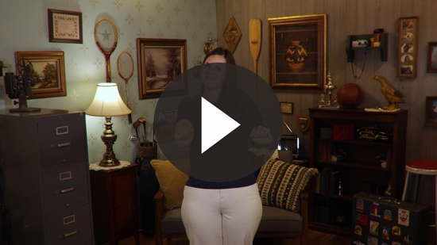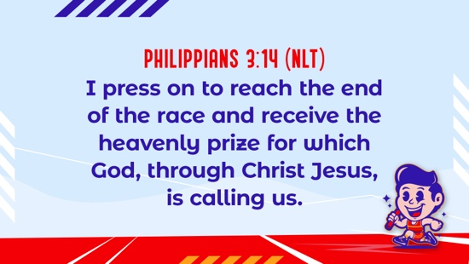

Philippians 3:14 (NLT)
I press on to reach the end of the race and receive the heavenly prize for which God, through Christ Jesus, is calling us.

Our Faith Verse reminds us that we are working toward a goal at the end of this life. We may not be able to see it, but the prize is waiting for us. If we ask Jesus to forgive us for the wrong things we have done and accept His forgiveness, we will live forever with God. Let’s say the Faith Verse and do the actions together.

Rememer what you are pressing on toward. It’s worth any risk or any loss to have the opportunity to live forever with God.

PRAYER AND RESPONSE
You Will Need | Getting Ready
No supplies are needed for this activity. | No prep is needed for this activity.

Consider playing a worship song softly in the background while kids pray.

There is a part about the end of this world that we don’t like to talk about because it’s really sad. Not everyone will choose to live forever with God. It’s only those who believe in Jesus and have asked Him to forgive their sins. We need to make sure that we have done that and are helping everyone we know believe in Him, too. We want to make sure that we will spend forever living with God.
- Give kids time to pray.
- Lead them in a salvation prayer.
- Then introduce the worship song. This could play in the background while kids pray or could be a worship song to sing together.

Worship Song
Play one or two worship songs.

Video Wrap-Up

Before we go to our small group activities, let’s see how the challenge worked out for the Challenge Accepted team.
• Play Bible Lesson Video B.

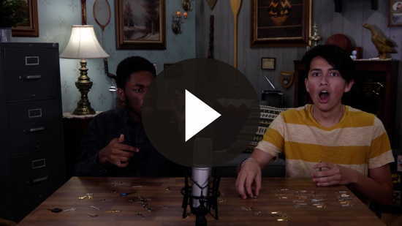

Let’s all accept the challenge that Dash gave us. Take time this week to read all of Revelation 21 on your own. Then draw a picture of what those verses tell us.
- Show the Faith Fact Slide or Motion Graphic.

Say the Faith Fact with me. I can live with God forever. I can’t wait to spend eternity living with God and all of you. Don’t forget to share God’s love with someone this week who doesn’t know Him. You could be the reason they choose to live with God forever, too.
- Dismiss kids to Small Group time or to go home if your group time ends here.

SMALL GROUP (30 Minutes)
This section can be done in conjunction with the large group, or on its own if you do small groups with your kids. During Small Group time, the goal is to connect the kids with the Word of God and to each other. All activities are led by the small group leader.

GROUP CONNECTION | Old or New
You Will Need | Getting Ready
No supplies are needed for this activity. | No prep is needed for this activity.

Not all things are better when they are new. Some things and people get better with age. You will get to choose if you would rather have something old and familiar or new and exciting. There are no right or wrong answers. It's completely up to you to decide.
- Have the kids sit in a circle.
- The leader will read an old or new option category for each round.
- Make sure everyone has a chance to share before moving on to the next option.
- Categories: French fries, friends, church, holiday traditions, candy, clothes, vacation, movie, video game, TV show, school, Bible.
- Create your own categories.

BIBLE LESSON RECAP | New Heaven and New Earth (Revelation 21:1–10; 21–27)
You Will Need | Getting Ready
- Bibles, one per kid | No prep is needed for this activity.

Well, we made it to the last book in the Bible. What a journey through the Bible it has been! I hope you have learned many new things from God’s Word. Today, we focused on what life will look like after Jesus returns. We definitely do not know everything or have all the details, but we don’t need to. It’s still fun to dream and imagine what life will look like when we get to spend forever with God.

We are reading almost a full chapter from the Book of Revelation today. Stick with me. I promise it will be worth it to hear more from Revelation, the last book in the Bible. We will be reading Revelation 21:1–10 and 21–27 together.
- Choose one kid to read Revelation 21:1–4, another kid to read Revelation 21:5–10, and another kid to read Revelation 21:21–27.

What is one thing that you remember about our Bible lesson? (Allow responses.)

Faith Fact
- Show the Faith Fact Slide or Motion Graphic.

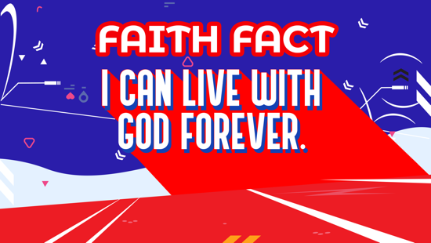

We have so much to look forward to after Jesus returns, but the main thing we have to look forward to is in today’s Faith Fact. Let’s say our Faith Fact together as a reminder. I can live with God forever.

GROUP DISCUSSION

Feel free to use all or just a few questions as a jumping-off place for good discussion. Questions marked with * are designed for more conversation. Adjust the questions based on the age or maturity of your group. Typically, older kids will be able to dive a little deeper than younger ones.

Questions

What is something you have had for a long time or something old that you like?

What is something new you would like to have?

* What are some good things about new things?

Do you prefer old or new things?

Do you think life is better right now than it will be in the new heaven and new earth?

* What is something that you are looking forward to about the new heaven and new earth that we talked about today?

* What is something that will be better about life for Christians after Jesus returns?

Who do you hope to meet in heaven who has already died?

Where do you want to live forever?

* How can you know that you will live with God forever?

APPLICATION AND RESPONSE

I am so thankful that we have something so amazing to look forward to after this life. We get to live with God forever. Can anyone remind the group of why we have the opportunity to live with God forever? (Allow responses.) That’s right. Jesus came down to earth and died for our sins.

Make It a Habit
Select a simple visual reminder of the session’s Faith Fact

Remember our Faith Fact? Let's say it together. I can live with God forever. Think about the new things we receive on this earth. We get new clothes, but they eventually wear out, or we outgrow them. We get an ice cream cone, and it melts as we eat it. We get a new bike, but it could break. The great thing about the new heaven and the new earth is that nothing will ever get old or melt or break again.

Living with God forever will be the greatest adventure. Every time you get something new or see something new this week, think about how amazing it will be to live in the new heaven and new earth with God forever. What else could we use to remember?
- Make notes of what the kids share.

Prayer
Let’s pray and thank Jesus for His death and resurrection that provided the way for us to live with God forever. Pray with me.

Dear Jesus, thank You for coming to live, die, and rise from the dead. You made the way for me to live with God forever. Help me to keep my eyes on the prize at the end of this life, spending forever with You. Amen.

FAITH VERSE REVIEW
You Will Need | Getting Ready
- Countdown60 Video | No prep is needed for this activity.

It’s our last time reviewing this Faith Verse. I think you know it by now, but just in case you need a refresher, we are going to review it again before we play a game. Let’s say the Faith Verse and do the actions for the verse together.
- Show the Faith Verse Video or Slide.

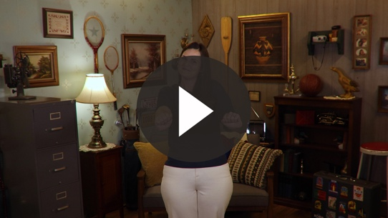

Philippians 3:14 (NLT)
I press on to reach the end of the race and receive the heavenly prize for which God, through Christ Jesus, is calling us.

Faith Verse Fun | Backwards Verse

We have been working on our Faith Verse for several weeks now. You should know it so well you could even say it backwards. Who thinks they can do it? We will have a one-minute Countdown Video. If you can say the verse backward correctly, you win.
- Give everyone a chance who wants to try to say it backward.
- Option: Try to say the verse backward slowly as a group.
- Play Countdown60 Video.


ACTIVITY PAGE | What Will Heaven Be Like?
You Will Need | Getting Ready
- Activity Page, one per kid  - Crayons or colored pencils | - Print the Activity Page, one per kid.
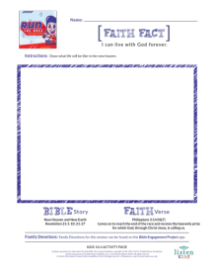

What have we said that the new heaven and new earth will be like? (Allow responses.) You remembered a lot of the details. Good job! Now, I want you to draw what life in the new heaven will be like.

Prayer

Dear God, thank You for sending Jesus to die for our sins so we would have the opportunity to spend forever with You. Nothing could be better than that. Amen.

FAITH FACT RECAP
- Display the Faith Fact Slide or Motion Graphic as parents are coming into the room.
- Maximize the time you have with your kids, so that parents see what their kids have learned. Have the kids repeat the Faith Fact, and then dismiss them to their parents.

The end of this life is nothing for us to be afraid of. We have so many amazing things to look forward to in the new heaven and new earth. Most importantly, we get to live with God forever.

This is the answer to the question your adults are going to ask: “What did you learn today?” Let’s say the Faith Fact together: I can live with God forever. I’m so glad that I got to learn more about God’s Word with you! We saved the best part for last! See you next time!

DISMISSAL
- Send home the Activity Page.
- Remind parents that there are Family Devotions available on the app to do with their kid.
- Tell everyone the date and time for the next session.

