

LEADER OVERVIEW

Volume Overview—My Journey Begins
In these sessions, kids will learn about the promise fulfilled through the baptism in the Holy Spirit and how the Early Church came together and grew. They will look at the change that happens when they recognize Jesus as Lord and know that God is always with them.

SESSION 1: Baptism in the Holy Spirit—  Acts 1:8; 2:1–12  Faith Fact: The Holy Spirit empowers me. | SESSION 2: The Church Begins—Acts 2:42–47  Faith Fact: The church helps me grow.
SESSION 3: Saul on the Damascus Road—  Acts 9:1–22  Faith Fact: God changes my life. | SESSION 4: Paul and Silas in Prison—  Acts 16:16–34  Faith Fact: With God, I am never alone.

SESSION OVERVIEW


In this session, kids will learn about the cost Paul and Silas paid to follow God’s call on their lives. Kids will be reminded that God is always with them.

Bible Lesson | Faith Fact
Paul and Silas in Prison  Acts 16:16–34 | With God, I am never alone.
Faith Verse
Acts 1:8 (NLT)
“But you will receive power when the Holy Spirit comes upon you. And you will be my witnesses, telling people about me everywhere—in Jerusalem, throughout Judea, in Samaria, and to the ends of the earth.”

Listen Kids is part of an entire kids’ discipleship strategy. Get access at KidminRoadmap.com.
PREPARING FOR THE SESSION
You Will Need | Getting Ready
Large Group  - Bible  - Worship songs (Song suggestions: “Zeal” by The Belonging Co; “Way Maker” by Hillsong; “See a Victory” by Elevation Worship; “Yes and Amen” by Chris Tomlin)  - Real dollar bills or play money  - Toy handcuffs, piece of rope, or length of chain.  - For groups not using a phone or tablet only, add:  - Projector or TV  - Laptop  - Countdown 5-Minute Video  - Theme Intro Video  - Faith Fact Slide or Motion Graphic  - Game Time Slide or Motion Graphic  - Countdown60 Video  - Bible Lesson Slides 1–2  - Bible Lesson Video A  - Bible Lesson Video B  - Faith Verse Video or Slide  Small Group  - Bibles, one per kid  - Small ball  - Small Group Activity Pages 1 and 2, one per kid  - Scissors  - Tape  - Crayons, markers, or colored pencils | Large Group  - Download videos and slides if needed.  - Select worship song(s) and have them ready to play.  Small Group  - Print copies of the Small Group Activity Page 1, one per kid.  - Print copies of the Small Group Activity Page 2, one per kid. Cut out the picture in the box.
Check out all the promotional and extra media files available for this theme. To access the Bible Engagement Project from a computer, visit App.BibleEngagementProject.com.

Find the corresponding Bible Fact-Pak® question numbers for this session in the Volume Additional Assets on the mobile or Web app.

LARGE GROUP (30 Minutes)
See what’s needed at the beginning of the session.

INTRODUCTION
- Optional: Play the Countdown 5-Minute Video.



Welcome

Welcome! I’m so glad you’re here! We’ve been talking about events in the Book of Acts. Let’s watch this video, and then we’ll get started.
- Play Theme Intro Video.

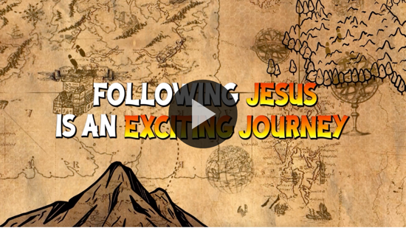

Remember Saul from our last time together? You may remember that he was the guy who was on a mission to arrest Christians and have them killed or put in jail. After his incredible encounter with Jesus on the way to Damascus, Saul was a changed man. He went from hunting believers to preaching to anyone who would listen. After a while, Saul started going by another version of his name—Paul.

Paul went on to do many incredible things for God, including writing letters that make up almost half of the books in the New Testament. God used Paul in the salvation and healing of many people, and he started churches of believers in many places. That all may sound great, but there is always a cost to following God’s call. Paul certainly experienced that cost in today’s Bible story.

Faith Fact
- Show the Faith Fact Slide or Motion Graphic.

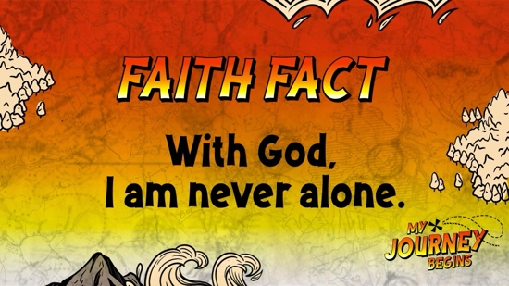

We are going to say the Faith Fact together. Today, I want you to turn to the person on your right and say the Faith Fact to remind us that we are not alone. With God, I am never alone. Now turn and say it to the person on your left. With God, I am never alone. Great!

GAME | Mirror Image
You Will Need | Getting Ready
- Countdown60 Video | No prep is needed for this activity.

- Show the Game Time Slide or Motion Graphic.


Did you know that you are never alone? God is always with every follower of Jesus. We are like a mirror image or a reflection of Him. Today, we are going to practice being each other's mirror images. Find a partner and stand facing each other. Each pair should choose a leader for the first round. The leader will make motions slowly to allow your partner to mirror you. As the follower, do your best to mirror your partner’s actions as quickly as possible. I’m going to give you 60 seconds on the timer. Then, we will switch roles. Let's see how good you are at being a mirror.
- Option: Play this multiple times and allow the kids to have different partners.
- Play Countdown60 Video.



That was a challenging game, but lots of fun. It’s a great reminder that we are all a reflection of God. How cool is that?

WORSHIP

I’m so glad that we are never alone because God is with us. That gives us a great reason to worship Him today. He is here with us and wants us to remember that as we worship Him by singing.
- Lead the kids in singing one or two praise songs. See suggestions at the beginning of the session.

BIBLE LESSON | Paul and Silas in Prison (Acts 16:16–34)

- See Preparing for the Session on page 2 for items needed here.

Worship is always better when we remember that God isn’t far away. He’s right here with us. Let’s pray and ask God to help us remember that He is with us in the hard and difficult situations we face as we hear about a hard situation Paul and Silas had to face in our Bible story.

Prayer

Dear God, thank You for being there for me all the time. Help me to respond to hard times with Your strength instead of my own. I love You. Amen.

Video Intro

Before we get started with the Bible story, let’s check in with the team from Challenge Accepted and see what they’re up to.
- Play Bible Lesson Video A.

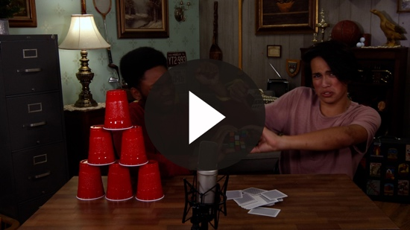

Wow! Would you like to accept that challenge? (Group response) I don’t know if I could do those things. We’ll see soon how it ties in with our Bible story today.

Teaching Time
If you have your Bible, turn with me to Acts 16:16–34. (Allow time for the kids to turn to the passage in their Bible.)

In Acts 16, Paul was already on his second missionary journey with his friend and ministry partner, Silas. By this point, Paul has changed a lot from when he used to hurt Christians. He had traveled out of Israel to other regions and told people about Jesus. Things were not always great and easy for Paul as he told others about Jesus.
- Show the Bible Lesson Slide 1.

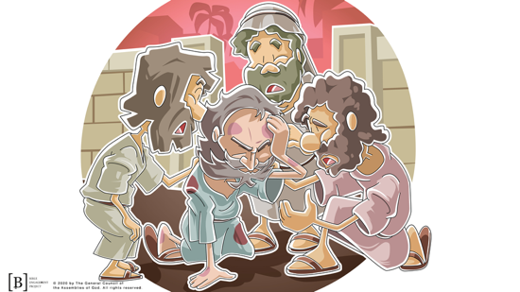

Paul hadn’t been the only one who didn’t like Christians. There were other people who heard Paul’s teachings and saw the miracles God did through Paul, and they didn't like it at all. Let's read about what happened one day to Paul and Silas in Acts 16:16–34.
- Read Acts 16:16–18.

Let's stop there for a moment. What happened to the slave girl who had been following Paul and Silas? (Allow responses.) God used Paul to tell the evil spirit inside her to leave.

This should have been amazing news, but sadly, the girl's masters were not so thrilled. The evil spirit who lived inside the slave girl gave her the ability to tell people's fortunes. People paid the girl’s masters to have their fortune told. When the evil spirit was gone, she couldn’t tell fortunes and earn money for her masters. Her masters managed to turn the entire city against Paul and Silas. They ended up being beaten up and thrown into prison.
- Show the money as you’re talking.

I'm sure they weren't expecting that. Paul had done something good for the slave girl, and now they were in prison. What would you do if you were Paul and Silas sitting in prison? (Allow responses.)
- Hold up the toy handcuffs, piece of rope, or length of chain.

Paul and Silas could have complained, cried, and just given up, but that's not what they did. Let's read about what they did and the amazing thing that happened next.
- Read Acts 16:25–26.
- Show the Bible Lesson Slide 2.

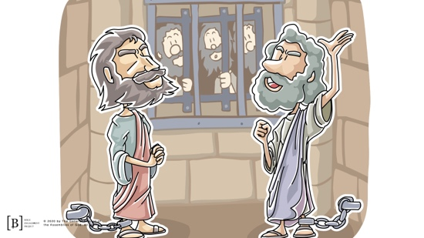

Wow! Paul and Silas prayed and sang. Then, God sent an earthquake to shake the prison doors open, and all their chains just fell off.
- Drop the toy handcuffs, piece of rope, or length of chain.

This was great news for everyone except the jailer in charge of all the prisoners. He would have been in huge trouble if all the prisoners escaped in the earthquake. He was ready to end his life when Paul stopped him. Paul explained that all of the prisoners were still there in the jail.

Here's the coolest part. The jailer asked Paul and Silas what he needed to do to be saved. He wanted what they had. Let’s read what Paul and Silas told him.
- Read Acts 16:31.

Paul and Silas could have felt so alone in that prison cell. They could have chosen to focus on the negative and to give up. However, they knew that they were never alone, even in a dark prison cell. God hadn't left them or abandoned them. God was right there with them in that prison cell. They invited His presence into that prison by praying and singing in worship to God.

This Bible story is a great reminder to us that following God has a cost. We may not always be comfortable or popular. Choosing to follow Jesus and live for Him may put you in awkward or uncomfortable situations at times. Are you going to face those situations the way Paul and Silas did by relying on God, or are you going to try to do it all on your own? God is always with you, and He wants to help you. Allow Him to work in your life.

Faith Verse
Our Faith Verse reminds us that we don’t have to do anything in our own power. Just like God is with us all the time, the Holy Spirit’s power is available to us anytime we need it. Let’s say the verse and do the actions together.
- Show the Faith Verse Video or Slide.

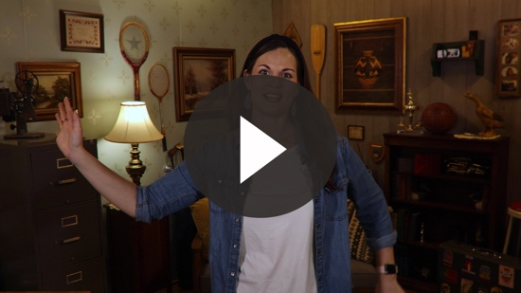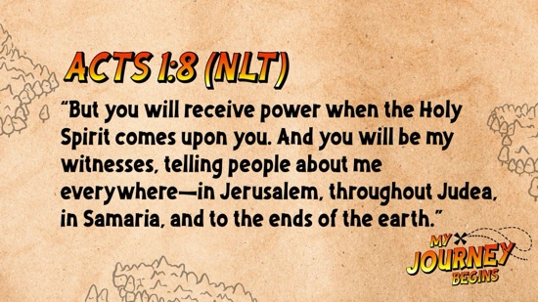

Acts 1:8 (NLT)
“But you will receive power when the Holy Spirit comes upon you. And you will be my witnesses, telling people about me everywhere—in Jerusalem, throughout Judea, in Samaria, and to the ends of the earth.”

We might think we can do things better on our own, but following God’s way will always be the best way.

PRAYER AND RESPONSE
You Will Need | Getting Ready
No supplies are needed for this activity. | No prep is needed for this activity.

Consider playing a worship song softly in the background while kids pray.

What hard things are you facing right now that you need God to step in and help you? Maybe life is going great right now, but hard times might be just around the corner for you. The best thing you can possibly do is invite God into all areas of your life—the good and the bad. God wants to be a part of it all. Remember, you are never alone because God is always with you.
- Give kids time to pray. Then introduce the worship song. This could play in the background while kids pray or could be a worship song to sing together.
- If appropriate, lead kids in a prayer for salvation.

Worship Song
Play one or two worship songs.

Video Wrap-Up

Before we go to our small group activities, let’s see how the challenge worked out for the Challenge Accepted team.
• Play Bible Lesson Video B.

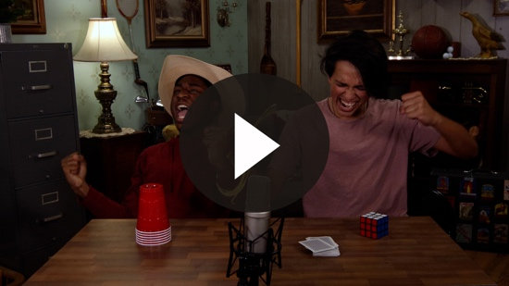

Are you ready to accept the challenge that Dash and Austin gave us? (Group response) Spending extra time alone with God in worship and prayer will help the week ahead go better.
- Show the Faith Fact Slide or Motion Graphic.

Say it with me. With God, I am never alone. God is here for it all. You can be confident that He will be there for you to comfort you, fight your battles, and love you when it seems like no one else is there for you. I hope this Faith Fact really sticks with you in the days ahead.
- Dismiss kids to Small Group time or to go home if your group time ends here.

SMALL GROUP (30 Minutes)
This section can be done in conjunction with the large group, or on its own if you do small groups with your kids. During Small Group time, the goal is to connect the kids with the Word of God and to each other. All activities are led by the small group leader.

GROUP CONNECTION | Alone or Together?
You Will Need | Getting Ready
No supplies are needed for this activity. | No prep is needed for this activity.

Do you prefer doing things alone or together with a group of friends? (Group response) Your answer might change depending on the activity we’re talking about. I am going to read through a list of activities. If you would prefer to do the activity alone, stay seated. If you would prefer to do it with a group, jump up.
- Read through the activities, stopping after each one to allow kids to respond.
Alone or Together Activities:
  - Ride a plane
  - Read a book
  - Go for a walk
  - Play basketball
  - Eat dinner
  - Ride your bike
  - Play outside
  - Go swimming
  - Do homework
  - Sing
  - Play a video game
  - Watch a movie

BIBLE LESSON RECAP | Paul and Silas in Prison (Acts 16:16–34)
You Will Need | Getting Ready
- Bibles, one per kid | No prep is needed for this activity.

Last time, we met Paul while he was someone who hated Christians before he met Jesus. That encounter with Jesus completely changed his life forever. He began telling anyone who would listen about Jesus. God used him to do miracles. Sadly, Paul wasn’t the only one who hated Christians and wanted them all locked up or killed.

The fact Paul was now preaching and trying to help people know about Jesus only made some people even angrier at Christians. They wanted to stop Paul from spreading the good news about Jesus. Let’s read about a difficult situation Paul and his missionary friend Silas had to face in Acts 16:16–34.
- Divide the Bible reading into smaller chunks for kids to read aloud: Acts 16:16–18, 19–24, 25–29, 30–34.

What is one thing that you remember about our Bible story? (Allow responses.)

Faith Fact
- Show the Faith Fact Slide or Motion Graphic.

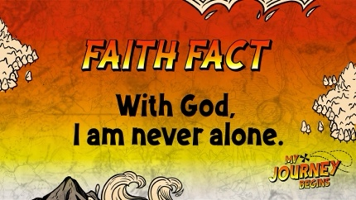

Even in the most difficult and darkest situations, God is present with those who love Him. God will always show up for you just like He did for Paul and Silas in prison. That’s why our Faith Fact is true and so powerful. Say it with me. With God, I am never alone.

GROUP DISCUSSION

Feel free to use all or just a few questions as a jumping-off place for good discussion. Questions marked with * are designed for more conversation. Adjust the questions based on the age or maturity of your group. Typically, older kids will be able to dive a little deeper than younger ones.

Questions

What did Paul and Silas do in jail?

Do you prefer to be alone or in a group? Why?

* When do you like to be alone?

* When do you like to have a group of people around?

* When do you feel the most alone?

How can you remember that you are never alone?

Have you ever been bullied or treated poorly because you are a Christian?

* When or in what situation is it the hardest for you to stand up for what you believe?

Have you ever pretended to not be a Christian just to fit in?

Are you willing to be rejected like Paul and Silas because you are a Christian?

* What is something you can't do because you are a Christian? Is it worth the cost?

APPLICATION AND RESPONSE

How do you handle difficult situations and problems that you face in your life? Do you respond like Paul and Silas by praying and worshipping God no matter what? Do you get a bad attitude and complain about your problems to anyone who will listen? God doesn’t mind us complaining to Him about our problems, but we have to get past the complaints and find His joy in all circumstances.

Make It a Habit
Select a simple visual reminder of the session’s Faith Fact

Remember our Faith Fact today? Let's say it together. With God, I am never alone. Whenever you start to feel lonely, grab your Bible. God's Word is His gift to us, and it is a great reminder that we are never alone. Read a few verses or even a few chapters until you feel like you have heard from God. He wants to speak to us through His Word every day if we take the time to read it.

What else could we use to help us remember our Faith Fact?
- Make notes of what the kids share.

Prayer
Let’s pray and ask God to remind us that He is with us when we forget.

Dear God, thank You for being with me all the time. Please forgive me for trying to handle my life all by myself. Help me to rely on You and Your strength. Amen.

FAITH VERSE REVIEW
You Will Need | Getting Ready
- Small ball | No prep is needed for this activity.

Our Faith Verse is Acts 1:8. It reminds us that God is with us and has given us the Holy Spirit to help us. Let’s say the Faith Verse and do the actions for the verse.
- Show the Faith Verse Video or Slide.

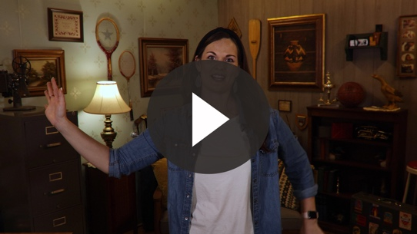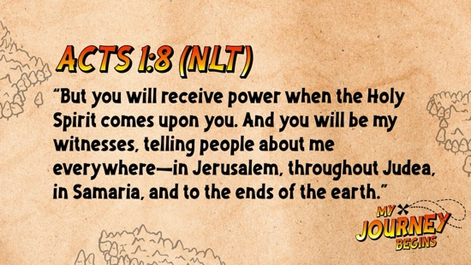

Acts 1:8 (NLT)

“But you will receive power when the Holy Spirit comes upon you. And you will be my witnesses, telling people about me everywhere—in Jerusalem, throughout Judea, in Samaria, and to the ends of the earth.”

Let’s go over the Faith Verse together as a group a couple of times. Remember to say it loud so all the other small groups can hear you!

Faith Verse Fun | Ball Toss

Who thinks they know the Faith Verse really well at this point? (Group response) That’s good because we are about to put your confidence to the test. I’m going to start the verse with the first word. Then, I will toss the ball to one of our friends who will say the next word. Each kid who catches the ball will say the next word of the verse until it is complete. Are you up for the challenge?
- Play several rounds and pass the ball faster in each round.

ACTIVITY PAGE | Paul and Silas in Prison
You Will Need | Getting Ready
- Activity Pages 1–2, one of each per kid  - Crayons, markers, or colored pencils  - Scissors  - Tape | - Print Activity Page 1, one per kid.  - Print Activity Page 2, one per kid. Cut out the picture in the box.
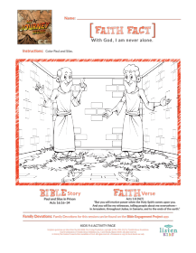

Paul and Silas were never alone in the jail cell. God was with them, and He makes all the difference in any situation. We are going to do a simple craft that reminds us of the difference that God can make in any situation.
- Give each kid the art of Paul and Silas in chains as well as Activity Page 1.
- Have the kids color both pictures.
- When they’re finished coloring, use tape to attach the top edge of the Activity Page 2 picture over the picture on Activity Page 1.
- The kids can flip up the picture of Paul and Silas in chains to see them free from their chains.

Prayer

Dear God, thank You for reminding me that You are always with me. Help me to remember that I can come to You when I’m sad or worried. You’ll give me the strength I need when I’m weak. I love You. Amen.

FAITH FACT RECAP
- Display the Faith Fact Slide or Motion Graphic as parents are coming into the room.
- Maximize the time you have with your kids, so that parents see what their kids have learned. Have the kids repeat the Faith Fact, and then dismiss them to their parents.

Have you taken the time to thank God for being with you all the time? If not, make a habit of thanking Him for being with you every single day.

This is the answer to the question your adults are going to ask: “What did you learn today?” Let’s say the Faith Fact together: With God, I am never alone.

DISMISSAL
- Send home the Activity Page.
- Remind parents that there are Family Devotions available on the app to do with their kid.
- Tell everyone the date and time for the next session.

