

LEADER OVERVIEW

Volume Overview—What’s the Word?
Our upbringing often influences our view of the Bible. In your home, was the Bible a dust-covered book that you thought kept people from having any fun? Was it honored as the living, breathing Word of God? Or did your childhood view of God’s Word fall somewhere in between? In this Learn volume, we want kids to know that God speaks through His Word to those who will listen, giving guidance and correction for their lives (2 Timothy 3:16–17).

SESSION 1: The Bible Is God’s Word—  Isaiah 7:14; Luke 1:26–38  Faith Fact: I will trust God’s Word. | SESSION 2: The Bible Is True—  Luke 4:14–22  Faith Fact: I will obey God’s Word.
SESSION 3: The Bible Is My Guide—  Luke 6:46–49  Faith Fact: I will follow God’s Word. | SESSION 4: The Bible Is My Weapon—  Luke 4:1–13  Faith Fact: I will use God’s Word.

SESSION OVERVIEW

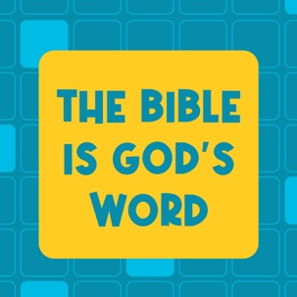
When we read the Bible, we’re mostly reading accounts of people’s interactions with God through history. Although people wrote down the words, God inspired them in what to write. God doesn’t make mistakes, so we can trust and follow the words that they wrote. This is exemplified in our Bible story. People were inspired by God to write about the coming Messiah (Jesus). Many years later, others were inspired by God to write down stories of how Jesus fulfilled all those prophecies written about the Messiah.

Bible Lesson | Faith Fact
Jesus Is Prophesied About  Isaiah 7:14; Luke 1:26–38 | I will trust God's Word.
Faith Verse
2 Timothy 3:16 (NLT)
All Scripture is inspired by God and is useful to teach us what is true.

Learn Kids is part of an entire kids’ discipleship strategy. Get access at KidminRoadmap.com.
PREPARING FOR THE SESSION
You Will Need | Getting Ready
Large Group  - Personal study Bible with highlights and notes  - Worship songs (Song suggestions: “Who You Say I Am” by Hillsong Worship; “Goodness of God” by Bethel Music; “Headlight” by Elevation Youth; “Breakthrough” by Elevation)  - For groups not using a phone or tablet only, add:  - Projector or TV  - Laptop  - Countdown 5-Minute Video  - Theme Intro Video  - Faith Fact Slide or Motion Graphic  - Game Slide or Motion Graphic  - Countdown60 Video–60 seconds  - Bible Lesson Video  - Teaching Point Slides 1–3  - Faith Verse Video or Slide  - Large eraser  - Theme Bookmark, one per four kids  - Card stock  - Scissors  - Prayer Station Poster  - 11x17" paper or card stock  - Foam board  - Glue  - Easel  - Large Group Prayer Response Page, one per ten kids  - Scissors  - Clothesline  - Clothespins, one per kid  - Index cards, one per kid  - Pencils or pens, one per kid  - Optional: Newsletter Template  Small Group  - Bibles, one per kid (preferably all the same version)  - “Books of the Bible” song from JumpStart3  - Optional: Books of the Bible Card, one per four kids  - Card stock  - Small Group Faith Verse Review Page, one per group  - Cup  - Scissors  - Small Group Activity Page, one per kid  - Small Group Activity Page Answer Page  - Pencils, one per kid | Large Group  - Download videos and slides if needed.  - Select worship song(s) and have them ready to play.  - Print the Theme Bookmark on card stock, one per four kids, and cut apart.  - Be prepared to:  - Show kids notes and highlights in your personal study Bible, if you have them.  - Explain who gave the Bible to you and why it means so much to you.  - Share a funny or small mistake you have made.  - Print the Prayer Station Poster on 11x17" paper, one per group.  - Mount the poster on foam board or card stock.  - Place the poster on an easel.  - Print copies of the Large Group Prayer Response Page. Cut apart the verses on the page so each kid has one verse.  - Hang the clothesline near the Prayer Station Poster.  - Clip the verses to the clothesline using the clothespins.  - Place the pencils at the prayer station.  - Place the index cards at the prayer station.  - Optional: Download and customize the Newsletter Template, if using.  Small Group  - Download “Books of the Bible” song from JumpStart3.  - Optional: Print the Books of the Bible Card, one per four kids.  - Print copies of the Small Group Faith Verse Review Page, one per group.  - Cut apart the Faith Verse slips and place each set in a cup.  - Print copies of the Small Group Activity Page, one per kid.

Check out all the promotional and extra media files available for this theme. To access the Bible Engagement Project from a computer, visit App.BibleEngagementProject.com.

LARGE GROUP (30 Minutes)
See what’s needed at the beginning of the session.

INTRODUCTION
- Optional: Play the Countdown 5-Minute Video.



Welcome

I’m so glad you’ve joined me today. For the next few sessions, we’ll be focusing entirely on God and His Word. What’s another name for God’s Word? (Group response) You might be thinking that we always focus on the Bible, and we do. But, we’re taking a deeper look at what God’s Word really is and why it matters to our lives today.
- Play Theme Intro Video.

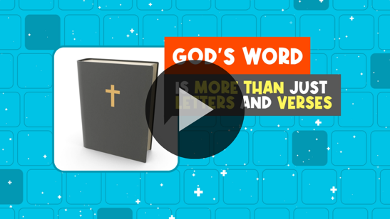

The Bible is a super old book that was written by a group of about forty authors thousands of years ago. Why does an old book written thousands of years ago matter to us? Well, it matters because it’s the inspired Word of God. What do you think I mean by that? (Allow responses.)

God chose the writers of the Bible. He even helped them with the words they wrote. He used these writers to bring His words to all of us! If we trust that God is who He says He is, we can also trust His Word.

Faith Fact
- Show the Faith Fact Slide or Motion Graphic.

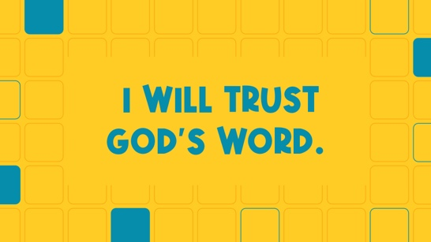

That’s what our Faith Fact for today says: I will trust God’s Word. Say it with me as loudly as you can. I will trust God’s Word. Now whisper it quietly. (Group response) Shout it again. (Group response) Great job!

GAME | Mirror Effect
You Will Need | Getting Ready
- Countdown60 Video–60 seconds | No prep is needed for this activity.

- Show the Game Slide or Motion Graphic.


As Christians, we believe and trust in God’s Word. We know that we can listen to what it says and follow the instructions inside it because they are from God. When you trust someone, like a parent or a friend, you’re willing to follow what they say and do. Choose a friend to play this game.
- Allow the kids to choose their partner. If you have an extra kid, have them partner with a leader.

Okay, here’s what you need to do. You’re going to work together to follow each other’s every move. Face your partner and choose who will be the leader first. The leader decides the actions to do. The partner must mirror every action the leader does for one minute. Then, you’ll switch places.
- Play the Countdown60 Video.
- Play until time is up. Then have the kids switch places and repeat.



How did your partner do as leader? Wave your hands up high if they did a good job. (Group response) How did they do as follower? Give me two thumbs-up if they did a good job. (Group response) I trust you chose the right partner and worked together well. The very best Partner we can choose is God. We can always trust and follow Him by knowing His Word.

WORSHIP
God also loves it when we spend time worshipping Him. One way to worship God is by singing. Let’s do that together now.
- Lead the kids in singing one or two praise songs. See suggestions at the beginning of the session.

BIBLE LESSON | Jesus Is Prophesied About (Isaiah 7:14; Luke 1:26–38)
You Will Need | Getting Ready
- Personal study Bible with highlights and notes  - Large eraser  - Theme Bookmark, one sheet per four kids  - Card stock  - Scissors | - Print the Theme Bookmark on card stock, one per four kids, and cut apart.  - Be prepared to:  - Show kids notes and highlights in your personal study Bible, if you have them.  - Explain who gave the Bible to you and why it means so much to you.  - Share a funny or small mistake you have made.

I really enjoyed worshipping God with all of you. Now, let’s pull out our Bibles and discover more about God’s Word together. Remember, people wrote down the words of the Bible, but God inspired them with what to say.

For example, God gave people, called prophets, information about Jesus hundreds of years before Jesus was born. That’s like God giving you information about your great-great-great-great-great-great-great-great-grandchild. What if this information included his or her name or all kinds of other things? That would be amazing, wouldn’t it? (Group response)

That’s exactly what God did with Jesus. The prophets wrote prophecies about Jesus in the Old Testament. A prophecy is often something that God says will happen in the future. When Jesus came to earth, He fulfilled the prophecies that were written about Him in the Old Testament. We’re going to read one of those prophecies and hear how Jesus fulfilled it in today’s Bible story. But first, let’s pray together.

Prayer

Dear God, thank You for giving us Your Word to read and learn from. Help us to fully trust in You and Your Word. Amen.

Video Intro

Before we look at the Bible story, let’s watch this video.
- Play the Bible Lesson Video.

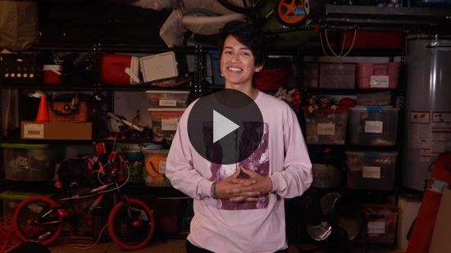

Teaching Time

Have you ever heard someone predict that something would happen and then it came true? (Allow responses.) Maybe they predicted the weather using science or predicted you would slip and fall because they threw a banana peel on the ground. Well, what the Old Testament prophets did was different from that. They wrote down things God told them about the future Messiah—Jesus. Everything they said about Him came true because God told the prophet what to write. Let’s read our Bible story and hear more about a very important prophecy about Jesus.

Open your Bible to Isaiah 7:14.
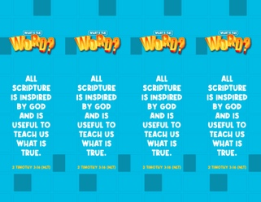
- Read Isaiah 7:14 aloud to the group.
- In order to keep Large Group time moving along, we don’t recommend having the kids read.
- Give a Theme Bookmark to each kid. Tell the kids to mark this place in their Bible with the Theme Bookmark, so they can read it on their own at home.

The verse we just read was written hundreds of years before Jesus was born. Now, let’s read about Jesus from the New Testament. Turn to Luke 1:26–38.
- Read Luke 1:26–38 aloud to the group.

Isn’t it amazing that God gave the prophets special details about Jesus coming to earth? Then, the prophets included these details when they wrote the Old Testament. They never could have guessed all those details correctly on their own. Only God knows everything that will happen in the future. Reading Old Testament prophecies that were fulfilled in the New Testament helps us believe that the Bible really is the inspired Word of God.
- Show the Faith Fact Slide or Motion Graphic.

Do you remember our Faith Fact? (Group response) That’s right. I will trust God’s Word. Let’s say that together one more time.
- Lead the kids in saying the Faith Fact again.

If we’re going to trust God’s Word, then there are three important things we need to know about God’s Word.

1. God’s Word was written by people but inspired by God.
- Show the Teaching Point 1 Slide.

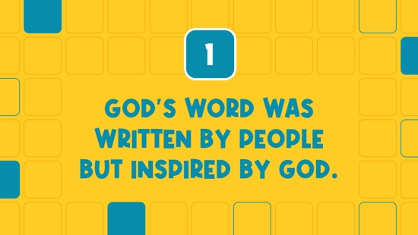

How could God’s Word be written by people? It’s really simple actually. God chose to allow certain individuals to be a part of writing the most important book ever. About forty people helped to write the Bible that we read today. God loves using ordinary people like you and me to do incredible things with His power behind them. Here’s how God gave us His Word.

God spoke to the writers. Kids, put your hands up to your mouth like you are creating your own megaphone. (Group response) The writers listened to God’s words. Now, put your hands up to your ears like you are trying really hard to listen to someone. (Group response)

The writers wrote God’s words down. Kids, hold up your hand and pretend to write something in the air. (Group response) It’s as simple as that. After many years of people copying those original writings and translating them into many different languages, all of us can read and study God’s Word now.

2. God doesn’t make mistakes.
- Show the Teaching Point 2 Slide.

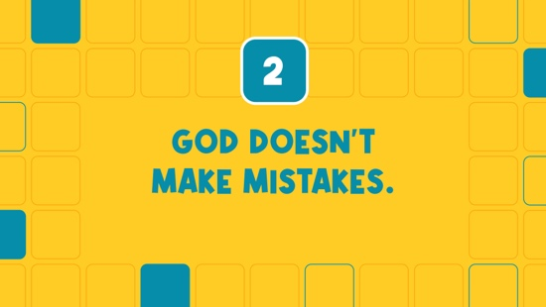

Do you make mistakes sometimes? (Group response) Do you think your parents make mistakes sometimes? (Group response) How about me? Do you think I make mistakes sometimes? (Group response) We all make mistakes sometimes because none of us is perfect.
- Share a funny story of a small mistake you have made.

Even though you, I, and every other person makes mistakes, God never makes mistakes. So we can be sure that everything He says is correct and true. All the words He gave the Bible writers had zero mistakes.
- Hold up the eraser.

God didn’t need a big eraser to erase His mistakes. He doesn’t need us to erase anything from His Word either. It’s important that we believe and trust in all of God’s Word, not just the parts we like or agree with. If we believe that God is perfect and doesn’t make mistakes, then we must believe that His Word is 100 percent true, too.

3. God’s Word is still for us today.
- Show the Teaching Point 3 Slide.

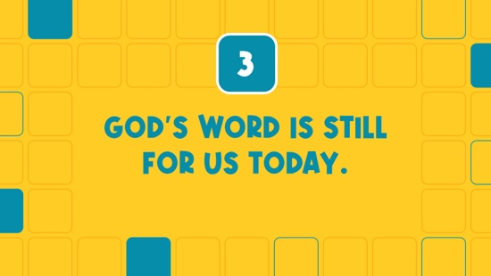

Knowing the Bible is God’s Word is only part of what’s important. We need to read it to know what it says. Think about how you like to read your Bible. Do you like to read a physical book or read it on a device? (Allow responses.) Would you rather listen while someone else reads the Bible to you? (Allow responses.)

We have so many options and ways to read God’s Word today. Your family might even own multiple Bibles and have many devices that you can read or listen to the Bible on. This is one of my Bibles that means a lot to me.
- Hold up a personal study Bible.
- Let them see the notes and highlights inside if you have them.
- Explain who gave it to you and why the Bible means so much to you.
- Keep your Bible in your hands as you read the next section.

The Bible has helped me so many times throughout my life. Did you know that the entire Bible wasn’t written at the same time? It wasn’t written as a big book from start to finish.

It’s incredible to think that first God had people write the Bible in separate parts. It took God and the writers more than a thousand years to write it. Back then people didn’t have the whole Bible at home, so they couldn’t choose to read whenever they wanted to. People would gather and listen as parts of the Bible were read to them. Then, they’d memorize large parts of Scripture.

The Bible is one of the oldest books ever. Did you know it wasn’t written in our language at the beginning? (Group response) The entire Bible has been translated into over seven hundred languages, including the one we speak. It’s the most read book in the world, and it has sold over five billion copies. That’s a lot of Bibles!

The Bible wasn’t just for people thousands of years ago. God inspired it for all of us. God wants us to spend time reading it every day. If you want to know God better, spend time reading His Word. It’s ready and available to you thanks to all the people who God used to give us the Bible.

PRAYER AND RESPONSE
You Will Need | Getting Ready
- Prayer Station Poster, one per group  - 11x17” sheet of paper or card stock  - Foam board  - Glue  - Easel  - Prayer Response Page, one per ten kids  - Scissors  - Clothesline  - Clothespins, one per kid  - Index cards, one per kid  - Pencils or pens, one per kid | - Print the Prayer Station Poster on 11x17” paper, one per group.  - Mount the poster on foam board or card stock.  - Place the poster on an easel.  - Print the Prayer Response Page, one per ten kids. Cut apart the page so each kid has one verse.  - Hang the clothesline near the Prayer Station Poster.  - Clip the verses to the clothesline using the clothespins.  - Place the pencils and the index cards at the prayer station.

Consider playing a worship song softly in the background while kids pray.

Think about this for a moment. When was the last time you spent time reading and thinking about God’s Word? Sometimes I get busy, and I forget to read the Bible. Other times I do my devotions quickly because I’m in a hurry instead of taking time to think about what I’m reading. Or I don’t take the time to listen to what God wants to say to me.

God wants to spend time with us. He wants to talk to us through His Word. Let’s pray and ask God to speak to us through His Word. Then, we’ll pause and listen quietly for a few moments.
- Optional: Have the kids repeat phrases of the prayer after you.

Prayer

Dear God, thank You for giving us Your inspired Word. We want to hear from You through it. Amen.
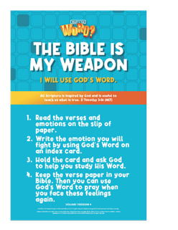
Prayer Station
God speaks to us in many ways and at different times. Hearing His voice is something we can practice. Let’s take some time and respond to what we’ve heard.

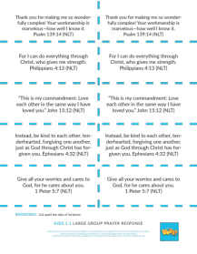
At the prayer station, you’ll see a clothesline and a poster. Attached to the clothesline are slips of paper that have different Bible verses on them. The poster tells you what to do.
- Read the steps on the Prayer Station Poster aloud if needed.
- Assist younger kids who can’t read the Scripture on their own.

While other kids are at the prayer station, I invite you to pray with a leader about what God spoke to you or about any other need you have today.
- Take time to pray with kids.
- Send the verse and index card home with kids so they can pray and review.

Optional: Salvation Prayer
Maybe you would like to follow God’s Word and ask Jesus to come and be in your life. He can forgive you of your sins and give you a fresh start. You can do that today and start that friendship with Him. I want to give you an opportunity to do that right now. If you’d like to invite Jesus to be your Lord and Savior, let’s pray together.
- Invite kids to pray with you or have everyone repeat the prayer after you.

Dear Jesus, I believe You came to earth and died on the Cross so I can be forgiven. Please forgive my sins and make me a new person. I want to live for You. I also believe You came back to life, and now I can live forever with You. Thank You for coming into my life. Amen.

Faith Verse
Our Faith Verse reminds us of why God’s Word is so important to our lives. Let’s practice it now.
- Show the Faith Verse Video or Slide.

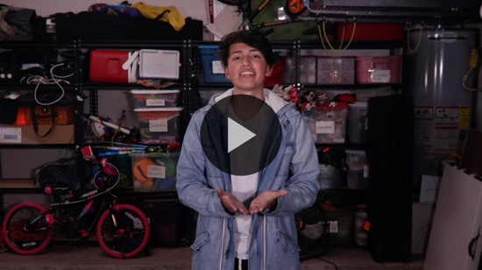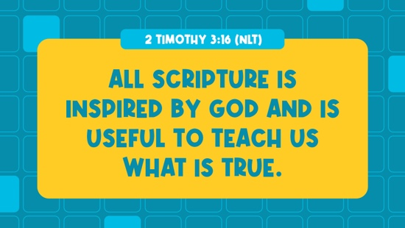

2 Timothy 3:16 (NLT)
All Scripture is inspired by God and is useful to teach us what is true.

Faith Fact
- Show the Faith Fact Slide or Motion Graphic.

We can trust what we read in the Bible because we believe that the words are inspired by God himself. Our Faith Fact reminds us of that. Say the Faith Fact with me one more time. I will trust God’s Word. I hope that you really do trust God and His Word. Let’s go to Small Group time and discover even more about the Bible.
- Dismiss kids to Small Group time or to go home if your group time ends here.

SMALL GROUP (30 Minutes)
This section can be done in conjunction with the large group, or on its own if you do small groups with your kids. During Small Group time, the goal is to connect the kids with the Word of God and to each other. All activities are led by the small group leader.

GROUP CONNECTION | Do You Trust Me?
You Will Need | Getting Ready
No supplies are needed for this activity. | No prep is needed for this activity.

Who do you trust the most in your life? (Allow responses.) We all have people we would trust with anything—our parents, grandparents, teachers, or pastors. How does someone earn your trust? (Allow responses.) People usually earn my trust by spending time with me. Then, we get to know each other well.

We’re going to play a game and see who we can trust in our group. Each of us will share a statement about ourselves. Then, we’ll ask, “Do you trust me?” Here’s the catch. What you share might be true or false. Everyone else in the group will decide if they trust your word or not. I’ll go first.
- Share a statement about yourself. It will be more fun if it’s something that’s not true. Then, have kids guess if they trust you.
- Keep playing until everyone has had at least one turn sharing a statement about themselves.

Was it easy or hard for you to tell who you could trust? (Group response) I’m glad we never have to ask that question about God. We know we can always trust Him and His Word.

LEARN ABOUT IT
You Will Need | Getting Ready
- Bibles, one per kid (preferably all the same version)  - “Books of the Bible” song from JumpStart3  - Optional: Books of the Bible Card, one per four kids | - Download “Books of the Bible” song from JumpStart3.  - Optional: Print the Books of the Bible Card, one per four kids.

Scripture Search: Acts 17:11; Romans 3:4; 1 Thessalonians 2:13; 2 Peter 1:20–21

Let’s dig deeper into God’s Word and see what else He has to say about the text here. As we find and read each of these verses, let’s consider: What does it mean for our lives today?
- Give each kid a Bible and search for one or more of the Scriptures as a group as time allows. When everyone has found the Scripture, have one of the kids read it. Then, answer the questions about it.
- Pair kids who need additional help with older kids or start simple and look up the session’s Bible story Scriptures: Isaiah 7:14; Luke 1:26–38. Kids will get better at finding Scriptures the more they practice.
- Optional: Make this a competition to see who can find the Scripture first.

Bible Reading Tip

Did you know that the Bible is one book that includes many different books? (Group response) You can see all the books of the Bible listed at the front of the Bible. Turn to the contents page. Let’s take a closer look.
- Have kids turn to the contents page in their Bible.

We don’t know who wrote every book of the Bible, but we do know that God inspired about forty people to write it. Some of the books begin by stating who wrote them. Some of the books are even named after the people who wrote them or who the book is about. Can you find any books that look like they might be named after the person who wrote it or who it is about?
- Point out some of the books of the Bible to the kids.
  - The first five books in the Old Testament were mostly written by Moses.
  - Esther and Daniel were written during a time most Israelites were not in Israel.
  - Matthew, Mark, Luke, and John are all books that tell about the life of Jesus on earth.
  - Third John is the shortest book in the Bible.

Challenge

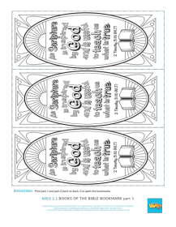
Each time we meet we’re going to have a challenge to do. Today’s challenge is to begin learning the names of all the books in the Bible in order. Let’s do that now.
- Play the “Books of the Bible” song.

During the week, turn to the list of books in your Bible and try to remember as many books as you can by next time.
- Optional: Give a Books of the Bible Card to each kid so they can take it home to color and use to learn the names of the books of the Bible.

Faith Fact
- Show the Faith Fact Slide or Motion Graphic.

All of our Bible reading is a reminder to me of our Faith Fact. Say it with me:

I will trust God’s Word.

GROUP DISCUSSION

Feel free to use all or just a few questions as a jumping-off place for good discussion. Questions marked with * are designed for more conversation. Adjust the questions based on the age or maturity of your group. Typically, older kids will be able to dive a little deeper than younger ones.
- If Small Group activities are not immediately following Large Group time, you may want to read the Bible story passage (Isaiah 7:14; Luke 1:26–38) before this discussion.

Questions

Do you trust everything you read on the internet? Why or why not?

Do you trust that the Bible is God’s Word? Why or why not?

Do you believe that God makes mistakes? Why or why not?

* Do you make mistakes? Share a mistake you have made with the group.

* Have you ever read something in the Bible that you had a hard time believing? What was it? What made it hard for you to believe it?

* Why should we believe that God’s Word is still helpful for us today even though it’s a really old book?

* How can you help others trust in God’s Word?

For additional questions, see the Bible Fact-Pak questions 1, 9, 10, 171, 279, 289, 291, 485. The Bible Fact-Pak resources are available from MyHealthyChurch.com.

Prayer Requests
Finish group discussion by sharing prayer requests and praise reports. Keep track of your small group’s prayer requests and review them each time you meet.

Prayer

Have kids pray for each other’s prayer requests.

FAITH VERSE REVIEW
You Will Need | Getting Ready
- Faith Verse Review Page, one per group  - Cup  - Scissors | - Print copies of the Faith Verse Review Page, one per group.  - Cut apart the Faith Verse slips and place each set in a cup.

Our Faith Verse for today is 2 Timothy 3:16. It tells us why we can trust God’s Word. Let’s practice it now.
- Show the Faith Verse Video or Slide.

2 Timothy 3:16 (NLT)
All Scripture is inspired by God and is useful to teach us what is true.

Let’s make sure we’re familiar with the Faith Verse. Let’s say it as a group a couple more times. (Group response)

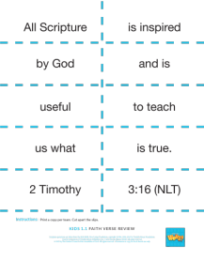
Faith Verse Fun | Scripture Scramble

Our Faith Verse is one that is very important to know because it reminds us why God’s Word is so important. Let’s practice it by unscrambling it together. Pay attention, because after we do it once together, we’ll divide into teams and see which team can unscramble it the fastest.
- Give kids the Faith Verse Review slips and let them work together to unscramble the verse.
- Play again. Record the fastest times for the teams and declare a winner.

ACTIVITY PAGE |Bible Book Word Search: New Testament
You Will Need | Getting Ready
- Activity Page, one per kid  - Answer Page  - Pencils, one per kid | - Print copies of the Activity Page, one per kid.

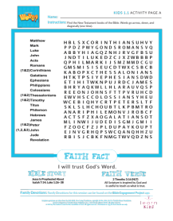
We’ve got a fun Activity Page to do today. It will help us to learn the names of the books of the Bible. We’re starting with the New Testament books. Let’s see how many you can find. Make sure you cross them off as you find them.
- Give each kid a copy of the Activity Page and a pencil. Let kids complete the word search.
- Optional: Play the “Books of the Bible” song as they search.

DISMISSAL

Thanks for coming and discovering more about God’s Word with me. I’m so glad we can trust the Bible. Let’s close in prayer.

Prayer

Dear God, thank You for giving us Your Word. It was awesome to read the prophecy about Jesus and then to see it fulfilled in Your Word. Help us trust what we read in Your Word. Amen.

Faith Fact Recap
- Display the Faith Fact Slide or Motion Graphic as parents are coming into the room.

One important thing I want you to remember from today is our Faith Fact. Let’s say it together: I will trust God’s Word. I’m glad you came today. I can’t wait to see you next time!
- Send home the Activity Page, Prayer Response items, and Theme Bookmark.
- Remind parents that there are Family Devotions available on the app to do with their kid.
- Tell everyone the date and time for the next session.

