

LEADER OVERVIEW

Volume Overview—What’s the Word?
Our upbringing often influences our view of the Bible. In your home, was the Bible a dust-covered book that you thought kept people from having any fun? Was it honored as the living, breathing Word of God? Or did your childhood view of God’s Word fall somewhere in between? In this Learn volume, we want kids to know that God speaks through His Word to those who will listen, giving guidance and correction for their lives (2 Timothy 3:16–17).

SESSION 1: The Bible Is God’s Word—  Isaiah 7:14; Luke 1:26–38  Faith Fact: I will trust God’s Word. | SESSION 2: The Bible Is True—  Luke 4:14–22  Faith Fact: I will obey God’s Word.
SESSION 3: The Bible Is My Guide—  Luke 6:46–49  Faith Fact: I will follow God’s Word. | SESSION 4: The Bible Is My Weapon—  Luke 4:1–13  Faith Fact: I will use God’s Word.

SESSION OVERVIEW

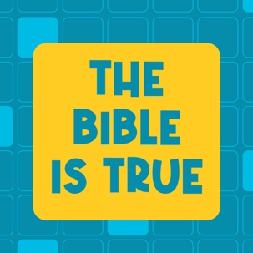
Throughout history the Bible has been proven to be true by archeology and other events. Although the books of the Bible were written by many people, they all speak to the truth of who God is. In our Bible story, Jesus reads a passage from the Old Testament that foretold information about Him. Based on what He read, Jesus announced that He was the One the passage was about. Although the people probably knew that passage well, most chose not to believe Jesus. We can learn from Jesus’ example and choose to believe and obey God’s Word.

Bible Lesson | Faith Fact
Jesus Proves the Scriptures Are True  Luke 4:14–22 | I will obey God's Word.
Faith Verse
2 Timothy 3:16 (NLT)
All Scripture is inspired by God and is useful to teach us what is true.

Learn Kids is part of an entire kids’ discipleship strategy. Get access at KidminRoadmap.com.

PREPARING FOR THE SESSION
You Will Need | Getting Ready
Large Group  - Bible  - Worship songs (Song suggestions: “Who You Say I Am” by Hillsong Worship; “Goodness of God" by Bethel Music; “Headlight” by Elevation Youth; “Breakthrough” by Elevation)  - For groups not using a phone or tablet only, add:  - Projector or TV  - Laptop  - Countdown 5-Minute Video  - Theme Intro Video  - Faith Fact Slide or Motion Graphic  - Game Slide or Motion Graphic  - Bible Lesson Video  - Teaching Time Video  - Teaching Point Slides 1–3  - Faith Verse Video or Slide  - Bibles, one per kid (preferably all the same version)  - Pile of books  - Black marker  - File folder  - Prayer Station Poster  - 11x17” sheet of paper or card stock  - Foam board  - Glue  - Easel  - Large Group Reponse Page, one per eight kids  - Scissors  - Clothesline  - Clothespins, one per kid  - Seeds—radish, grass, and sunflower seeds germinate within days  - Baggies, one per kid  - Crayons  Small Group  - Small prize or candy, one per kid  - Bibles, one per kid (preferably all the same version)  - “Books of the Bible” song by JumpStart3  - Ball, one per group  - Small Group Activity Page, one per kid  - Pencils, crayons, or markers | Large Group  - Download videos and slides if needed.  - Select worship song(s) and have them ready to play.  - Read the Bible Lesson Scripture to prepare for Teaching Time.  - Use the black marker to label the folder “Evidence.”  - Gather different types of books such as storybooks, history books, comic books, etc.  - Print the Prayer Station Poster on 11x17” paper, one per group.  - Mount the poster on foam board or card stock.  - Place the poster on an easel.  - Print the Large Group Prayer Response Page, one per eight kids. Cut apart the page so each kid has one flower.  - Hang the clothesline near the Prayer Station Poster.  - Place a few seeds inside each baggie, one baggie per kid.  - Clip the baggies to the clothesline using the clothespins.  - Place the flower pictures and crayons at the prayer station.  - Optional: Download and customize the Newsletter Template, if using.  Small Group  - Download “Books of the Bible” song from JumpStart3.  - Print the Small Group Activity Page, one per kid.

Check out all the promotional and extra media files available for this theme. To access the Bible Engagement Project from a computer, visit App.BibleEngagementProject.com.

LARGE GROUP (30 Minutes)
See what’s needed at the beginning of the session.

INTRODUCTION
- Optional: Play the Countdown 5-Minute Video.



Welcome

We’re back for another incredible time together. Who can remember what we’re focusing on in these sessions? (Allow responses.) Last time, we learned what the Bible is and why it matters to us. We learned that the Bible is God’s Word. People wrote the words, but God inspired them and told them what to write.
- Play Theme Intro Video.

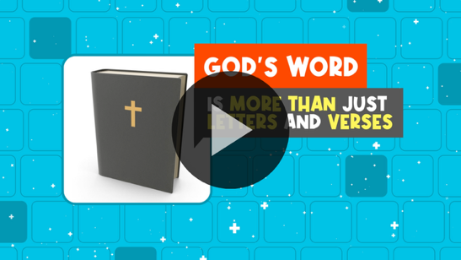

Today, we will hear that the Bible is true. I hope you already believe that. Why do you believe the Bible is true? (Allow responses.) Those are great answers. If you’re not convinced yet, we’re going to discover why we know the Bible is 100 percent true. We’ll unpack some of the evidence we have that proves the Bible is true.

Faith Fact
- Show the Faith Fact Slide or Motion Graphic.

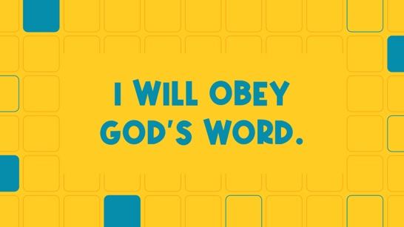

Because we know that the Bible is true, we must obey what it says. So our Faith Fact today says: I will obey God’s Word. Let’s say it together three times as fast as we can! Ready? I will obey God’s Word.
- Lead the kids in saying the Faith Fact three more times.

GAME | Obey the Leader
You Will Need | Getting Ready
No supplies are needed for this activity. | No prep is needed for this activity.

- Show the Game Slide or Motion Graphic.


Obeying isn't always easy. We’re instructed to obey God, His Word, our parents, and everyone in authority over us. That's a lot of obeying! Do you obey all the time? (Group response)

We all make mistakes, but our intent should be to always obey. We’re going to practice obeying those in authority over us during today's game. The leader is going to give instructions. Everyone must obey if the leader says, “The leader says,” before the instruction. If the leader doesn’t say, “The leader says,” first, ignore the instruction. If you fail to obey the correct instructions, you’re out of the game.
- Choose someone to be the leader.
- Have everyone stand up at their seats. If needed, have them spread out from each other and face the leader.
- Examples of instructions: jump five times, do three jumping jacks, high-five a friend, count to twenty as fast as you can, hop on one foot six times, etc.
- Watch the kids during the game to call them out as needed.
- Play as long as time allows.
- Congratulate the winner.

That was a fun way to practice obeying the leader. It’s a great way to remind us that God wants us to obey Him, too.

WORSHIP

Let’s take some time to worship God today by singing and thanking Him for all He has done for us.
- Lead the kids in singing one or two praise songs. See suggestions at the beginning of the session.

BIBLE LESSON | Jesus Proves the Scriptures Are True (Luke 4:14–22)
You Will Need | Getting Ready
- Bibles, one per kid (preferably all the same version)  - Pile of books  - Black marker  - File folder | - Use a black marker to label the folder “Evidence.”  - Gather different types of books such as storybooks, history books, comic books, etc.

That was a great time of worship. Are you ready to hear more about why we believe the Bible is true? (Group response) Well, the first thing you’ll need is your Bible. I have my Bible. Now, let’s get ready to discover something new.
- Hold up your Bible.

Did you remember that the Bible is made up of more than one book? (Group response) How many books are in the Bible? (Allow responses.) There are sixty-six total. That’s a lot of books. Who’s read sixty-six books in your entire life? Raise your hand. (Group response)

There’s a lot packed into our Bible, but none of that even matters if we don’t believe it’s true. If the Bible is just a fictional book of made-up stories, why would we even take the time to read it? But if we know that it’s really God’s Word and filled with truth that can help us in our lives, we should want to spend time studying it. Let’s pray and ask God to reveal a new truth to us from His Word.

Prayer

Dear God, thank You for speaking the truth to us in Your Word. Help us to obey all Your instructions found in it. Amen.

Video Intro

Before we get started with the Bible story, let’s watch this video.
- Play the Bible Lesson Video.

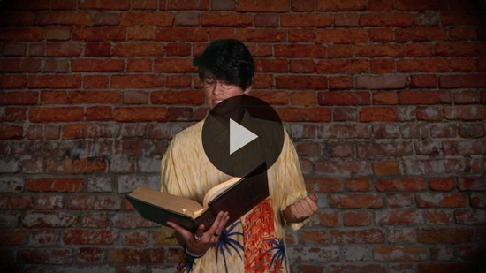

Teaching Time

Who’s lived in the same house for your entire life? Raise your hand. (Group response) Who’s moved around a lot? Raise your hand. (Group response) Jesus moved around when He was young. He was born in Bethlehem. He lived in Egypt for about three years, but He grew up in a place called Nazareth. As an adult, Jesus lived mainly in Capernaum, but He constantly traveled from town to town to do ministry.

In our Bible story today, Jesus returned to His hometown of Nazareth. He planned on teaching and doing ministry there, but the people in His hometown weren’t very receptive. Let’s see what Jesus said while He was in Nazareth that they might not have agreed with, but Jesus proved was true.

Grab your Bible or pull up a Bible app on your device. Open it to Luke 4:14–22.
- Read Luke 4:14–22 aloud to the group.
- In order to keep Large Group time moving along, we don’t recommend having the kids read.
- Tell the kids to mark this place in their Bible with the Theme Bookmark so they can read it on their own at home.

It’s pretty amazing that when Jesus, the Son of God, taught the people in His hometown, He was given the scroll of Isaiah to read—a book that has many prophecies about Jesus. Not only was Jesus fulfilling a super old prophecy, but also He was recognizing the writings of Isaiah as God’s Word. Jesus proved that the Scriptures were true. Many people still chose not to believe in Him. We know it’s important not only to believe God’s Word but also to obey it.
- Show the Faith Fact Slide or Motion Graphic.

Let’s say today’s Faith Fact together again. I will obey God’s Word. (Group response)
In today’s lesson, there are three things we need to know about God’s Word.

- Many writers shared God’s truth.
- Show the Teaching Point 1 Slide.

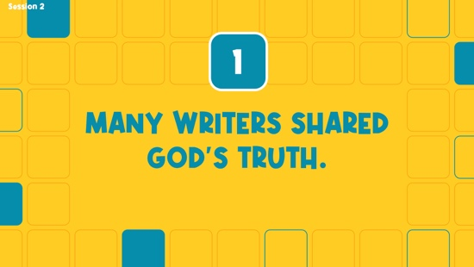

- Pick up a pile of random books.

Look at all these books. I like to read all kinds of books. How about you? (Group response) There are history books, storybooks, fantasy books, and comic books. All these books talk about different things, and they were all written by different people.
- Show kids the different types of books as you name them (storybooks, history books, comic books, etc.).
- Hold up the Bible.

Did you know the Bible is a unique book? In fact, it looks like one book, but it’s really one very long book that is made up of sixty-six smaller books. Those sixty-six books are different kinds of books, too. Some of them are full of rules and laws. Some tell the history of God’s people, the Israelites. Others are full of poems and wise sayings. Some are letters written to specific people or churches. Can you think of any other book like it? (Allow responses.)

I can't think of any other book that even comes close to the Bible. Remember, last time we heard that the words in the Bible were written by people, but God inspired the words and gave them to the writers. The books found in the Bible may be very different from each other and written by different people, but they’re all filled with God’s truth. They point to who God is and what His plan is for His people. It’s not only for His people in Bible times, but also for us, too. That’s amazing!

Every one of those books was inspired by God to be written and placed in the Bible we read today. If you’re looking for something interesting to read, the Bible has what you are looking for.

2. The Bible is proven to be true.
- Show the Teaching Point 2 Slide.

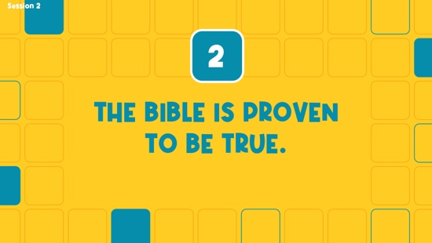

Believing the Bible is true requires an element of faith. For example, close your eyes right now.
- Wait for all the kids to close their eyes.

Can you see God? (Group response) Open your eyes.
- Wait for all the kids to open their eyes.

Can you see God now? (Group response) What about heaven? Can you see it? (Group response) Can you see any angels? (Group response)

We believe all these exist even though we can't see, hear, or touch them right now. That's the definition of faith. However, we don't have to just blindly believe that the Bible is true and God is real. The Bible has been proven to be true by many sources.

There are people whose jobs focus on finding out what happened in the past. They are archaeologists, and they study the things they find when they dig up the ground. They discover what part of history those things came from. Over the years, we’ve learned about the places of the Bible from what they have found. Check out this video of some of the old places from the Bible in the city of Jerusalem.
- Play Teaching Time Video in the background.

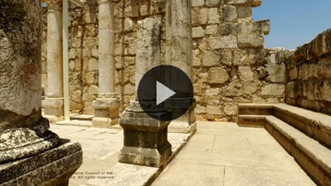

For example, archaeologists have found very old scrolls and writings of parts of the Bible. They’ve found evidence of some of the major events described in the Bible. There are many discoveries like this. It’s one of the reasons that prove we can trust the Bible. Jesus proved much of the Bible to be true when He fulfilled many prophecies through His life on earth.

We know Jesus taught people by using Old Testament Scripture passages, which proves that He believed those Scriptures are relevant and true. Other authors of ancient books also said that Jesus was real, not just the Bible. These books also tell about events that took place in the Bible.

3. I will choose to believe and obey the Bible.
- Show the Teaching Point 3 Slide.

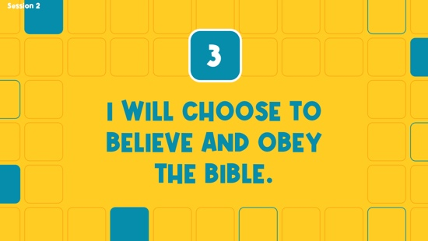

- Hold up the folder labeled “Evidence” while you talk.

I wish I could explain all the evidence that would help you know why we can trust God’s Word. Do you want to know a secret? (Group response) Even if I showed you all the evidence, you would still have to choose to believe that the Bible is true. That’s just like the people Jesus was talking to in our Bible story today.

We can’t go back in time and watch the Bible being written. We can’t watch David defeat Goliath or see Noah’s ark. Those are incredible stories that the Bible tells us about, but we can’t see for ourselves.

In the end, you must choose to believe that the Bible is true. You will never have proof that every event in the Bible happened. That's where the faith I was talking about earlier comes in. If you believe that God is real and you have chosen to follow Him, you must also choose to believe that God's Word is true and choose to obey the instructions found in it.

PRAYER AND RESPONSE
You Will Need | Getting Ready
- Prayer Station Poster, one per group  - 11x17” sheet of paper or card stock  - Foam board  - Glue  - Easel  - Prayer Response Page, one per eight kids  - Scissors  - Clothesline  - Clothespins, one per kid  - Seeds—radish, grass, and sunflower seeds germinate within days  - Baggies, one per kid  - Crayons | - Print the Prayer Station Poster on 11x17” paper, one per group.  - Mount the poster on foam board or card stock.  - Place the poster on an easel.  - Print the Prayer Response Page, one per eight kids. Cut apart the page so each kid has one flower.  - Hang the clothesline near the Prayer Station Poster.  - Place a few seeds inside each baggie, one baggie per kid.  - Clip the baggies to the clothesline using the clothespins, one per kid.  - Place the flower pictures and crayons at the prayer station.

Consider playing a worship song softly in the background while kids pray.

- Hold up a seed.

When we look at a seed, it seems strange to think that one day it can become a large plant. There is science and evidence to back that up. But, when we put a seed in the ground, we must trust that it will grow into a plant. In the same way, we can trust that the Bible is God’s Word. If it is God’s Word, then we must choose to obey what it says. Let’s pray.
- Optional: Have the kids repeat phrases of the prayer after you.

Prayer

Dear God, thank You for the Bible. We believe it is Your Word for us. We want to obey what You have said to us. Help us to do that now. Amen.

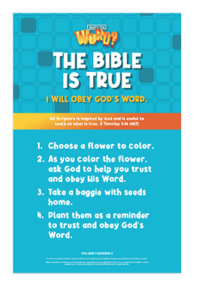
Prayer Station
Today you’re going to color a flower and take home a few seeds to plant. As you color the flower, ask God to help you trust His Word. The next part may be harder. Because you trust God’s Word, ask Him to show you how you need to obey the Bible more. Then, sit quietly and see if He speaks to you.

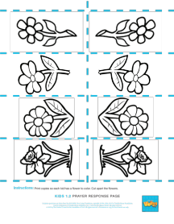
At the prayer station, you’ll see a clothesline and a poster. Attached to the clothesline are bags with some seeds in them. The poster tells you what to do.
- Read the steps on the Prayer Station Poster aloud if needed.
- Allow kids time to choose a flower and color it.

While other kids are at the prayer station, I invite you to pray with a leader about what God spoke to you or about any other need you have today.
- Take time to pray with kids.
- Send the flower pictures and seeds home with kids. They can plant the seeds as a reminder to trust and obey God’s Word.

Optional: Salvation Prayer
Maybe you would like to take a step of faith. You want to show that you believe God’s Word and want to ask Jesus to come and be a part of your life. He can forgive you of your sins and give you a fresh start. You can make that step of faith today. You have an opportunity to do that right now. If you’d like to invite Jesus to be your Lord and Savior, let’s pray together.
- Invite kids to come forward to pray with you or have everyone repeat the prayer after you.

Dear Jesus, I believe You came to earth and died on the Cross so I can be forgiven. Please forgive my sins and make me a new person. I want to live for You. I also believe You came back to life, and now I can live forever with You. Thank You for coming into my life. Amen.

Faith Verse
Our Faith Verse reminds us that God’s Word teaches us the truth. It’s found in 2 Timothy 3:16. Say it with me.
- Show the Faith Verse Video or Slide.

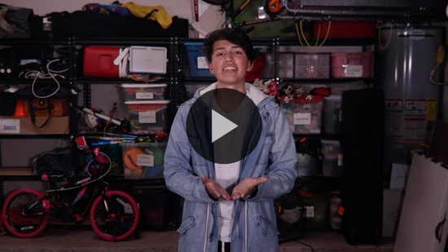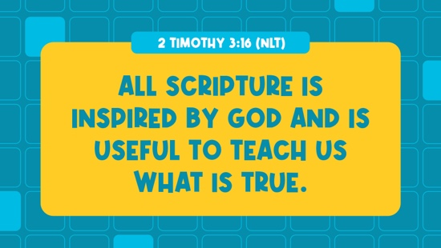

2 Timothy 3:16 (NLT)
All Scripture is inspired by God and is useful to teach us what is true.

The truths we read about in the Bible will help guide the way we live. If we obey God’s Word, we will stay on the right path. I want to do that. How about you? (Group response)

Faith Fact

Before we go to our small groups, let’s review our Faith Fact again.
- Show the Faith Fact Slide or Motion Graphic.

Shout it with me. I will obey God’s Word. I hope you discovered something new about God’s Word today. Enjoy your Small Group time.
- Dismiss kids to Small Group time or to go home if your group time ends here.

SMALL GROUP (30 Minutes)
This section can be done in conjunction with the large group, or on its own if you do small groups with your kids. During Small Group time, the goal is to connect the kids with the Word of God and to each other. All activities are led by the small group leader.

GROUP CONNECTION | Take a Risk
You Will Need | Getting Ready
- Small prize or candy, one per kid | No prep is needed for this activity.

Are you ready for a challenge? (Group response) You’ll have to take a little risk and be ready to obey any instruction I give if you want to win a prize. Who wants to go first in our obedience challenge? (Group response)
- Give each volunteer one of the following challenges:
  - Do your favorite move.
  - Share one thing that is true about you that most people wouldn't know.
  - Sing a line from your favorite song.
  - Say your favorite verse in the Bible from memory.
  - Come up with a challenge for someone else in the group to do.
  - Make the craziest face you can.
  - Show everyone a body trick you can do.
  - Try to do a handstand.
  - Make up a simple handshake with someone in the group.
  - Share today's Faith Fact or Faith Verse with the group.
  - Come up with a challenge for the leader to do.
- If they choose to take the challenge and complete it, give them a small prize or candy.
- Keep playing until everyone who wants to play has had a chance to take a challenge.

That was great! You were very brave to do these challenges.

LEARN ABOUT IT
You Will Need | Getting Ready
- Bibles, one per kid (preferably all the same version)  - Books of the Bible” song from JumpStart3 | - Download “Books of the Bible” song from JumpStart3.

Scripture Search: Psalm 33:4; Proverbs 30:5–6; 2 Timothy 3:14–15; 2 Timothy 3:16–17

Let’s dig deeper into God’s Word and see what else He has to say about the Bible. As we find and read each of these verses, let’s consider:

How does this Scripture teach us about what God wants us to know about trusting His Word?

What does it mean for our life today?
- Give each kid a Bible and search for one or more of the Scriptures as a group as time allows. When everyone has found the Scripture, have one of the kids read it. Then, answer the questions about it.
- Pair kids who need additional help with older kids or start simple and look up the session’s Bible story Scripture: Luke 4:14–22. Kids will get better at finding Scriptures the more they practice.
- Optional: Make this a competition to see who can find the Scripture first.

Bible Reading Tip

Whenever we read the Bible, it’s important that we ask this question: Because this is true, what should I do? We should be looking for ways to make sure we’re obeying what God says in His Word. If you aren’t sure about something it asks you to do, then you can always ask an adult about it or look for other Bible verses that tell you to do a similar thing.

Challenge

Choose a passage of the Bible to read this week that you haven't read before or aren't familiar with. Write down some of the things the passage tells you to do on a piece of paper. Show it to your parents or bring it to Small Group next time.

While we’re discovering more things about God’s Word, let’s memorize all the books in the Bible, too. Let’s sing the “Books of the Bible” song.
- Play the “Books of the Bible” song.

Faith Fact
- Show the Faith Fact Slide or Motion Graphic.

All of our talking about the Bible reminds me of our Faith Fact. Say it with me: I will obey God’s Word.

GROUP DISCUSSION

Feel free to use all or just a few questions as a jumping-off place for good discussion. Questions marked with * are designed for more conversation. Adjust the questions based on the age or maturity of your group. Typically, older kids will be able to dive a little deeper than younger ones.
- If Small Group activities are not immediately following Large Group time, you may want to read the Bible story passage before this discussion.

Questions

How many books are there in the Bible?

About how many authors wrote the books that are included in the Bible?

* How many books of the Bible can we name? Try not to repeat any of the books that have already been mentioned.

* In our Bible story, how did Jesus prove the Bible is true? What other ways do you think Jesus proves that the Bible is true?

Do sources other than the Bible prove that it is true?

* Why do you believe that the Bible is true?

* Are there any instructions in the Bible that are hard for you to follow? Why?

* How can we work on obeying God's Word?

* Have you ever disobeyed something in God’s Word? Share about it with the group, if you’re willing.

For additional questions, see the Bible Fact-Pak questions 2, 179, 273, 289, 291. The Bible Fact-Pak resources are available from MyHealthyChurch.com.

Prayer Requests
Finish group discussion by sharing prayer requests and praise reports. Keep track of your small group’s prayer requests and review them each time you meet.

Prayer

Have kids pray for each other’s prayer requests.

FAITH VERSE REVIEW
You Will Need | Getting Ready
- Ball, one per group | No prep needed for this activity.

Our Faith Verse is 2 Timothy 3:16. It tells us that we can learn the truth by reading God’s Word. Let’s say it together.
- Show the Faith Verse Video or Slide.

2 Timothy 3:16 (NLT)
All Scripture is inspired by God and is useful to teach us what is true.

Faith Verse Fun | Verse Pass

Everyone will need to do their small part in saying the Faith Verse. We’re going to pass a ball. When you catch the ball, you have to say just one word of the Faith Verse. If you don’t know the next word in the verse, the group can help you. Do you think we can work together as a group to say the Faith Verse? (Group response) Let’s see how it goes.
- Have the group sit down or stand up in a circle with some distance between each kid.
- The person holding the ball will say the first word of the Faith Verse and pass the ball to the next kid in the group until the Faith Verse is completed.
- Play a few rounds encouraging the kids to try to get faster each time.
- Challenge option: Toss or roll the ball to any kid in the group to say the next word in the verse.
- Remember to help out kids if they don’t know the verse yet.

ACTIVITY PAGE | Design a Bible Cover
You Will Need | Getting Ready
- Activity Page, one per kid  - Pencils, crayons, or markers | - Print the Activity Page, one per kid.

When we believe that God’s Word is full of truth, we should want everyone we know to read the Bible. Did you know that the people who print Bibles sometimes give them very creative covers? (Group response)
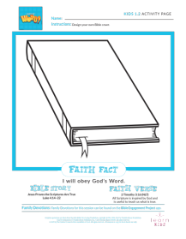
- Look at the covers of Bibles kids brought with them.

Today, you’re going to design a creative Bible cover. Decorate it however you’d like.
- Give each kid the Activity Page and pencils, crayons, or markers. (Some kids like to sketch a design in pencil first.)
- Optional: Practice the “Books of the Bible” song as they work on their design.

DISMISSAL

I enjoyed learning with you how we can know God’s Word is true. Let’s close in prayer.

Prayer

Dear God, thank You for teaching us the truth through Your Word. Help us to obey all the instructions found in it. Amen.

Faith Fact Recap
- Display the Faith Fact Slide or Motion Graphic as parents are coming into the room.

One important thing I want you to remember from today is our Faith Fact. Say it with me: I will obey God’s Word. I’m so glad you came today. See you next time.
- Send home the Activity Page and Prayer Response items.
- Remind parents that there are Family Devotions available on the app to do with their kid.
- Tell everyone the date and time for the next session.

