

LEADER OVERVIEW

Volume Overview—What’s the Word?
Our upbringing often influences our view of the Bible. In your home, was the Bible a dust-covered book that you thought kept people from having any fun? Was it honored as the living, breathing Word of God? Or did your childhood view of God’s Word fall somewhere in between? In this Learn volume, we want kids to know that God speaks through His Word to those who will listen, giving guidance and correction for their lives (2 Timothy 3:16–17).

SESSION 1: The Bible Is God’s Word—  Isaiah 7:14; Luke 1:26–38  Faith Fact: I will trust God’s Word. | SESSION 2: The Bible Is True—  Luke 4:14–22  Faith Fact: I will obey God’s Word.
SESSION 3: The Bible Is My Guide—  Luke 6:46–49  Faith Fact: I will follow God’s Word. | SESSION 4: The Bible Is My Weapon—  Luke 4:1–13  Faith Fact: I will use God’s Word.

SESSION OVERVIEW

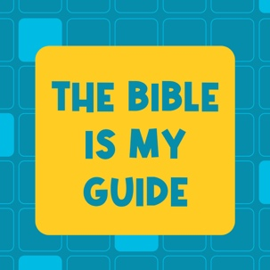
In the Bible story, Jesus shares a parable of two men who built houses on different foundations. Jesus explained that those who build their lives on His words are like the man building on a firm foundation. God’s Word can help us make good choices in our life and ultimately build our life on the right foundation. As we read His Word, God speaks through it and uses it to help guide our life. No matter what we’re facing, we can listen to what God is saying through His Word and be guided to make the right choices.

Bible Lesson | Faith Fact
Jesus Teaches about a Firm Foundation  Luke 6:46–49 | I will follow God’s Word.
Faith Verse
2 Timothy 3:16 (NLT)
All Scripture is inspired by God and is useful to teach us what is true.

Learn Kids is part of an entire kids’ discipleship strategy. Get access at KidminRoadmap.com.

PREPARING FOR THE SESSION
You Will Need | Getting Ready
Large Group  - Bible  - Worship songs (Song suggestions: “Who You Say I Am” by Hillsong Worship; “Goodness of God” by Bethel Music; “Headlight” by Elevation Youth; “Breakthrough” by Elevation)  - For groups not using a phone or tablet only, add:  - Projector or TV  - Laptop  - Countdown 5-Minute Video  - Theme Intro Video  - Faith Fact Slide or Motion Graphic  - Game Slide or Motion Graphic  - Bible Lesson Video  - Teaching Point Slides 1–3  - Faith Verse Video or Slide  - Large Group Game Pages, one set per group  - Scissors  - Hammer or building tool  - Phone  - Headphones  - Prayer Station Poster, one per group  - 11x17” paper or card stock  - Foam board  - Glue  - Easel  - Large Group Prayer Response Page, one per ten kids  - Scissors  - Clothesline  - Clothespins, one per kid  - Optional: Newsletter Template  Small Group  - Bibles, one per kid (preferably all the same version)  - “Books of the Bible” song by JumpStart3  - Sticky notes  - Pen  - Small Group Activity Page, one per kid  - Pencils or pens, one per kid | Large Group  - Download videos and slides if needed.  - Select worship song(s) and have them ready to play.  - Read the Bible Lesson Scripture to prepare for Teaching Time.  - Print the Large Group Game Pages, one set per group, and cut apart the pictures.  - Hide the Bible pictures in your meeting area before the kids arrive.  - Find music to play on your phone.  - Print the Prayer Station Poster on 11x17” paper, one per group.  - Mount the poster on foam board or card stock.  - Place the poster on an easel.  - Print the Large Group Prayer Response Page, one per ten kids. Cut apart the verses on the page so each kid has one verse.  - Hang the clothesline near the Prayer Station Poster.  - Clip the verses to the clothesline using the clothespins.  - Optional: Download and customize the Newsletter Template, if using.  Small Group  - Download “Books of the Bible” song by JumpStart3.  - Write the individual words of the Faith Verse on sticky notes, one set per group.  - Optional: Make multiple sets if the small groups are larger. If your groups are small, divide the verse into phrases to use fewer sticky notes.  - Print the Small Group Activity Page, one per kid.

Check out all the promotional and extra media files available for this theme. To access the Bible Engagement Project from a computer, visit App.BibleEngagementProject.com.

LARGE GROUP (30 Minutes)
See what’s needed at the beginning of the session.

INTRODUCTION
- Optional: Play the Countdown 5-Minute Video.



Welcome

Welcome back! I’m so glad you’re here. We’ve been learning about the Bible and why it’s so important in our lives. So far, we’ve learned that the Bible is God’s Word and that it’s 100 percent true.
- Play Theme Intro Video.

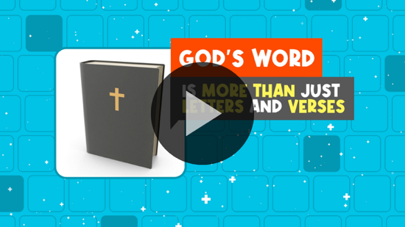

Today, we’ll focus on how the Bible is our guide. What do you think that means? (Allow responses.)

Faith Fact
- Show the Faith Fact Slide or Motion Graphic.

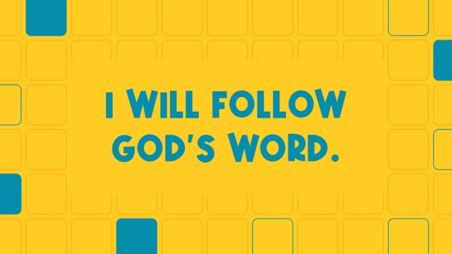

One of the ways the Bible guides us is it helps us know what choices to make. When we follow the rules and instructions found in God’s Word, it helps us make good choices in all areas of our lives. That’s why our Faith Fact today is I will follow God’s Word.

When I hear the word follow, I think about moving. Let’s stand up and say our Faith Fact three times while running in place. I will follow God’s Word. (Group response) Great job!

GAME | Bible Seek and Find
You Will Need | Getting Ready
- Game Pages, one set per group  - Scissors | - Print the Game Pages, one set per group, and cut apart the pictures.  - Hide the Bible pictures in your meeting area before the kids arrive.

- Show the Game Slide or Motion Graphic.


We can find the guidance we need in God’s Word. Psalm 119:105 says that the Bible “is a lamp to guide my feet and a light for my path.” That means that we can look to the Bible for guidance on how we should live and that we should follow what it says. First, we must know what God’s Word says to be able to follow it. That means we need to know where our Bibles are. Do you know where your Bible is right now? (Group response) I hope your Bibles at home aren’t too hidden. For our game, we’re going to do a Bible seek and find.
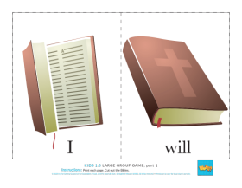

I’ve hidden four pictures of Bibles somewhere in this area. The first people to find them should bring them up here. Ready? Go!
- Give kids time to find the Bible pictures.
- Have the kids who find the Bible pictures stay up front with you.

That was so much fun! Hey, it looks like there are some words on the pages. Can you read them to us?
- Have kids read the words aloud.

What do you think those words mean? (Allow responses.) Let’s put them in the right order.
- Have kids show the Faith Fact to the group.

Say it with me. I will follow God’s Word. That’s a great reminder of what we should always do. Just like we found these Bibles in our game, I hope you know exactly where your Bible is at home. More importantly, remember that God wants you to read it regularly.

WORSHIP

I’m so thankful we get to know God better together. What about you? (Group response) Let’s stand up and spend some time worshipping God together by singing.
- Lead the kids in singing one or two praise songs. See suggestions at the beginning of the session.

BIBLE LESSON | Jesus Teaches about a Firm Foundation (Luke 6:46–49)
You Will Need | Getting Ready
- Hammer or building tool  - Phone  - Headphones | - Find music to play on your phone.

In the Bible, Jesus often shared stories called parables with the people when He taught them. Does anyone know what a parable is? (Allow responses.)

A parable is a story about everyday life, but it has a spiritual meaning. Jesus used parables to teach people how to live for Him. In the parable we’re going to read today, Jesus taught about two men who were each building a house. One house was built to last, but the other wasn’t. Let’s pray and ask God to help us understand how we should live from this parable that Jesus told.

Prayer

Dear God, thank You for helping us understand Your Word. Help us to learn from the examples of the people in the parable Jesus taught many years ago. Amen.

Video Intro

Before we look at the Bible story, let’s watch this video.
- Play the Bible Lesson Video.

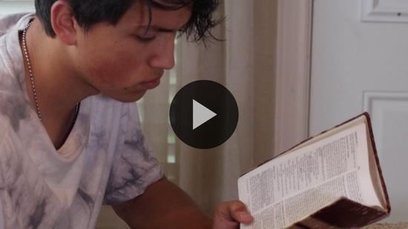

Teaching Time

If we were trying to build a house, what do you think we would need? (Allow responses.) Those are all great answers. Did you know one of the most important things you can do when building a house is to create a strong, firm foundation? That’s the part that the whole house stands on.

In today’s Bible story, Jesus taught about two men who were building houses. Only one of them understood the importance of laying a strong foundation. Grab your Bible or pull up a Bible app on your device. Turn to Luke 6:46–49.
- Read Luke 6:46–49 aloud to the group.
- In order to keep Large Group time moving along, we don’t recommend having the kids read.
- Tell the kids to mark this place with their Theme Bookmark so that they can read it on their own at home.

Why do you think Jesus taught people using this story about building houses? (Allow responses.) I think He wanted to give them a practical example of the importance of a firm foundation. Jesus wasn’t actually trying to teach people how to build a house. He used a story about building to give them an example they would remember of how important it is to build their lives on the strong foundation of God’s Word.

When we follow God’s Word, we’re building our lives on the best foundation we could choose. Let’s say our Faith Fact together. I will follow God’s Word. (Group response)

Here are three things we need to know about following God’s Word:

1. God’s Word helps us make good choices.
- Show the Teaching Point 1 Slide.

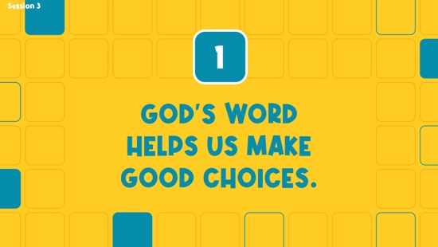

Make your bed. Clean your room. Don’t lie. Eat your veggies. Do your homework. Don’t stay up late playing video games. Don’t watch scary movies. Keep a good attitude. Don’t cheat.

What do all these things I just read have in common? (Allow responses.) They’re all rules or guidelines your parents or teachers might have for you.

Do you like rules? (Group response) Some people love rules, while others think rules are meant to be broken. Rules are very important because they’re meant to help us, guide us, and protect us. Your parents and teachers say all those things to you because they love you and want to see you make the right choices. The same is true about God. You’ll find many good rules inside your Bible. God gives us guidance in His Word to help us make good choices in our daily life.

Can you imagine what life would be like without any rules or laws? It sounds like fun at first, but then you realize that the world would be a very dangerous and chaotic place. For example, imagine if we didn’t have a rule that everyone had to stop at red lights. Drivers could just choose if they wanted to stop or not. Would you feel safe riding in a car? (Group response)

It’s the same with what God wants us to do. He wants to keep us safe and following Him. That’s one reason why it’s important for us to read God’s Word every day. We’re faced with making many choices every day. We can find the wisdom and advice we need to make good choices in the Bible.

2. God speaks through His Word.
- Show the Teaching Point 2 Slide.

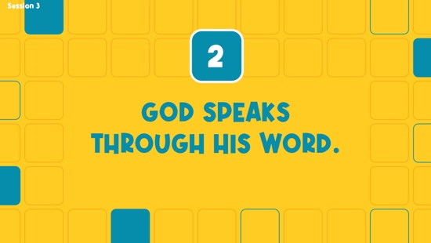

Do you like listening to music? (Group response) Who’s your favorite singer? (Allow responses.) I love listening to music. Whenever I get a chance, I like to play my favorite song. Then, I sing along and do my best moves.
- Play a cheesy song, sing along off key, and add some silly moves.

Sometimes when I try to listen to music, I can’t focus on the words because there are so many distractions. Maybe people are talking in the room or making fun of me, or maybe the TV is on. Distractions can make it tough for me to hear the words of the song. That’s why my favorite way to listen to music is by using my noise-cancelling headphones. They make it so much easier for me to hear music and sing along.
- Put on headphones. Play a cheesy song and sing along off key.

It’s kind of like that when we listen to God. Have you ever wished that you could hear God speak to you? (Group response) I know I have. Some people say they’ve heard God speak to them in a clear voice, but God speaks to us in many different ways. What are some of the ways God can speak to us? (Allow responses.)

Those are some great ways we can hear from God. He sometimes speaks through other people. You might hear something God wants you to know or do today through what I share. We might hear a voice and know the words are from God. Maybe we feel God speaking to us through a certain event that happens. Those are all ways to hear God’s voice. Sometimes, especially when there are distractions, these aren’t the easiest ways to know exactly what God is saying. It can be a little bit like listening to music with the volume turned way down.

If we really want to hear God’s voice, then we need to remove the distractions in our life. We need to find a quiet place where we can focus on God. When we take time every day to go to that place to pray and read the Bible, one of the ways that God can speak to us is through His Word. It helps us focus on what God really wants to say to us.

One of the most consistent ways to hear from God is to spend time reading His Word every day. You might be wondering how an old book that was written thousands of years ago could possibly be God speaking to you today. But the Bible is no ordinary book. Hebrews 4:12 tells us it’s alive and powerful. That means that the words from God found in the Bible are still true for you and me.

3. We must build our life on God’s Word.
- Show the Teaching Point 3 Slide.

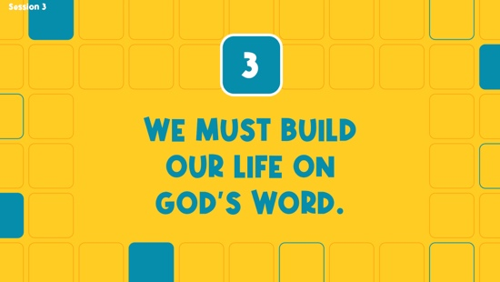

- Hold up a hammer or building tool and pretend to build something while you talk.

Let’s pretend we’re going to build a new church building together. What did we discover in our Bible story is the most important thing we need to get right before we build the rest of the building? (Group response) That’s right. The foundation is the most important step when building a house, a church, or any other building. Why is that? (Allow responses.)

We could put a bunch of time and money into building an incredible church building, but if we skipped the foundation or just made a weak one, it would all be a waste. The first big storm would destroy all our hard work. The same is true in our lives. We sometimes put a lot of our time, energy, and money into things that don’t matter.

A building needs a solid foundation, built on rock or concrete, to stand the test of a storm. Jesus wasn’t really teaching them about a building. He wanted the people to remember what to build their lives on. What should that be? (Group response) We should build our life on the teaching found in God’s Word. That means we have to listen to God’s teaching and follow His Word by living it every day.

PRAYER AND RESPONSE
You Will Need | Getting Ready
- Prayer Station Poster, one per group  - 11x17" paper or card stock  - Foam board  - Glue  - Easel  - Prayer Response Page, one per ten kids  - Scissors  - Clothesline  - Clothespins, one per kid | - Print the Prayer Station Poster on 11x17” paper, one per group.  - Mount the poster on foam board or card stock.  - Place the poster on an easel.  - Print the Prayer Response Page, one per ten kids. Cut apart the page so each kid has one verse.  - Hang the clothesline near the Prayer Station Poster.  - Clip the verses to the clothesline using the clothespins.

Consider playing a worship song softly in the background while kids pray.

Are you willing to commit to building your life on the foundation of God’s Word? Are you ready to follow what God’s Word says no matter what? If you’re ready to make that commitment, I want you to take a brave step right now. Stand up, come to the front of the room, and raise your hands in the air.
- Allow kids to respond and come to the front of the room.

We raise our hands in the air to show God that we’re completely surrendering or giving our life to Him. Now, we’re going to practice listening to His voice. I want you to pause right here. Let’s put our hands on our ears (pause for response) and repeat after me, “God, help me to listen for Your voice.” Let’s put our hands on our mouths like this (place finger at mouth as if to motion “sh” and pause for response) and repeat after me, “God, help me to be quiet, so I can listen to You.” Finally, let’s put our hands on our heart (pause for response) and repeat, “God, help me to know You’re speaking directly to me.” Now, let’s be quiet for just a minute and see what God says.
- Allow a minute to pass.

Sometimes when God speaks, it’s just that still, small thought that we hear in our mind. He might be telling us, “I love you. I’m with you. You’ve got this.” Other times He might tell us to stop doing something that the Bible says is wrong or tells us to apologize for something we did that hurt someone. It takes practice to hear His voice. Pausing and listening like this is something we can do every day to try to hear from Him.
- Optional: Have the kids repeat phrases of the prayer after you.

Prayer

Dear God, thank You for being willing to speak to us. We know You want good things for us. Help us to be ready to listen and follow You. Amen.

Prayer Station
God speaks to us in many ways and at different times. Hearing His voice is something we can practice. Let’s take some time and respond to what we’ve learned.
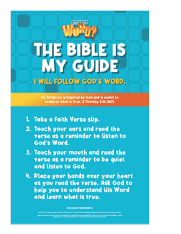
At the prayer station, you’ll see a clothesline and a poster. Attached to the clothesline are slips of paper that have our Faith Verse on them. Read our Faith Verse and ask God to help you to understand His Word and learn what is true and right.
- Read the steps on the Prayer Station Poster aloud if needed.
- Assist younger kids who can’t read the Scripture on their own.
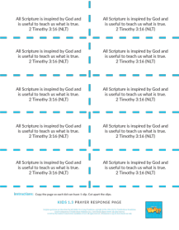
While other kids are at the prayer station, I invite you to pray with a leader about what God spoke to you or about any other need you have today.
- Take time to pray with kids.
- Send the verse home with kids to review.

Optional: Salvation Prayer
Maybe you would like to ask Jesus to come and be in your life. He can forgive you of your sins and give you a fresh start. If you’d like to invite Jesus to be your Lord and Savior, let’s pray together.
- Invite kids to pray with you or have everyone repeat the prayer after you.

Dear Jesus, I believe You came to earth and died on the Cross so I can be forgiven. Please forgive my sins and make me a new person. I want You to be my Lord and Savior. I want to live for You. I believe You came back to life, and now I can live forever with You. Thank You for coming into my life. Amen.

Faith Verse
Our Faith Verse reminds us that God’s Word is filled with teaching that can help guide our life. It’s found in 2 Timothy 3:16. Let’s review it now.
- Show the Faith Verse Video or Slide.

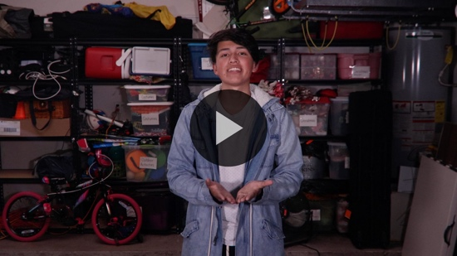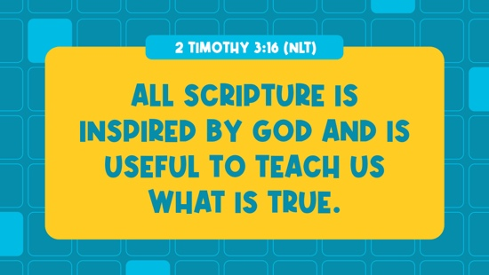

2 Timothy 3:16 (NLT)
All Scripture is inspired by God and is useful to teach us what is true.

Faith Fact
- Show the Faith Fact Slide or Motion Graphic.

When we listen to God’s Word and follow what it tells us, we’re choosing to build a firm foundation in our life. Let’s review our Faith Fact again. I will follow God’s Word.

Stand up and march in place as you say it with me. I will follow God’s Word. (Group response) Remember to build your life on the firm foundation of God’s Word.
- Dismiss kids to Small Group time or to go home if your group time ends here.

SMALL GROUP (30 Minutes)
This section can be done in conjunction with the large group, or on its own if you do small groups with your kids. During Small Group time, the goal is to connect the kids with the Word of God and to each other. All activities are led by the small group leader.

GROUP CONNECTION | Red Light Green Light
You Will Need | Getting Ready
No supplies are needed for this activity. | No prep is needed for this activity.

Today’s game is about listening closely to the leader. In just a moment, you’ll line up side by side. We’re going to play Red Light, Green Light. If the leader says, “Green light,” you’ll take steps forward. If they say, “Red light,” you’ll stop immediately. If they say, “Yellow light,” you’ll walk in slow motion.

Now, if you don’t follow the leader’s commands, you have to go back to the beginning and start over. The first one to get to the leader is the winner. Are you ready to play? (Group response)
- Choose a leader and have kids line up.
- If anyone fails to listen when commands change, send them back to the starting line.
- Let the winner be the leader if you have time to play again.

Faith Fact
- Show the Faith Fact Slide or Motion Graphic.

That was a fun way to practice our Faith Fact. Say it with me. I will follow God’s Word. (Group response)

LEARN ABOUT IT
You Will Need | Getting Ready
- Bibles, 1 per kid (preferably all the same version)  - “Books of the Bible” song by JumpStart3 | - Download “Books of the Bible” song by JumpStart3.

Scripture Search: Joshua 1:7–8; Psalm 119:11; Psalm 119:101–105; Luke 6:48–49

Let’s dig deeper into God’s Word and see what else He has to say about how the Bible should guide us. As we find and read each of these verses, let’s consider: What does this Scripture show us about what God wants us to know about following His Word?

What does it mean for our life today?
- Give each kid a Bible and search for one or more of the Scriptures as a group as time allows. When everyone has found the Scripture, have one of the kids read it. Then, answer the questions about it.
- Pair kids who need additional help with older kids or start simple and look up the session’s Bible story Scripture: Luke 6:46–49. Kids will get better at finding Scriptures the more they practice.
- Optional: Make this a competition to see who can find the Scripture first.

Bible Reading Tip

Here’s a tip for you. Find ways to make sure you don’t forget to read your Bible every day. Place your Bible somewhere in your room where you can always see it like on a nightstand or a dresser. If you have a personal device, download a Bible app and put it on the front screen. Then, you’ll see the Bible app every time you look at your device, and you can read God’s Word on the go. Put a sticky note on the mirror in your room or bathroom that says, “Have you read your Bible today?” to remind you.

Challenge

Do you have a hard time remembering to read your Bible every day? Maybe you feel that there is never enough time because you are too busy to spend time in God’s Word. There is a great way to avoid this problem. Read your Bible first thing in the morning before you do anything else. Don’t leave your bedroom, check your phone, eat breakfast, or get distracted by anything else. If you need to wake up fifteen minutes earlier to make time for it, do it. Take the Bible first challenge this week. See how building your day on God’s Word makes a difference in your life.

While we’re discovering new things about God’s Word, let’s learn all the books in the Bible, too. Let’s sing the “Books of the Bible” song.
- Play the “Books of the Bible” song.

GROUP DISCUSSION

Feel free to use all or just a few questions as a jumping-off place for good discussion. Questions marked with * are designed for more conversation. Adjust the questions based on the age or maturity of your group. Typically, older kids will be able to dive a little deeper than younger ones.
- If small group activities are not immediately following Large Group time, you may want to read the Bible story passage (Luke 6:46–49) before this discussion.

Questions

* Do you have a hard time following instructions? Why or why not?

* What do you like or dislike about rules?

What’s another word for the stories Jesus told?

* What are some ways we can get more of the Bible in our life?

How can God’s Word help us make good choices?

* Do you make better choices after you spend time in God’s Word? Share an example.

* How does God speak to you through the Bible?

What are some other ways God can speak to you?

For additional questions, see the Bible Fact-Pak questions 202, 489. The Bible Fact-Pak resources are available from MyHealthyChurch.com.

Prayer Requests
Finish group discussion by sharing prayer requests and praise reports. Keep track of your small group’s prayer requests and review them each time you meet.

Prayer

Have kids pray for each other’s prayer requests.

FAITH VERSE REVIEW
You Will Need | Getting Ready
- Sticky notes  - Pen | - Write the individual words of the Faith Verse on sticky notes, one set per group.  - Optional: Make multiple sets if the small groups are larger. If your groups are small, divide the verse into phrases to use fewer sticky notes.

Our Faith Verse for today is 2 Timothy 3:16. It tells us that the Bible is from God and helps us know the truth. It’s a great guide to show us how to live our life. Let’s watch the video and do the actions for the verse together.
- Show the Faith Verse Video or Slide.

2 Timothy 3:16 (NLT)
All Scripture is inspired by God and is useful to teach us what is true.

Let’s review our Faith Verse as a group again. Try to memorize it as best as you can because you will need to know it for the Faith Verse game.
- Say the verse as a group a couple of times.

Who thinks they know the Faith Verse and would like to say it to the group? (Allow responses.)

Faith Verse Fun | Sticky Verse

You’re going to work together as a group to help each other put the Faith Verse in order. Here’s the catch, the words for the verse will be stuck on your foreheads. You won’t be able to remove your own sticky note to read the word(s). You’ll have to rely on each other to get in the correct order of the verse.
- If you have fewer kids than sticky notes, place two sticky notes with adjacent words/phrases of the verse on each kid’s forehead.

ACTIVITY PAGE | Journey to God’s Word
You Will Need | Getting Ready
- Activity Page, one per kid  - Pencils or pens, one per kid | - Print the Activity Page, one per kid.
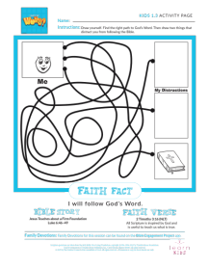

What’s our Faith Fact? (Group response) I will follow God’s Word. Sometimes it’s easy to be distracted by the things of this world and find yourself on the wrong path. When we get distracted, we must return to God’s Word and begin the journey of following it again. Today’s Activity Page is a reminder that we need to stay focused on God’s Word. On your Activity Page, find the right path to the Bible.
- Give each kid a copy of the Small Group Activity Page and a pencil.

This page had some paths that didn’t lead to the Bible. It’s important for us to be aware of what gets in our way of following God’s Word. What are some things that can distract us? (Allow responses.) At the end of other paths, draw things that can distract you from following God’s Word.

DISMISSAL

Thanks for joining me as we learned that God wants us to build the foundation of our lives on His Word, the Bible. Let’s close in prayer.

Prayer

Dear God, thank You for forgiving me when I get distracted by other things. Help me to focus on Your Word and follow it for the rest of my life. Amen.

Faith Fact Recap
- Display the Faith Fact Slide or Motion Graphic as parents are coming into the room.

One very important thing to remember from today is our Faith Fact. Let’s say it together: I will follow God’s Word. See you next time.
- Send home the Activity Page and Prayer Response items.
- Remind parents that there are Family Devotions available on the app to do with their kid.
- Tell everyone the date and time for the next session.

