LEADER OVERVIEW

Volume Overview—Run the Race
In these sessions, kids will discover that God has a plan for each one of them and the importance of listening to and doing what God says. They will also learn about the hope of Jesus’ return and what it will be like to live with God forever.

SESSION 1: Timothy Learns from Paul—  2 Timothy 3:10–17  Faith Fact: God has a plan for me. | SESSION 2: Faith and Works—  James 1:19–27; 2:14–26  Faith Fact: God wants me to take action.
SESSION 3: Jesus Is Coming Back—  1 Thessalonians 4:13–18; 5:1–11  Faith Fact: Jesus is coming back. | SESSION 4: New Heaven and New Earth— Revelation 21:1–10, 21–27  Faith Fact: I can live with God forever.

SESSION OVERVIEW

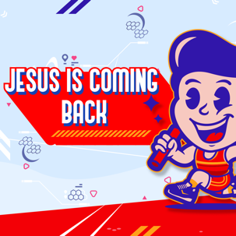
In this session, preschoolers discover that Jesus is coming back. As believers, this is one of the most exciting things about our faith. We know that what we do every day is not in vain. Someday our Lord and Savior Jesus Christ will come back, and we will meet Him face-to-face. Part of being a believer is being vigilant. Because we don’t know when it will happen, we are instructed in Scripture to watch for His arrival and always be ready. Use this time to help your preschoolers remember to keep serving Jesus and loving Him because He will come back for them soon.

Bible Lesson | Faith Fact
Jesus Is Coming Back  1 Thessalonians 4:13–18; 5:1–11 | Jesus is coming back.
Faith Verse
Philippians 3:14 (NLT)
I press on to reach the end of the race and receive the heavenly prize
for which God, through Christ Jesus, is calling us.

Bible Engagement Project Preschool curriculum is connected with the intentional, yearlong ministry strategy for kids available at KidminRoadmap.com.
PREPARING FOR THE SESSION
You Will Need | Getting Ready
Preservice Activities  - Three large plastic cups  - Items to hide under the cups (marble, marshmallow, toy car, etc.)  - Cereal  - Small marshmallows  - Small cups, one per kid  Large Group  - Bible  - Worship songs (Song suggestions: “On the Board with the Lord” by Jana Alayra; “Who You Say I Am” by Hillsong Kids)  - For groups not using a phone or tablet only, add:  - Projector or TV  - Laptop  - Countdown 5-Minute Video  - Theme Intro Video  - Bible Lesson Video A  - Bible Lesson Video B  - Faith Fact Sound video (bell ringing)  - Faith Fact Slide or Motion Graphic  - Faith Verse Slide or Motion Graphic  Small Group  - Trumpet Sound Video  - Small Group Activity Page, one per kid  - Crayons  - Small Group Hands-On Learning Page, one per kid plus an extra  - Card stock, one sheet for every two kids  - Markers or crayons  - Stickers, optional  - Tape  - Scissors | Preservice Activities  - Set out toys and snacks.  Large Group  - Download videos and slides if needed.  - Select worship song(s) and have them ready to play.  Small Group  - Print copies of the Small Group Activity Page, one per kid.  - Print copies of the Small Group Hands-On Learning Page, one per kid plus an extra. Cut out the trumpet bell for each kid.  - Cut the sheets of card stock in half lengthwise to make two strips, one strip per kid.  - Make a sample trumpet from the Small Group Hands-On Learning Page.  Optional: Use empty paper towel roll tubes instead of card stock.

Check out all the promotional and extra media files available for this theme. To access Bible Engagement Project from a computer, visit App.BibleEngagementProject.com.

PRESERVICE ACTIVITIES (30 Minutes)
See what’s needed at the beginning of the session.

Bible Story Warm-Up
How many cups do I have here? Can you help me count? 1, 2, 3 cups! I have this marble that I’m going to hide under one of the cups. After I mix up the cups, you will guess which cup the marble is hiding under. Ready? Now, when I place this marble under the cup, does that mean the marble is gone because you can’t see it? (Group response) You’re right, it is still there. Can you guess which cup it is under? (Allow responses.) Here it is.

When Jesus went back to heaven, did that mean He was gone forever? No, He is in our hearts, too. Just like when we hid the marble under the cup and you couldn’t see it anymore, we can’t see Jesus since He went to heaven. But, just as you knew the marble was still under the cup, we know Jesus is still with us. Just as we could see the marble when we chose the right cup, we know that Jesus is coming back.

Snack: Cereal Surprise
Serve cereal as a snack. Before you fill each cup, place a small marshmallow in the bottom.

Friends, we have a special snack today. As you are eating your snack, look for a special surprise. Today, we are learning about watching for Jesus’ return.

Free Play
Any extra time can be spent playing with toys.

LARGE GROUP (25 Minutes)
See what’s needed at the beginning of the session.

INTRODUCTION
- Optional: Play the Countdown 5-Minute Video.
- Use this time to pick up toys and transition to the large group area.



Welcome
Hi, kids! Who is excited to learn about Jesus today? How are we going to learn about Jesus? (Group response) That’s right! We learn about Him from God’s Word, the Bible. (Hold up the Bible.) Each story in the Bible tells us something about God, and today, we will discover that Jesus is coming back. If you are ready to start our story, look at me like it's a really sunny day. (Place one hand perpendicular to your forehead just above your eyes to shade them like you would on a sunny day.) I see lots of kids looking at me in our very bright room. You must be ready to get started.
- Play the Theme Intro Video.



BIBLE TIME | Jesus Is Coming Back (1 Thessalonians 4:13–18; 5:1–11)

Bible Video A
God’s Word is so important for our life. It is important that we take time to see what the Bible tells us. Today, we will hear that Jesus is coming back. Lizzy will help us with that. Let’s check in with her now.
- Play Bible Lesson Video A.

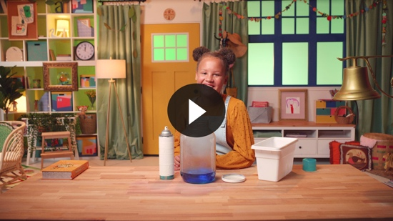

Faith Fact

That was very cool! You did a great job helping Lizzy solve all the clues. Can you show me how you play a trumpet? (Group response) We learned that Jesus is coming back and that we need to be watching for His return. God gave us the Bible so that we would have instructions for our lives, and one of those instructions was to watch for Jesus’ return. This is awesome news.
  - Play the Faith Fact Sound video.

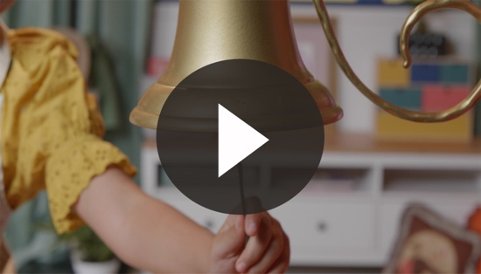

- Show the Faith Fact Slide or Motion Graphic.



Did you hear that sound? (Group response) You know what it means, right? That means it’s time to say the Faith Fact. Say it with me. Jesus is coming back. Great job, friends!

WORSHIP
Let’s spend some time singing songs and thanking God for His Word!

Praise
Are you glad God made you and me? Wave your hands up high. (Group response)
Are you glad Jesus is alive? Wave your hands down low. (Group response)
Are you glad Jesus is coming back for us? Spin in a circle to the right. (Group response)
Who wants to thank God? Do three jumping jacks. (Group response)

Prayer
You are so much fun! Now let’s bow our heads and pray. Say this prayer after me.

Dear God, thank You for Jesus. Thank You for sending Your Son to earth. Thank You that someday He will come back for me and everyone who follows Him! Amen.

Sing
One way to give God thanks is worshipping Him by singing. Let’s sing a couple of songs.
- Lead the kids in singing one or two songs. See suggestions at the beginning of the session.

BIBLE TIME continued | Jesus Is Coming Back (1 Thessalonians 4:13–18; 5:1–11)

Bible Video B
Now we’re all warmed up. Let’s check back in with Lizzy. I wonder if her grandpa is home.
• Play Bible Lesson Video B.

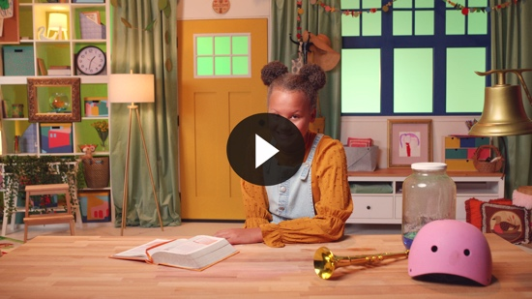

A surprise party for Grandpa? That sounds like fun. Lizzy and Grandpa have really been fun to spend time with. Now, it’s time to practice saying our Faith Verse and doing the actions. Time to stand up on your feet with me. Awesome!

Faith Verse
- Show the Faith Verse Slide or Motion Graphic.

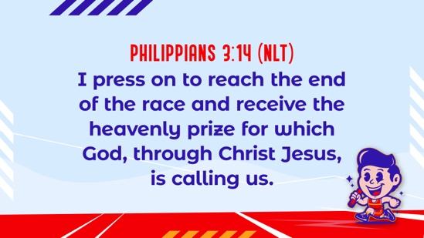

Philippians 3:14 (NLT)
I press on to reach the end of the race and receive the heavenly prize for which God, through Christ Jesus, is calling us.
Hey, you have done such a good job learning our Faith Verse. It’s important for us to learn God’s Word, so we can hide it in our minds and hearts forever.
Response Time

Consider playing a worship song softly in the background while kids pray.

Today we have talked about how one day Jesus will return, and we are to watch and wait! Isn’t that so exciting? (Group response) Until then, we are to love God and others. What are some things you can do to show love as you wait for Jesus to return? (Allow responses.)

Closing
What a fun time we had today! We’ve learned that Jesus is coming back. And we learned how to be ready for His return. We’ve worshipped God by praising, praying, and singing. We are doing so well with our Faith Verse, too. You are so amazing. It’s been such a fun day.
  - Play the Faith Fact Sound video.

- Show the Faith Fact Slide or Motion Graphic.

Do you remember what we’re supposed to do? (Shout out the Faith Fact.) Let’s say our Faith Fact now. Jesus is coming back. Let’s whisper it in our softest voice. Jesus is coming back. Now, let’s shout it as loud as we can. Jesus is coming back.

Great job, friends!

Dismissal to Small Groups
Now it’s time to head to small group with your friends and do some more fun activities.
- Dismiss the kids by groups.

Leader Tip: This can be done by assigning colors to teams or by age groups. Note that some preschoolers may not know their age. Using a colored sticker, jersey, or wristband will help separate the kids and help identify their small groups.

SMALL GROUP (25 Minutes)
See supplies and prep instructions at the beginning of the session or in each activity below.

Leader Tip: All groups can do each activity at the same time. If you choose to rotate, you will need at least one leader per group.

Circle 1

GROUP CONNECTION

Watch to See
You Will Need | Getting Ready
- Trumpet Sound Video | No prep is needed for this activity.

Goal: Kids will be reminded about the Bible story and to be ready for Jesus’ return.

Today, we learned that we should be watchful for Jesus’ return. Does anybody remember what sound we will hear when Jesus comes back? (Allow responses.) That’s right! We will hear a trumpet sound. Right now, we will practice. We will be very quiet, and when you hear a trumpet sound, jump up as fast as you can and yell our Faith Fact. Do you remember what it is? Jesus is coming back. Are you ready?
- Play the Trumpet Sound Video multiple times, giving kids a chance to say the Faith Fact.

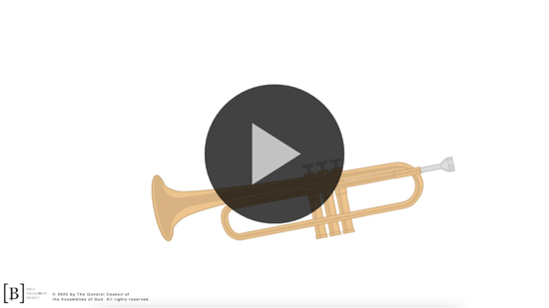

Remember that we need to be watching and waiting for Jesus to come back.

Circle 2

ACTIVITY PAGE TIME

I’m Watching Craft
You Will Need | Getting Ready
- Activity Page, one per kid  - Crayons | - Print copies of the Activity Page, one per kid.
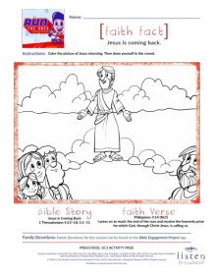
Goal: Kids will picture themselves ready and waiting for Jesus’ return.

Let’s see how beautifully you can color this picture of Jesus returning. Can you draw yourself on your picture watching for Jesus? Take time to draw your family in the picture too.

Circle 3
FEET-TO-FLOOR GAME TIME

Watchful Eyes
You Will Need | Getting Ready
No supplies are needed for this activity. | No prep is needed for the activity.

Goal: Kids will play an active game that reinforces our need to be watchful.

We are going to play a game. We’ll divide the group into two teams and line up. You can cheer for your team. The kid at the front of the line will run to the other side of the room and touch the wall (or give a leader a high five). Then, the kid will run back and tag the next friend in line. When that person is tagged, it is their turn to go. The first team to get all their friends back in place wins.

Those waiting in line must watch carefully for your friends to come back for the game. This is the same way we watch for Jesus to come back.
- You can switch it up and have kids do turns, tiptoe, crawl, hop, etc.
- Repeat as time allows.

Circle 4

HANDS-ON LEARNING

Trumpet
You Will Need | Getting Ready
- Hands-On Learning Page, one per kid plus an extra  - Card stock, one sheet for every two kids  - Marker or crayons  - Stickers, optional  - Tape  - Scissors | - Print copies of the Hands-on Learning Page, one per kid plus an extra. Cut out the trumpet bell for each kid.  - Cut the sheets of card stock in half lengthwise to make two strips, one strip per kid.  - Make a sample trumpet from the Hands-On Learning Page.  Optional: Use empty paper towel roll tubes instead of card stock.

Goal: Kids will create a tangible reminder that Jesus is coming back and engage their imagination.

We’re going to make something to remind us of our Bible story.
- Give each kid a card stock strip and cut-out trumpet bell from the Hands-On Learning Page.

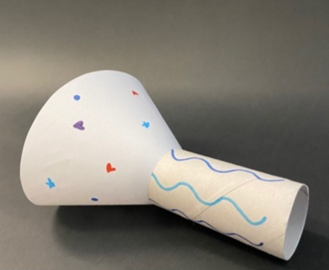
Look at your items and think about the story. What do you think we are going to make? (Group response) We are going to make a trumpet like this one. (Show sample.) When we hear the trumpet sound from heaven, who will be coming back? (Group response) Decorate your trumpet so you can always remember that Jesus is coming back.
- Help kids tape the trumpet bell shape into a cone and the card stock into a tube. Then, help them tape the cone and cylinder together to create a trumpet.
- You can roll the card stock into a cylinder to make it long or short.

FAITH FACT RECAP
- Display the Faith Fact Slide or Motion Graphic as parents are coming into the room.
- Maximize the time you have with your kids, so that parents see what their kids have learned. Have the kids repeat the Faith Fact, and then dismiss them to their parents.

One thing I want you to remember from today is our Faith Fact. Let’s say it together. Jesus is coming back.

DISMISSAL
- Send home the Activity Page and the trumpet with each kid.
- Remind parents that there are Family Devotions available on the app to do with their kid.
- Tell everyone the date and time for the next session.

