LEADER OVERVIEW

Volume Overview—Run the Race
In these sessions, kids will discover that God has a plan for each one of them and the importance of listening to and doing what God says. They will also learn about the hope of Jesus’ return and what it will be like to live with God forever.

SESSION 1: Timothy Learns from Paul—  2 Timothy 3:10–17  Faith Fact: God has a plan for me. | SESSION 2: Faith and Works—  James 1:19–27; 2:14–26  Faith Fact: God wants me to take action.
SESSION 3: Jesus Is Coming Back—  1 Thessalonians 4:13–18; 5:1–11  Faith Fact: Jesus is coming back. | SESSION 4: New Heaven and New Earth— Revelation 21:1–10, 21–27  Faith Fact: I can live with God forever.

SESSION OVERVIEW

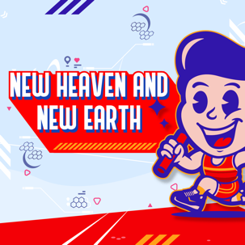
In this session, preschoolers discover that I can live with God forever. Preschoolers need to know that the earth as we know it is not our permanent home. Someday when Jesus comes back, Christians will live with Him in a new home, a new earth. That new home will be amazing and will be centered on a beautiful holy city, the New Jerusalem. We serve a God who always was and always will be. God gave us the gift of eternal life and wants us to spend forever with Him.

Bible Lesson | Faith Fact
New Heaven and New Earth  Revelation 21:1–10, 21–27 | I can live with God forever.
Faith Verse
Philippians 3:14 (NLT)
I press on to reach the end of the race and receive the heavenly prize
for which God, through Christ Jesus, is calling us.

Bible Engagement Project Preschool curriculum is connected with the intentional, yearlong ministry strategy for kids available at KidminRoadmap.com.
PREPARING FOR THE SESSION
You Will Need | Getting Ready
Preservice Activities  - Interlocking building blocks or plastic blocks  - Graham crackers  Large Group  - Bible  - Worship songs (Song suggestions: “God Made Everything” by The Village Kids; “Creation Song” by Saddleback Kids)  - For groups not using a phone or tablet only, add:  - Projector or TV  - Laptop  - Countdown 5-Minute Video  - Theme Intro Video  - Bible Lesson Video A  - Bible Lesson Video B  - Faith Fact Sound video (bell ringing)  - Faith Fact Slide or Motion Graphic  - Faith Verse Slide or Motion Graphic  Small Group  - Ball  - Small Group Activity Page, one per kid  - Crayons  - Craft jewel stickers  - Floor-safe tape  - Small Group Hands-On Learning Page, one per four kids plus an extra  - Card stock  - Lengths of fabric ribbon, one per kid plus an extra  - Hole punch  - Marker  - Crayons | Preservice Activities  - Set out toys and snacks.  Large Group  - Download videos and slides if needed.  - Select worship song(s) and have them ready to play.  Small Group  - Print copies of the Small Group Activity Page, one per kid.  - Make a large circle on the floor with the floor-safe tape.  - Print copies of the Small Group Hands-On Learning Page, one per four kids plus an extra.  - Cut out the medals and punch a hole in each medal.  - Cut lengths of fabric ribbon, one per kid plus an extra.  - Make a sample of the Small Group Hands-On Learning Page winner’s medal.

Check out all the promotional and extra media files available for this theme. To access Bible Engagement Project from a computer, visit App.BibleEngagementProject.com.

PRESERVICE ACTIVITIES (30 Minutes)
See what’s needed at the beginning of the session.

Bible Story Warm-Up
Set up a station where the kids can build a city from interlocking plastic blocks or building blocks. As they build, ask them these questions:

Where is Jesus right now?
Is He coming back for us one day?
How long will we live after He comes back for us?

One day, God will make a wonderful new earth. We can have a new home there with Him, too. On that new earth, He will put a beautiful and special city. It will be the most beautiful place you have ever seen. It won’t be made of wood or blocks like our town, but of gold and gems. Someday we can see it on the new earth where we can live with God forever.

Snack: Graham Cracker Walls
Before they begin to eat, show kids how to build a wall with the crackers. Talk about the wall around the special city, which will be made of jasper, and about the city, which will be made of gold.

Free Play
Any extra time can be spent playing with toys.

LARGE GROUP (25 Minutes)
See what’s needed at the beginning of the session.

INTRODUCTION
- Optional: Play the Countdown 5-Minute Video.
- Use this time to pick up toys and transition to the large group area.



Welcome
Hi, kids! Who is excited to talk about God today? How are we going to learn about Him? (Group response) That’s right, we will hear about God from His Word, the Bible. (Hold up the Bible.) Each story in the Bible tells us something about God, and today, we will discover that I can live with God forever. Give your neighbor a high five if you’re ready to get started.
- Play the Theme Intro Video.



BIBLE TIME | New Heaven and New Earth (Revelation 21:1–10, 21–27)

Bible Video A

Let’s check in with Lizzy and her grandpa.
- Play Bible Lesson Video A.

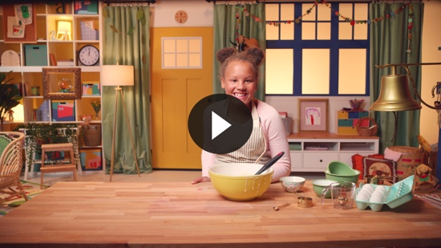

It’s always fun practicing the Faith Verse with Lizzy. I’m guessing her cake turned out great. I can’t wait to find out. While we’re waiting, let’s review the Faith Verse.

Faith Verse
- Show the Faith Verse Slide or Motion Graphic.

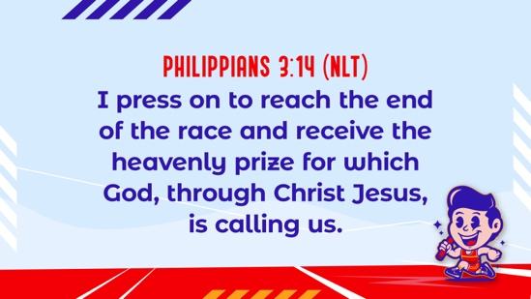

Philippians 3:14 (NLT)
I press on to reach the end of the race and receive the heavenly prize for which God, through Christ Jesus, is calling us.

You did such a good job memorizing our Faith Verse. I’m so proud of you!

WORSHIP
Let’s spend some time singing songs and thanking God for His Word!

Praise
Are you glad God made you and me? Clap once over your head. (Group response)
Are you glad He is coming back? Clap once down by your feet. (Group response)
Are you glad we get to live with God forever? Clap once on the right side. (Group response)
Who wants to thank God? Clap once on the left side. (Group response)

Are you ready to tell God thank you? If so, give me one clap and hold your hands together so we can pray.

Prayer
Now we’ll all bow our heads and pray.

Dear God, thank You for Your Word. Thank You that someday we will get to live with You forever! Amen.

Sing
One way to give God thanks is worshipping Him by singing.
- Lead the kids in singing one or two songs. See suggestions at the beginning of the session.

BIBLE TIME continued | New Heaven and New Earth (Revelation 21:1–10, 21–27)

Bible Video B
I know God loves listening to you worship Him. Now, who’s ready to see how Lizzy’s cake turned out? (Group response) Me too!
• Play Bible Lesson Video B.

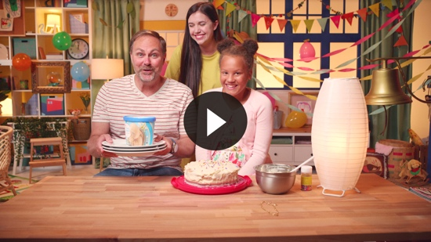

I love that God gave us the Bible. It helps to know that when Jesus returns, we will live forever with Him in a new home. We just need to keep living for Him every day and running the race.

Faith Fact
  - Play the Faith Fact Sound video.

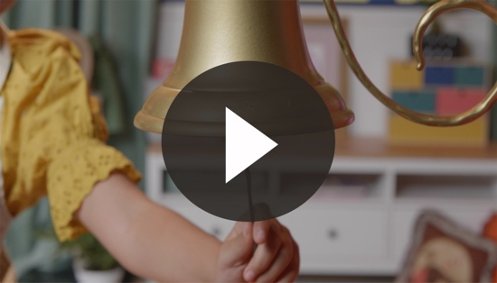
- Show the Faith Verse Slide or Motion Graphic.



That sound means it’s time to practice our Faith Fact. Today’s Faith Fact is I can live with God forever. Can you say that with me on the count of three? 1, 2, 3. I can live with God forever. So good!

Response Time

Consider playing a worship song softly in the background while kids pray.

Today we have talked about how we can live with God forever. Isn’t that so exciting? (Group response) We are to love God and others. How can you show love as you wait for the new earth? (Allow responses.)

Father, help us to always look forward to the day when we will be with You forever. Help us to always be ready for that day and to encourage others to be ready too!

Closing
Did you have fun today, kids? We’ve heard that I can live with God forever. We also heard about heaven, a new earth, and even a beautiful city. We’ve worshipped God by praising, praying, and singing. We’ve worked on our Faith Verse, too. You kids are all rock stars. I know God is so proud of the way you joined in today.
  - Play the Faith Fact Sound video.

- Show the Faith Fact Slide or Motion Graphic.

Do you remember what we’re supposed to do when we hear that sound? Let’s shout our Faith Fact now. I can live with God forever. Great job, friends!

Dismissal to Small Groups
Now it’s time to head to small group with your friends and do some more fun activities.
- Dismiss the kids by groups.

Leader Tip: This can be done by assigning colors to teams or by age groups. Note that some preschoolers may not know their age. Using a colored sticker, jersey, or wristband will help separate the kids and help identify their small groups.

SMALL GROUP (25 Minutes)
See supplies and prep instructions at the beginning of the session or in each activity below.

Leader Tip: All groups can do each activity at the same time. If you choose to rotate, you will need at least one leader per group.

Circle 1

GROUP CONNECTION

Getting to Know You
You Will Need | Getting Ready
- Ball | No prep is needed for this activity.

Goal: Kids will learn about their friends in the group and practice the Faith Fact.

Let’s all sit on the floor in a circle. Today we are going to get to know our friends in this circle. We will pass the ball to the person on our right. Do you know which hand is your right hand? (Group response) When the ball is passed to you, say your name and one thing about yourself. Or you can say the Faith Fact. Who remembers the Faith Fact today? (Group response) That’s right, I can live with God forever.
- When everyone has said something about themselves or the Faith Fact, have the kids practice saying the Faith Fact together.

Circle 2

ACTIVITY PAGE TIME

A Beautiful City
You Will Need | Getting Ready
- Activity Page, one per kid  - Crayons  - Craft jewel stickers | - Print copies of the Activity Page, one per kid.
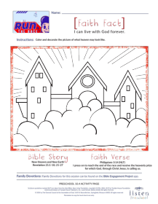
Goal: Kids will color and decorate a page as they imagine what heaven will be like.

Let’s see how beautifully you can color this picture of heaven. Then, we will decorate the walls with the jewel stickers.
- Read the description of the city in Revelation 21:21–27.
- Help kids with the stickers as needed.
- At some point during the activity, interrupt and practice the Faith Fact: I can live with God forever.
  - Play the Faith Fact Sound video.

- Show the Faith Fact Slide or Motion Graphic.

Say it with me: I can live with God forever. I’m so glad that I can live with Him forever!

Circle 3
FEET-TO-FLOOR GAME TIME

Forever Circle
You Will Need | Getting Ready
- Floor-safe tape | - Make a large circle on the floor with floor-safe tape.

Goal: Kids will play an active game to help them understand the concept of forever.

We are going to play a game called Forever Circle. Everyone will stand on the line of the circle. When I say, “Go,” I want you to start walking around the circle until you reach the end of the circle.
- As the kids begin to walk around the circle, ask, “Are you at the end yet?”
- Help them to realize that there is no end to a circle.
- Keep playing over and over trying to find the end of the circle.

This circle is like our Faith Fact: I can live with God forever. It goes on forever.

Circle 4

HANDS-ON LEARNING

The Prize
You Will Need | Getting Ready
- Hands-On Learning Page, one per four kids plus an extra  - Card stock  - Lengths of fabric ribbon, one per kid plus an extra  - Hole punch  - Marker  - Crayons | - Print copies of the Hands-On Learning Page on card stock, one per four kids plus an extra.  - Cut out the medals and punch a hole in each medal.  - Cut lengths of fabric ribbon, one per kid plus an extra.  - Make a sample of the winner’s medal.
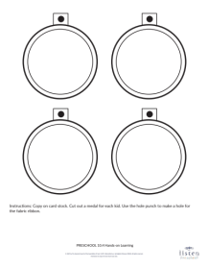
Goal: Kids will create a winner’s medal to remind them to press on to the heavenly prize.

Our Faith Verse talks about finishing the race. Have you ever seen a race? What does the winner get? (Allow responses.) The winner receives a medal kind of like this. (Show the sample craft.) When we finish our race for God, we will receive a heavenly prize. Isn’t that exciting? (Group response) For now, let’s create our own medals to remind ourselves to finish the race.
- Give each kid a medal with a hole punched where the solid black circle is.
- Help them write their names with a marker on the back.
- Have the kids color their medals.
- Give each kid a length of ribbon. Help them thread their medal onto the ribbon to tie them around their neck.

FAITH FACT RECAP
- Display the Faith Fact Slide or Motion Graphic as parents are coming into the room.
- Maximize the time you have with your kids, so that parents see what their kids have learned. Have the kids repeat the Faith Fact, and then dismiss them to their parents.

One thing I want you to remember from today is our Faith Fact. Let’s say it together. I can live with God forever.

DISMISSAL
- Send home the Activity Page and the Hands-On Learning winner’s medal with each kid.
- Remind parents that there are Family Devotions available on the app to do with their kid.
- Tell everyone the date and time for the next session.

