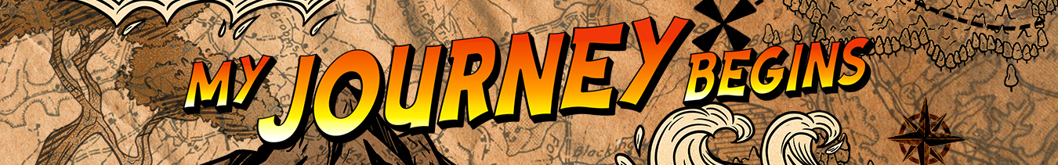LEADER OVERVIEW

Volume Overview—My Journey Begins
In these sessions, kids will learn about the promise fulfilled through the empowerment of the Holy Spirit and how the Early Church came together and grew. They will look at the change that happens when they recognize Jesus as Lord and know that God is always with them.

SESSION 1: Baptism in the Holy Spirit—  Acts 1:8; 2:1–12  Faith Fact: The Holy Spirit empowers me. | SESSION 2: The Church Begins—  Acts 2:42–47  Faith Fact: The church helps me grow.
SESSION 3: Saul’s Conversion—  Acts 9:1–22  Faith Fact: God changes my life. | SESSION 4: Paul and Silas in Prison—  Acts 16:16–34  Faith Fact: With God, I am never alone.

SESSION OVERVIEW

In this session, preschoolers will discover that Paul and Silas were traveling and telling others that God loved them. Even though they didn’t do anything wrong, they were thrown into prison. While they were in prison, God was with them. When they were worshipping God, He swung the prison doors open. Kids will learn that with God, they are never alone.

Bible Lesson | Faith Fact
Paul and Silas in Prison  Acts 16:16–34 | With God, I am never alone.
Faith Verse
Acts 1:8 (NLT)
“But you will receive power when the Holy Spirit comes upon you. And you will be my witnesses, telling people about me everywhere—in Jerusalem, throughout Judea, in Samaria, and to the ends of the earth.”

Bible Engagement Project Preschool curriculum is connected with the intentional, yearlong ministry strategy for kids available at KidminRoadmap.com.
PREPARING FOR THE SESSION
You Will Need | Getting Ready
Preservice Activities  - Building blocks  - Table  - Pretzel sticks  Large Group  - Bible  - Worship songs (Song suggestions: “Fruit of the Spirit” by KidSpring; “Holy Spirit” by Worship Together Kids)  - For groups not using a phone or tablet only, add:  - Projector or TV  - Laptop  - Countdown 5-Minute Video  - Theme Intro Video  - Bible Lesson Video A  - Bible Lesson Video B  - Faith Fact Sound video (bell ringing)  - Faith Fact Slide or Motion Graphic  - Faith Verse Slide or Motion Graphic  Small Group  - Small Group Group Connection Page, one per kid plus an extra  - Flashlight  - Crayons  - Small Group Activity Page, one per kid  - Scissors  - Glue Sticks  - Black construction paper  - Musical instruments or items that make noise, one per kid  - Music player (stereo, phone, etc.)  - Kids worship music (preferably songs used in Large Group)  - Small Group Hands-On Learning Page, one per kid plus an extra  - Stapler | Preservice Activities  - Set out toys and snacks.  Large Group  - Download videos and slides if needed.  - Select worship song(s) and have them ready to play.  Small Group  - Print copies of the Small Group Group Connection Page, one per kid plus an extra. (Print the two pages double-sided, if possible.)  - Print copies of the Small Group Activity Page, one per kid.  - Cut thin strips of black construction paper, the size of the bars in the Activity Page picture, seven bars per kid.  - Print copies of the Small Group Hands-On Learning Page, one per kid plus an extra. Cut apart the strips and make a sample.

Check out all the promotional and extra media files available for this theme. To access Bible Engagement Project from a computer, visit App.BibleEngagementProject.com.

PRESERVICE ACTIVITIES (30 Minutes)
See what’s needed at the beginning of the session.

Bible Story Warm-Up
Start building a tower of blocks on the table and ask kids to help you. Then, to get the kids thinking about today’s Bible story, ask questions like those below.

This is a pretty cool tower. I wonder what would happen if we shook the table. What do you think will happen? (Allow responses.) Let’s shake the table and see. (Pause for kids to help you shake the table.)

Wow! Our building fell down! Today, we are going to hear a story about two men who were in prison when an earthquake shook their chains free and opened their cell door. It reminded them that with God they are never alone.

Do you remember who was in our last Bible story? (Group response) That’s right! It was about Saul. Sometimes, Saul used the name Paul just like you may have a nickname or use your middle name.

Today’s Bible story is about Paul and his friend Silas. Do you have a good friend? (Group response) Paul and Silas had some hard times and sometimes felt alone. Do you ever feel alone? (Group response) We can all feel alone sometimes. Do you know who is always with us even though we can’t see Him? (Allow responses.) You’re right! With God, you are never alone. You can talk to Him anytime and anywhere. You can ask Him for help, and He will help you.

Before we hear our Bible story, let’s have a snack.

Snack: Pretzel Sticks
For our snack, we are going to eat pretzel sticks. If you line up pretzel sticks in a row, they look like prison bars. Do you want to try? (Pause for kids to line up their pretzel sticks.) Good job! Today, we are going to hear how God was with Paul and Silas in prison. God helped them, and He helps us today.
- Be sure to line up some pretzel sticks to look like prison bars to show the kids.

Let’s eat our yummy snack.

Free Play
Any extra time can be spent playing with toys.

LARGE GROUP (25 Minutes)
See what’s needed at the beginning of the session.

INTRODUCTION
- Optional: Play the Countdown 5-Minute Video.
- Use this time to pick up toys and transition to the large group area.



Welcome
Hi, boys and girls. I am so excited that you are here! Today, we are going to hear about Paul and Silas from a story in God’s Word, the Bible. (Hold up the Bible.) Paul and Silas went through tough times, but God was with them. They were never alone. And guess what our Faith Fact is for today? With God, I am never alone. Do you want to learn more about Paul and Silas? (Group response) It’s going to be fun.
- Play the Theme Intro Video.

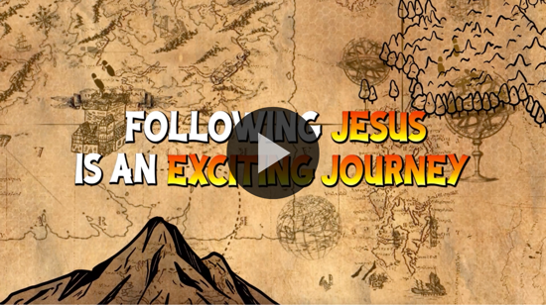

BIBLE TIME | Paul and Silas in Prison (Acts 16:16–34)

Bible Video A
I am so thankful that God is always with us. We never have to worry about being alone. Are you excited about checking in with Lizzy? (Group response) Me too! Let’s see what fun she has in store for us today.
- Play Bible Lesson Video A.

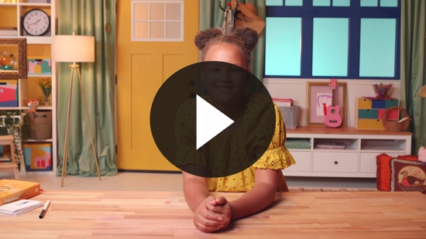

It’s not fun when you feel left out and alone. I am glad Lizzy cheered up a little when she reviewed the Faith Verse together with her friends. Now let’s talk about today’s Faith Fact.

Faith Fact
  - Play the Faith Fact Sound video.

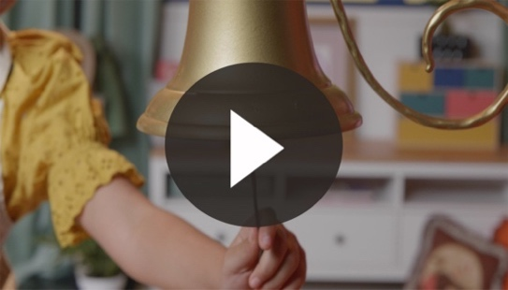

- Show the Faith Fact Slide or Motion Graphic.

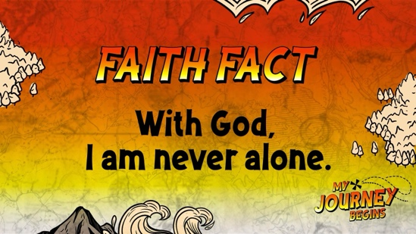

Was that the Faith Fact sound? (Group response) Every time we hear it, we have a Faith Fact to say. Our Faith Fact today is with God, I am never alone. Can you say it with me? (Group response) Good job, everyone!

WORSHIP
I’m so thankful that with God we are never alone. Let’s take some time to thank God for always being with us!

Praise
Are you glad that with God you are never alone? Wave your hands up high. (Group response)
Are you glad God helps us? Wave your hands down low. (Group response)
Are you glad God loves you? Wave your hands up high. (Group response)
Who wants to thank God? Wave your hands down low. (Group response)
Who wants to thank God for listening to our prayers? Wave your hands down low. (Group response)

Prayer
Let’s pray and talk to God. You can say the words after me.

Dear God, help me to remember that I’m never alone because You are with me. Thank You so much for always being there. Amen.

Sing
Great job, kids! Who wants to give God thanks by worshipping Him? (Group response) Jump to your feet. Let’s worship God together by singing.
- Lead the kids in singing one or two songs. See suggestions at the beginning of the session.

BIBLE TIME continued | Paul and Silas in Prison (Acts 16:16–34)

Bible Video B
I just know God loves listening to you worship Him. Now, let’s take a seat and check back in with Lizzy to see how she is doing.
• Play Bible Lesson Video B.

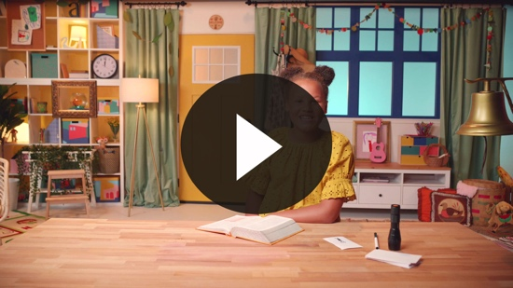

Wow! That Bible story was so powerful. It reminds me of our Faith Verse because Paul and Silas were going to lots of places to tell people about Jesus. Are you ready to practice it together? (Group response) Let’s jump up on our feet so we can say it nice and loud.

Faith Verse
- Show the Faith Verse Slide or Motion Graphic.

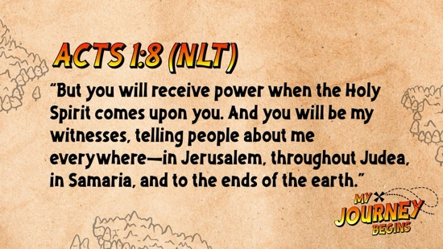

Acts 1:8 (NLT)
“But you will receive power when the Holy Spirit comes upon you. And you will be my witnesses, telling people about me everywhere—in Jerusalem, throughout Judea, in Samaria, and to the ends of the earth.”

You have all done such a great job with the Faith Verse! It’s a really long verse and you can say it now! That’s a huge accomplishment. Well done!

Response Time

Consider playing a worship song softly in the background while kids pray.

Today, we heard how God helped Paul and Silas when they were in prison. God never left them alone, and He never leaves us. God loves us and is always with us. He is always willing to help us.

Raise your hand if you would like to thank God for always being with you. (Allow responses.) Raise your hand if you need God to help you with something. (Allow responses.) Let’s pray. Put your hands together and bow your heads. You can say these words after me.

Dear God, thank You for always being with me. Please help me with whatever I need Your help with. Amen.

Closing
I am so proud of each of you. I’m so thankful that we are never alone and that God is always with us. Let’s say the Faith Fact again before we go to our small groups.
  - Play the Faith Fact Sound video.

- Show the Faith Fact Slide or Motion Graphic.

Who can say it louder—boys or girls? (Group response) Okay boys, let’s say our Faith Fact together. (Group response) With God, I am never alone. Girls, it’s your turn. With God, I am never alone. (Group response) I think it was a tie!

Dismissal to Small Groups
Great job, kids! Now it’s time to head to small group with your friends and do some more fun activities.
- Dismiss the kids by groups.

Leader Tip: This can be done by assigning colors to teams or by age groups. Note that some preschoolers may not know their age. Using a colored sticker, jersey, or wristband will help separate the kids and help identify their small groups.

SMALL GROUP (25 Minutes)
See supplies and prep instructions at the beginning of the session or in each activity below.

Leader Tip: All groups can do each activity at the same time. If you choose to rotate, you will need at least one leader per group.

Circle 1

GROUP CONNECTION

With God, I Am Never Alone
You Will Need | Getting Ready
- Group Connection Page, one copy per kid plus an extra  - Flashlight  - Crayons | - Print copies of the Group Connection Page, one per kid plus an extra. (Print the two pages double-sided, if possible.) See note below if your printer doesn’t do double-sided printing.

NOTE: If you can’t print the two pages double-sided, just hold the page with Jesus on it behind each kid’s page. Shine the flashlight through the paper from the back side.
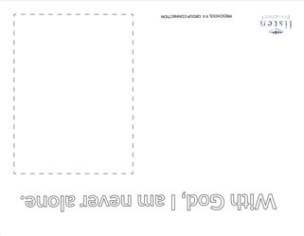
Goal: Kids will try Lizzy’s experiment and review the Faith Fact.

Today, has been such a fun day. Wasn’t Lizzy’s experiment cool? It reminded her that with God she is never alone. Would you like to try the experiment? (Group response) Me too!

I have this paper, and on it I am going to draw a person. (Draw a person or stick figure in the box.) Does this person look alone? (Group response) They do, but when I shine this flashlight on the back of the page, we can see Jesus and that reminds us that with God we are never alone.

Who wants to try and draw themselves? (Group response) Be sure to stay in the box. When you are done, we can shine the flashlight on the back of it and see that with God you are never alone.
- At some point, interrupt and practice the Faith Fact: With God, I am never alone.
- Play the Faith Fact Sound video.

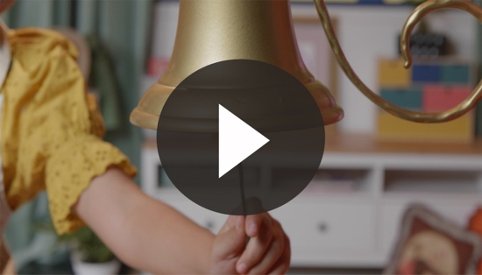

- Show the Faith Fact Slide or Motion Graphic.

Circle 2

ACTIVITY PAGE TIME

Paul and Silas Coloring Page
You Will Need | Getting Ready
- Activity Page, one per kid  - Crayons  - Scissors  - Glue sticks  - Black construction paper | - Print copies of the Activity Page, one per kid.  - Cut thin strips of black construction paper, the size of the bars in the Activity Page picture, seven bars per kid.

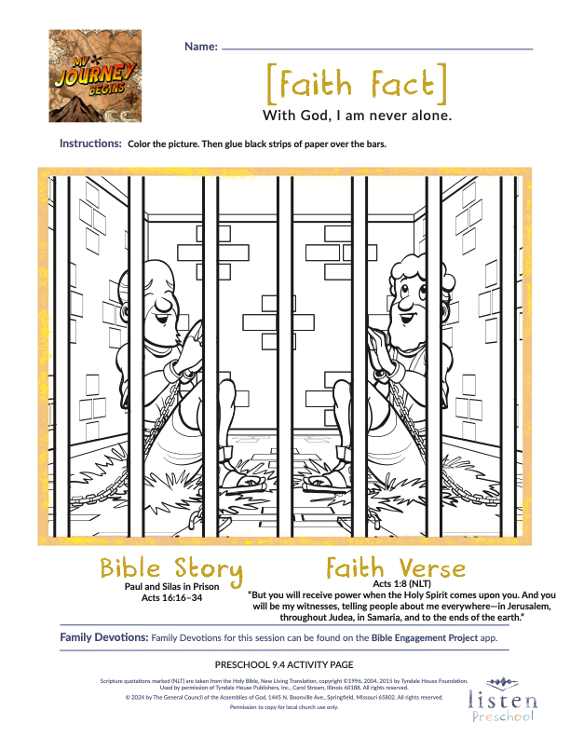
Goal: Kids will review the story while coloring the Activity Page.

Today, we heard about Paul and Silas. They loved God so much. They were thrown into what place? (Allow responses.) You’re right! They were thrown into prison. They could have been upset and mad, but instead what did they do? (Allow responses.) Exactly right! They worshipped and prayed to God. The other prisoners were listening to them.

Suddenly, a mighty earthquake shook the prison, the doors flew open, and all of their chains fell off. The prison guard was afraid that he was going to be in trouble because he thought the prisoners had all run away. Paul called out to him. The prison guard wanted to know more about God, so Paul and Silas taught him and his family about Jesus.

Let’s color the picture and remember that God was with Paul and Silas and that He is always with us.
- Help the kids as needed and be sure to write each kid’s name on their Activity Page.
- After they have colored the picture, give each kid seven thin strips of black construction paper for prison bars.
- Help the kids glue the bars onto the picture, if needed.
- While gluing the bars to the prison, practice the Faith Verse.
- Show the Faith Verse Slide or Motion Graphic.

Acts 1:8 (NLT)
“But you will receive power when the Holy Spirit comes upon you. And you will be my witnesses, telling people about me everywhere—in Jerusalem, throughout Judea, in Samaria, and to the ends of the earth.”

Circle 3
FEET-TO-FLOOR GAME TIME
Worship Celebration
You Will Need | Getting Ready
- Musical instruments or items that make noise, one per kid  - Musical player (stereo, phone, etc.)  - Kids worship music (preferably songs used in the Large Group) | No prep is needed for this activity.

Goal: Kids will play music and be reminded that Paul and Silas worshipped God in prison.

Today, we learned a very special Faith Fact: With God, I am never alone. Paul and Silas knew that they were not alone in prison. They knew that God was with them. They worshipped and prayed, and everyone in the prison was listening to them. Paul and Silas were able to teach the prison guard and his family about Jesus.

Let’s have a worship celebration together. Go ahead and grab a musical instrument. I’m going to play some worship music, and we will sing for Jesus like Paul and Silas did.
- Make sure all the kids get instruments.
- You can use items that make sound, not just musical instruments.

Circle 4

HANDS-ON LEARNING

Chain Link
You Will Need | Getting Ready
- Hands-On Learning Page, one per kid plus an extra  - Crayons  - Glue sticks or stapler | - Print copies of the Hands-On Learning Page, one per kid, plus an extra. Cut apart the strips and make a sample.

Goal: Kids will think about the Bible story and remember the Faith Fact.

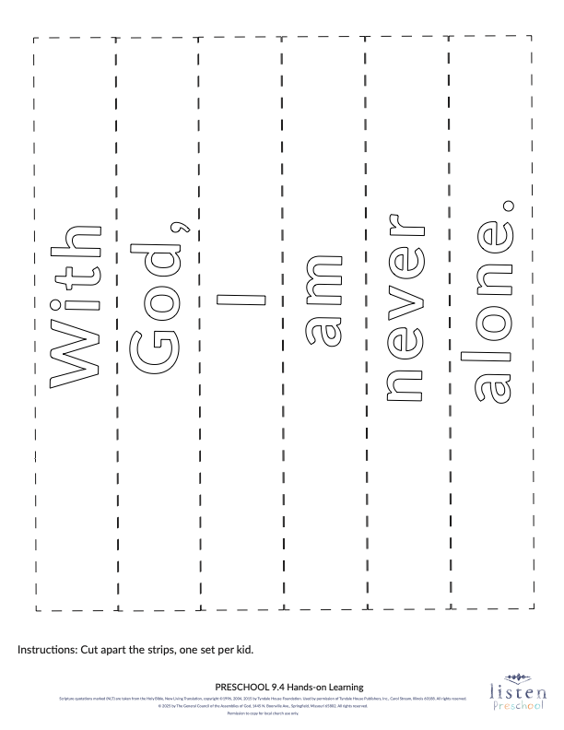
Today, we heard about Paul and Silas being thrown into prison even though they didn’t do anything wrong. They knew God was with them, and God is always with us, too. They worshipped and prayed to God in prison, and their chains came off. Today, we are going to make a set of chains to remind us of our Faith Fact: With God, I am never alone. Our Faith Fact is printed on our chains.

First, you can color these strips. When you are finished coloring, bring them to a leader who will help you put them together to make a chain.
- Be sure to write each kid’s name on their chain.
- During the activity, practice the Faith Fact: With God, I am never alone.
- Play the Faith Fact Sound video.

- Show the Faith Fact Slide or Motion Graphic.

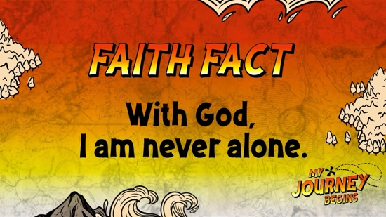

FAITH FACT RECAP
- Display the Faith Fact Slide or Motion Graphic as parents are coming into the room.
- Maximize the time you have with your kids, so that parents see what their kids have learned. Have the kids repeat the Faith Fact, and then dismiss them to their parents.

One thing I want you to remember from today is our Faith Fact. Say it with me. With God, I am never alone.

DISMISSAL
- Send home the Group Connection Page, the Activity Page, and the Hands-On Learning craft.
- Remind parents that there are Family Devotions available on the app to do with their kid.
- Tell everyone the date and time for the next session.

