

LEADER OVERVIEW

Volume Overview—What’s the Word?
Our upbringing often influences our view of the Bible. In your home, was the Bible a dust-covered book that you thought kept people from having any fun? Was it honored as the living, breathing Word of God? Or did your childhood view of God’s Word fall somewhere in between? In this volume, we want kids to know that God speaks through His Word to those who will listen, giving guidance and correction for their lives (2 Timothy 3:16–17).

SESSION 1: The Bible Is God’s Word—  Isaiah 7:14; Luke 1:26–38  Faith Fact: I will trust God’s Word. | SESSION 2: The Bible Is True—  Luke 4:14–22  Faith Fact: I will obey God’s Word.
SESSION 3: The Bible Is My Guide—  Luke 6:46–49  Faith Fact: I will follow God’s Word. | SESSION 4: The Bible Is My Weapon—  Luke 4:1–13  Faith Fact: I will use God’s Word.

SESSION OVERVIEW
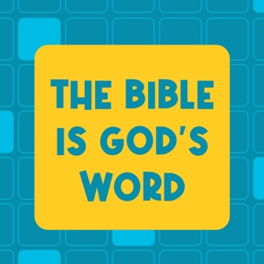

In this session, preschoolers will discover that the Bible is God’s Word. He inspired all the words in it. From the very beginning, God’s plan was in place, and we had the promise of Jesus coming to save us.

Bible Lesson | Faith Fact
Jesus Is Prophesied About  Isaiah 7:14; Luke 1:26–38 | I will trust God's Word.
Faith Verse
2 Timothy 3:16 (NLT)
All Scripture is inspired by God and is useful to teach us what is true.

Learn Preschool is part of an entire kids’ discipleship strategy. Get access at KidminRoadmap.com.
PREPARING FOR THE SESSION
You Will Need | Getting Ready
Preservice Activities  - Personal study Bible with highlights and notes  - Variety of books that can be sorted into groups (animal books, people books, coloring books, etc.)  - Small paper plates, one per kid  - Red licorice whips (Twizzlers), one for every two kids  - Graham crackers  - Frosting  - Spoon  Large Group  - Bible  - Worship songs (Song suggestions: “Only a Boy Named David” by Bible Songs for Kids; “The Lord Is My Rock” by freedomkids; “Nothing Is Impossible” by Planetshakers Kids)  - For groups not using a phone or tablet only, add:  - Projector or TV  - Laptop  - Countdown 5-Minute Video  - Theme Intro Video  - Faith Fact Sound video (bell ringing)  - Faith Fact Slide or Motion Graphic  - Faith Verse Slide or Motion Graphic  - Bible Lesson Video A  - Bible Lesson Video B  - Optional: Newsletter Template  Small Group  - Bible  - Music you can start and stop (cell phone, laptop, etc.)  - Small Group Activity Page, one per kid  - Crayons or markers  - Two different colored pieces of paper  - Tape  - Plate that will hold water  - Glass or pitcher  - Warm water  - Skittles®, any flavor  - Theme Bookmark, one per four kids  - Card stock  - Scissors | Preservice Activities  - Set out toys and snacks.  - Cut licorice whips in half, one half per kid.  - Break graham crackers in half to create squares, two squares per kid.  - Put a spoonful of frosting in a line on each plate, one plate per kid.  - Create a sample snack.  Large Group  - Download videos and slides if needed.  - Select worship song(s) and have them ready to play.  - Optional: Download and customize the Newsletter Template, if using.  Small Group  - Print copies of the Small Group Activity Page, one per kid.  - Hang up one piece of colored paper on one side of the space and one on the other.  - Optional: If you don’t have space to run across the room, place the papers on the floor about five feet apart. Have kids touch the correct paper with their toes.  - Fill the glass or pitcher with warm water.  - Print the Theme Bookmark on card stock, one per four kids, and cut apart.

Check out all the promotional and extra media files available for this theme. To access the Bible Engagement Project from a computer, visit App.BibleEngagementProject.com.

PRESERVICE ACTIVITIES (30 Minutes)
See what’s needed at the beginning of the session.

Bible Story Warm-Up
Today, we will learn all about this book. (Hold up a Bible.) Do you know what it is? The Bible is God’s Word. It tells us how much God loves us. It’s full of true stories that are incredible.
- Point to the books.

All of these books have stories and pictures in them, too! Let’s take a look and answer some questions.
- Ask questions that introduce the Bible story:
What kind of books do you see?
Which books are alike? Let’s put them into groups.
- Help kids sort the books.

Do you have a favorite book? What is it? Today, we will learn about the best book ever—the Bible. It’s a gift from God to us. Isn’t that amazing? I’m so excited for us to learn more about the Bible.

Snack: Graham Cracker Book
As kids are eating the snack, share the following:
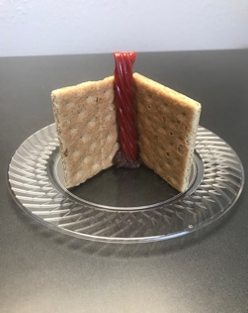
Today, we will create books for our snack.
- Pass out the items to the kids.

First, take both of your graham crackers and stick them in the frosting, so they’re standing up like an open book. Then, put your licorice between the two crackers to make a bookmark.
- Help kids make the snack.

Let’s pretend your book is all about you. What’s a story that you want to share with us while we eat our snack? Maybe something special happened to you this week. Tell us about it. (Allow responses.)

What do you think we’re going to learn from the Bible today? (Allow responses.)

Free Play
Any extra time can be spent playing with toys.

LARGE GROUP (30 Minutes)
See what’s needed at the beginning of the session.

INTRODUCTION
- Optional: Play the Countdown 5-Minute Video.
- Use this time to pick up toys and transition to the large group area.



Welcome
Hi, friends. I’m so excited that you’re here today. I’m ready to have fun together. How about you? (Group response) This next part is my favorite part. It’s where we get to learn all about the Bible. (Hold up the Bible.)

Who knows what the Bible is? (Allow responses.) The Bible is God’s Word. It’s a book that God wanted us to have. He chose many people to write down the words. It took them a long time to write the Bible. God helped all those people know just what to write. That’s why we know the Bible tells us important things that God wants us to know.
- Play the Theme Intro Video.

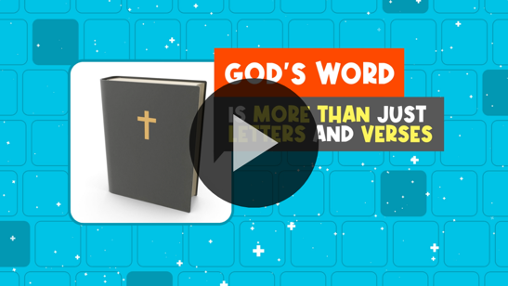

Faith Fact
Even though people helped to write the Bible, we know it’s God’s Word. That means we can trust it.
- Show the Faith Fact Slide or Motion Graphic.

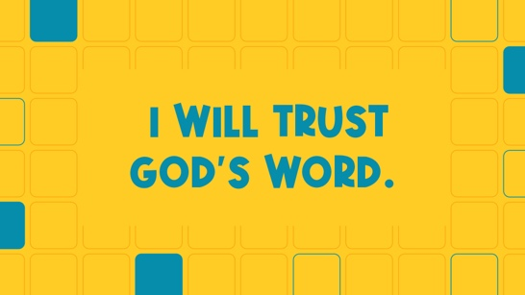

Our Faith Fact today is I will trust God’s Word. Can you say that with me on the count of 3? Ready? 1, 2, 3. I will trust God’s Word. Great job!

Can you whisper it with me on the count of 3? Ready? 1, 2, 3. I will trust God’s Word.
Now can you say it as loud as you can? On the count of 3? Ready? 1, 2, 3. I will trust God’s Word. That was awesome! Let’s find out more about God’s Word.

BIBLE TIME | Jesus Is Prophesied About (Isaiah 7:14; Luke 1:26–38)

Bible Video A
I’m so excited to check in with our friends Grandpa and Lizzy. I can’t wait to meet them and see what they’re up to today! If you’re ready to meet them, raise your hands in the air. Now give me one big clap on the count of 3. 1, 2, 3. (Clap) Great job! Let’s turn our eyes to the screen and watch what happens.
- Play Bible Lesson Video A.

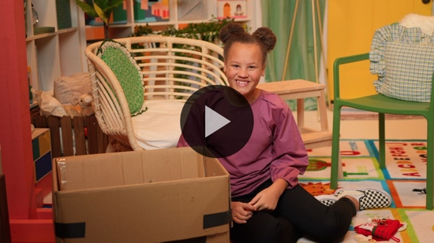

Wow! What a great story about Jesus, Mary, and Joseph. I love hearing about how Jesus was born. We get to celebrate His birthday every year at Christmas. Lizzy and Grandpa taught us that the Bible said Jesus would be born a long time before He was. Have you ever had to wait a long time for a little brother or sister to be born? (Group response) It can be hard to wait, but when God promises something will happen, we can know that it will. We can trust what the Bible says.

WORSHIP
One of the ways we can celebrate God’s Word and His promises is by worshipping Him!

Praise
Are you glad God gave us His Word, the Bible? Jump up high. (Group response)
Are you glad you can trust God’s Word? Clap your hands three times. (Group response)
Who wants to tell God thank you for the Bible? Point up and say, “Thank You, God!” (Group response)

Sing
Now let’s jump to our feet and sing some worship songs!
- Lead the kids in singing one or two songs. See suggestions at the beginning of the session.

Prayer
I just know that God loves it when He hears you singing to Him. When we pray, we talk to God. Will you bow your head and pray with me?

Dear God, we thank You that You are the one true God. We know the Bible is Your Word for us, so we can trust it. Help us to live like You show us to every day. In Jesus’ name. Amen.

BIBLE TIME continued | Jesus Is Prophesied About (Isaiah 7:14; Luke 1:26–38)

Hey! I think Lizzy has a new Faith Verse to teach us. Let’s check in with her now.
- Play Bible Lesson Video B.

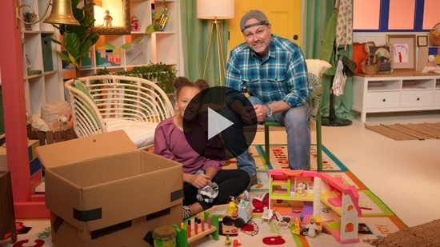

Response Time
- Consider playing a worship song softly.
You’re doing a great job learning our new Faith Verse. Today, we discovered that the Bible is God’s Word. From the very beginning, God promised us a Savior. His name is Jesus.

We’re going to pray and thank God because we can trust Him and His Word. We know His Word is true and is full of promises for each of us. Can you hold your hands out like this? (Palms extended in a receiving stance) Let’s pray together.
- Optional: Have the kids repeat phrases of the prayer after you.

Dear God, thank You for giving us the Bible. Help us to always trust it. Help us look to Your Word when we need Your help because of things going on in our life. In Jesus’ name. Amen.

Faith Verse
Our new Faith Verse goes great with what we learned about the Bible today.
- Show the Faith Verse Slide or Motion Graphic.

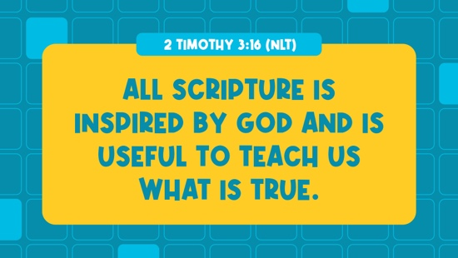

2 Timothy 3:16 (NLT)
All Scripture is inspired by God and is useful to teach us what is true.

Do you remember the actions for the verse? Let’s try to say it with the actions. Repeat after me.
- Say the Faith Verse with actions.

2 Timothy (hands at waist, spread apart, palms up and out)
3: (hands together like a clap)
16 (hands opened to “book”)

All Scripture is inspired (hold out hands in front, palms up)
by God (point up)
and is useful to teach us (roll hands over each other)
what is true. (two thumbs up)

Closing
We’ve learned so much today about Jesus, about God’s Word, and about how His Word is for all of us. We also learned that we can trust that God’s Word is true. Who’s thankful that we have the Bible to help us every day? (Group response)
- Play the Faith Fact Sound video (bell ringing).

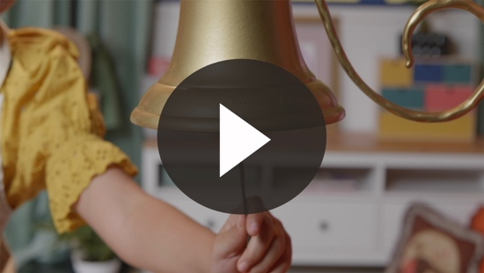

Remember what that sound means? (Group response)
- Show the Faith Fact Slide or Motion Graphic.

It’s time to say our Faith Fact: I will trust God’s Word.

Before we go, let’s say our Faith Fact one more time together on the count of 3. Ready? 1, 2, 3.
I will trust God’s Word.

Dismissal to Small Groups
You’re amazing. Let’s go see what fun we’re going to have in our circle times.
- Dismiss the kids by groups.

Leader Tip: This can be done by assigning color teams or by age groups. Note that some young preschoolers may not know their age. Using a colored sticker, jersey, or wristband will help separate the kids and help identify their small groups.

SMALL GROUP (30 Minutes)
See the supplies and prep instructions at the beginning of the session or in each activity below.

Leader Tip: All groups can do each activity at the same time. If you choose to rotate, you will need at least one leader per group.

Circle 1

GROUP CONNECTION | Pass the Bible
You Will Need | Getting Ready
- Bible  - Music you can start and stop | No prep is needed for this activity.

We’re going to play a game called Pass the Bible. We need to sit in a circle. Let’s do that now.
- Have the kids sit in a circle close enough together to pass the Bible easily.

God didn’t give us His Word so we could just keep it to ourselves. He wants us to share it with others. If you tell someone the Faith Verse, you’re sharing God’s Word with them. It’s great to share God’s Word with others!

I’m going to play music. As it’s playing, pass the Bible to the friend next to you. When the music stops, whoever is holding the Bible will stand up and shout the Faith Fact: I will trust God’s Word. We’ll all help you. Who’s ready to play? (Group response)
- Play the game until time runs out.

Circle 2

ACTIVITY PAGE TIME | Bible Dot-to-Dot
You Will Need | Getting Ready
- Activity Page, one per kid  - Crayons or markers | - Print the Activity Page, one per kid.

Today, we’ve talked about a very special book. If you remember what book we learned about, raise your hand. (Group response) What is it?
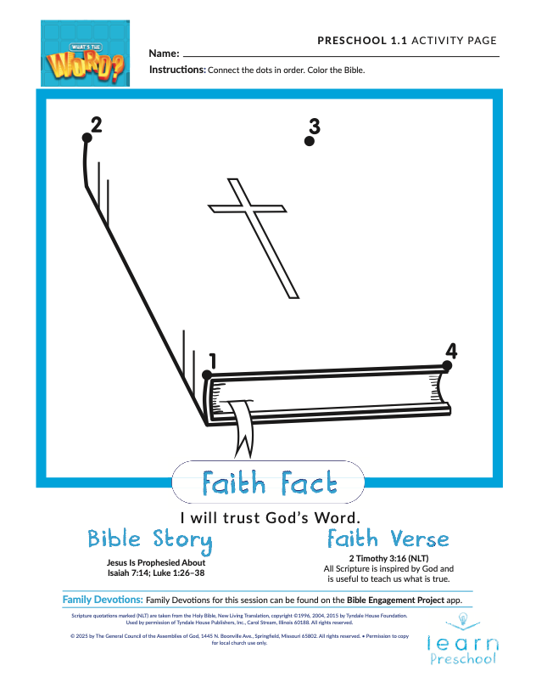
- Hand out the Activity Page and crayons.

(Looking at the picture.) Hmm. I’m not sure what this is. I see a bunch of dots on the page. We need to connect them to see what this picture is. Let’s count from one to four to make sure we don’t miss any dots.
- Help kids connect the dots if needed.
- Have kids color the page as time allows.

Who knows what this is a picture of? (Group response) That’s right. It’s the Bible. The Bible is full of true stories from God that help us every day. What’s one of your favorite Bible stories? (Allow responses.)
- Share your favorite Bible story with the group.
- During the activity, interrupt and practice the Faith Fact: I will trust God’s Word.
- Play the Faith Fact Sound video. Review the Faith Fact even if you can’t play the sound.

Circle 3

FEET-TO-FLOOR GAME TIME | Color Corners
You Will Need | Getting Ready
- Two different colored pieces of paper  - Tape | - Hang up one piece of colored paper on one side of the space and one on the other.  - Optional: If you don’t have space to run across the room, place the papers on the floor about five feet apart. Have kids touch the correct paper with their toes.

I’m glad we can trust God’s Word. We never have to wonder if what’s in the Bible is true or not. In life, not everything we hear is true, so let’s practice. I’m going to tell you some things. If you think what I say is true, go and stand by the _______ colored paper. If you think it’s not true, go and stand by the ______ colored paper over there. (Point to the other paper across the room.)
- As you read each statement, allow time for the kids to run to the correct spot.
- Have them return to you between statements, so they get to move around a lot.

Here we go. Let’s see if you know what’s true and what’s not.
- The Bible is God’s Word. (True)
- Giraffes are pink. (False)
- Eggs are green. (False)
- Jesus was born as a baby. (True)
- In the Bible, Jonah was swallowed by a big fish. (True)

You’re doing so great. Here are some harder ones.
- Ice is hot. (False)
- God created everything except spiders. (False) God even made spiders!
- The Bible was written down by only one person. (False) God chose many people to help write the Bible.

We have learned a lot about the Bible today. Now, these are some statements that you might choose a different answer than your friends. It might be true for you and not true for them, or it could be the other way around.
- Broccoli is delicious. (True or False)
- Dogs are the best animal God created. (True or False)

Even though God made every one of us, He didn’t make us exactly the same. Some of you like dogs best and some of you like another animal best. Some of you like broccoli, and some of you don’t. We can all agree on two very important things. The Bible is God’s Word, and we can trust God’s Word.

Circle 4

HANDS-ON LEARNING | Skittles Rainbow
You Will Need | Getting Ready
- Plate with a lip around the edge so it will hold water  - Glass or pitcher  - Warm water  - Skittles, any flavor | - Fill the glass or pitcher with warm water.

Today, we learned that we can trust God’s Word. When He promises us something in the Bible, it comes true. Remember our Bible story? God promised in the Bible that He would send a Savior, and many years later Jesus was born. All of God’s words, including His promises, are true.

Did you know a rainbow is a promise from God that we can read about in the Bible? (Group response) Maybe you remember the story of Noah, the ark, and all the animals. God made it rain for a very long time, but after the rain ended, God sent a beautiful rainbow and made a promise to us. He promised that we would always be safe from water covering the whole earth. Today, we will see if we can make a rainbow with Skittles. Do you think we can? (Group response)
- Open the bag and show the Skittles.

Do these candies look like a rainbow to you? (Group response) They’re rainbow colors, but they aren’t blended together like a rainbow. Let’s do an experiment and see if we can get all the colors to mix together to make a beautiful rainbow. Can you help me put the Skittles around the outside edge of the plate?
- Have kids help you organize the Skittles in a circle around the edge of the plate.

Remember what happened right before God made the rainbow in the Bible? (Group response) It rained and rained. Now, let’s add some water.
- Gently pour warm water in the center of the plate. Make sure to add enough water to cover the Skittles and fill the plate.

Let’s watch and see what happens next.
- Watch the Skittles’ colors move toward the center of the plate to make beautiful rainbow streaks.

Wow! We made a rainbow. Every time you see a rainbow in the sky, remember the promise God made to us. When we remember that promise, we know we can trust Him. We can always trust God’s Word.

DISMISSAL

Thanks for coming and discovering more about God’s Word with me. I’m so glad we can trust the Bible. Let’s close in prayer.

Prayer

Dear God, thank You for giving us Your Word. It was awesome to read the prophecy about Jesus and then to see it fulfilled in Your Word. Help us trust what we read in Your Word. Amen.

Faith Fact Recap
- Display the Faith Fact Slide or Motion Graphic as parents are coming into the room.
- Maximize the time you have with your kids, so that parents see what their kids have learned. Have the kids repeat the Faith Fact and then dismiss them to their parents.

One important thing I want you to remember from today is our Faith Fact. Let’s say it together: I will trust God’s Word. I’m glad you came today. I can’t wait to see you next time!
- Send home the Activity Page and Theme Bookmark.
- Remind parents that there are Family Devotions available on the app to do with their kid.
- Tell everyone the date and time for the next session.
- Circle Leaders: Practice this Sing-Along Song for next time.
(Song is sung to the tune of “Twinkle, Twinkle, Little Star” and the alphabet song.)
I can trust the Bible’s true.
Obeying God's Word is what I do.
When I work and when I play,
I’ll follow God every day.
I can trust the Bible’s true.
Obeying God's Word is what I do.

