

LEADER OVERVIEW

Volume Overview—What’s the Word?
Our upbringing often influences our view of the Bible. In your home, was the Bible a dust-covered book that you thought kept people from having any fun? Was it honored as the living, breathing Word of God? Or did your childhood view of God’s Word fall somewhere in between? In this volume, we want kids to know that God speaks through His Word to those who will listen, giving guidance and correction for their lives (2 Timothy 3:16–17).

SESSION 1: The Bible Is God’s Word—  Isaiah 7:14; Luke 1:26–38  Faith Fact: I will trust God’s Word. | SESSION 2: The Bible Is True—  Luke 4:14–22  Faith Fact: I will obey God’s Word.
SESSION 3: The Bible Is My Guide—  Luke 6:46–49  Faith Fact: I will follow God’s Word. | SESSION 4: The Bible Is My Weapon—  Luke 4:1–13  Faith Fact: I will use God’s Word.

SESSION OVERVIEW
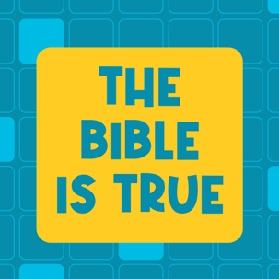

In this session, preschoolers discover that the Bible is true. As they take a closer look at the life of Jesus, they will learn that not only is the Bible true but also that they have the ability to obey God’s Word. As Christ followers, we are called to live a life according to God's Word. Preschoolers will learn that they can obey God’s Word because it’s true!

Bible Lesson | Faith Fact
Jesus Proves the Scriptures Are True  Luke 4:14–22 | I will obey God’s Word.
Faith Verse
2 Timothy 3:16 (NLT)
All Scripture is inspired by God and is useful to teach us what is true.

Learn Preschool is part of an entire kids’ discipleship strategy. Get access at KidminRoadmap.com.
PREPARING FOR THE SESSION
You Will Need | Getting Ready
Preservice Activities  - Snacks with a lot of colors (M&M’s®, Skittles®, Fruit Loops®, etc.)  Large Group  - Bible  - Worship songs (Song suggestions: “Only a Boy Named David” by Bible Songs for Kids; “The Lord Is My Rock” by freedomkids; “Nothing Is Impossible” by Planetshakers Kids)  - For groups not using a phone or tablet only, add:  - Projector or TV  - Laptop  - Countdown 5-Minute Video  - Theme Intro Video  - Faith Fact Sound video (bell ringing)  - Faith Fact Slide or Motion Graphic  - Faith Verse Slide or Motion Graphic  - Bible Lesson Video A  - Bible Lesson Video B  - Optional: Newsletter Template  Small Group  - Small Group Activity Page, one per kid  - Crayons or markers  - Play dough for each kid | Preservice Activities  - Set out toys and snacks.  Large Group  - Download videos and slides if needed.  - Select worship song(s) and have them ready to play.  - Optional: Download and customize the Newsletter Template, if using.  Small Group  - Print copies of the Small Group Activity Page, one per kid.

Check out all the promotional and extra media files available for this theme. To access the Bible Engagement Project from a computer, visit App.BibleEngagementProject.com.

PRESERVICE ACTIVITIES (30 Minutes)
See what’s needed at the beginning of the session.

Bible Story Warm-Up
Today, we’ll learn about the importance of obeying. Everyone say, “Obey.” (Group response) Good job! Does anyone know what the word obey means? (Allow responses.) Obey means to do what you’re asked or told to do. For example, when your parents tell you it’s time to go to bed, I hope you obey them right away.

Let's play a fun game that will help us practice following what someone else tells us to do. It’s called Monkey See, Monkey Do. Can you guess which animal we’re going to start with? (Group response) You’re right! We will start with a monkey. As I act like a monkey and make sounds like one, I want you to do the same thing. Let’s try it.
- Demonstrate how to act like a monkey and continue until all kids are doing the same actions.

Great job! Every day we need to obey lots of things. So let’s see how quickly you can change animals to match what I’m doing.
- Demonstrate two to three additional animal actions and sounds.
- Allow kids to suggest their favorite animals.
- Be sure to celebrate each time they catch on and switch to the new animal.

That was a lot of fun! It’s important to obey the leader in that game. Did you know that there’s an even more important person we should obey? Who do you think it is? (Group response) God. That's right! When we obey God, it shows Him how much we love Him. Raise your hand if you love God. (Group response)

Today, we’ll learn how God’s Word is true. Because God’s Word is true, we can obey and do what the Bible tells us to do.

Snack: Multicolored Snack
Let’s play Follow the Leader while we have snack time.
- Hand out the snacks to the kids.

Carefully open your snack, but don’t eat anything yet. What do you notice about the snack? (Allow responses.) There are a lot of colors, aren’t there? So, let’s see who can obey what the leader says as we eat. I’ll start. Eat everything in your bag that’s the color ______.
- Help kids pick out the snack that is that color.
- Be aware that some kids may be color-blind or not know colors and can’t distinguish the colors correctly.

Now what color should we eat next? (Allow responses.)
- Continue until all the colors are eaten.

Was it hard or easy to wait and only eat the snack as we picked the colors?
Raise your hand if you were able to obey and only eat them when I said to.
Raise your hand if it’s easy for you to obey your parents.

Great job! I’m looking forward to learning more about obeying with you today.

Free Play
Any extra time can be spent playing with toys.

LARGE GROUP (30 Minutes)
See what’s needed at the beginning of the session.

INTRODUCTION
- Optional: Play the Countdown 5-Minute Video.
- Use this time to pick up toys and transition to the large group area.



Welcome
Hey, friends! I’m so excited that you’re here. If you’re excited to be here, wave your hands in the air. (Wave hands in air with kids.) We’re going to have a great time learning to obey God’s Word. Obeying is one way we can show God that we love Him and want to follow Him.

There are so many different ways that we can obey God’s Word. Does anyone know where we can go to learn about how God wants us to obey Him? (Allow responses.) Those are great answers. The best place to go is to the Bible. What are some things that the Bible tells us to do? (Allow responses.) Wow! Those are some great answers.
- Play the Theme Intro Video.

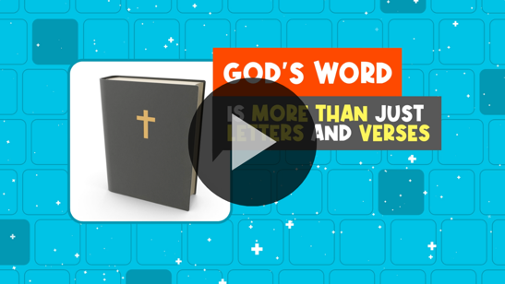

Faith Fact
God wants all of us to obey Him and do what He says in the Bible. That’s why our Faith Fact today is: I will obey God’s Word.
- Show the Faith Fact Slide or Motion Graphic.

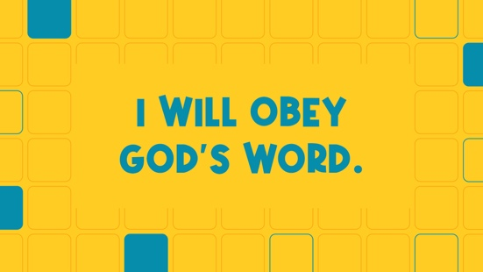

Let’s say it together. I will obey God’s Word. Okay, let's try it again, and this time let’s say it really slowly. I will obey God’s Word. Now, let’s say it really fast. I will obey God’s Word. Great job!

BIBLE TIME | Jesus Proves the Scriptures Are True (Luke 4:14–22)

Bible Video A
I think it’s time to check in with Lizzy! If you’re ready to listen, wiggle your ears! (Group response)
- Play Bible Lesson Video A.

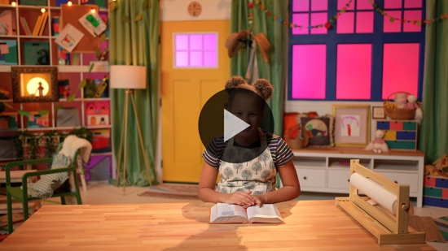

Wow! What a great Bible verse we’re learning. It tells us that the Bible will teach us what is true. I’m thankful to have the Bible to guide and teach me. How about you? (Group response)

WORSHIP
One of the things that God's Word teaches us is that it’s really important to worship God. We can worship with the words we sing and the way we live. When we worship and obey God, we show Him how much we love Him.

Praise
Are you glad to know God’s Word is true? Touch your toes down low. (Group response)
Are you ready to show God you love Him by obeying Him? Shout, “Yes,” and clap your hands three times. (Group response)
Are you ready to worship Him now? Wave your hands up high. (Group response)

Sing
I love to worship God because it’s our chance to tell God how much we love Him. As we sing these songs, let's remember to focus on God. It’s one of the ways we worship.
- Lead the kids in singing one or two songs. See suggestions at the beginning of the session.

Prayer
You’ve done such a great job worshipping and singing. Let’s pray and tell God how thankful we are for Him and His Word. Close your eyes and bow your head. Let’s pray.

Dear God, thank You for loving us. Thank You for giving us the Bible to show us how to live. Help us to obey Your Word and follow You. Amen.

BIBLE TIME continued | Jesus Proves the Scriptures Are True (Luke 4:14–22)

Let’s check back in with Lizzy and see what she’s doing now.
- Play Bible Lesson Video B.

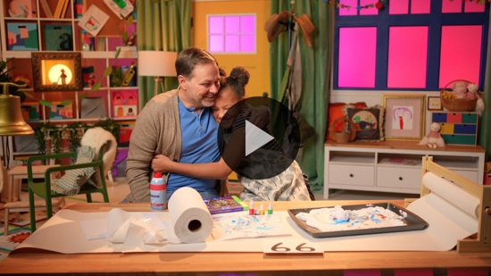

Lizzy did a great job following Grandpa’s instructions. Didn’t her wrapping paper turn out great? What colors would you have used? (Allow responses.) Those are great colors. It was nice of Grandpa to help their neighbors. By helping them, he was obeying God’s Word. I’m going to try hard to obey God’s Word. How about you? (Group response)

Response Time
Today, we’ve learned why we should obey God’s Word. Jesus taught us that we can trust God's Word is true. He showed us how He obeyed God, too. Sometimes it might be hard to do the right thing, but when we trust God and follow Him, we see His way is always best. Whether it’s loving our friends, sharing our toys, or listening to our parents, there are lots of ways we can obey the things God has told us to do. If you’re going to obey God, put two thumbs up and say our Faith Fact. I will obey God’s Word. Now, let’s pray together and ask God to help us.
- Optional: Have the kids repeat phrases of the prayer after you.

Dear God, thank You for teaching us that we can obey Your Word. Help us to always follow Your ways as we learn more about You. We love You. Amen.

Faith Verse
If we want to follow God’s Word, we have to know God’s Word. Let’s take some time and practice our Faith Verse.
- Show the Faith Verse Slide or Motion Graphic.

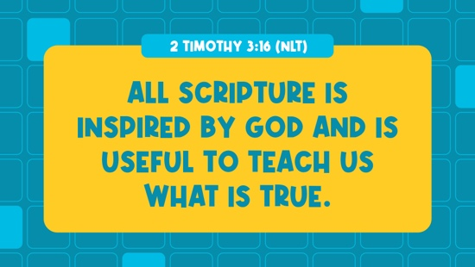

2 Timothy 3:16 (NLT)
All Scripture is inspired by God and is useful to teach us what is true.

Let’s say it together and do the actions.

2 Timothy (hands at waist, spread apart, palms up and out)
3: (hands together like a clap)
16 (hands opened to “book”)

All Scripture is inspired (hold out hands in front, palms up)
by God (point up)
and is useful to teach us (roll hands over each other)
what is true. (two thumbs up)

Closing
Wow! We learned so much today. Raise your hand if you can tell me one thing you’ve learned. (Allow responses.) That’s awesome! I love that we can all come together and learn so much.
- Play the Faith Fact Sound video (bell ringing).

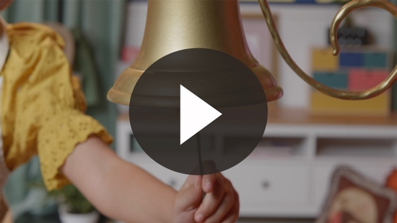

- Show the Faith Fact Slide or Motion Graphic.

I know what that sound means. Do you? (Group response) Before we go, let’s say the Faith Fact one more time, big and loud. I will obey God’s Word.

Dismissal to Small Groups
Great job! Let’s continue to have fun and learn to obey God’s Word in our circle times.
- Dismiss the kids by groups.

Leader Tip: This can be done by assigning color teams or by age groups. Note that some young preschoolers may not know their age. Using a colored sticker, jersey, or wristband will help separate the kids and help identify their small groups.

SMALL GROUP (30 Minutes)
See the supplies and prep instructions at the beginning of the session or in each activity below.

Leader Tip: All groups can do each activity at the same time. If you choose to rotate, you will need at least one leader per group.

Circle 1

GROUP CONNECTION | Sing-Along
You Will Need | Getting Ready
No supplies are needed for this activity. | - Practice the song before circle time.

Who loves to sing? (Group response) Today, we’ll learn a new version of a song you may have already heard. I want you to pay attention and see if you can pick out which song it sounds like.
- Introduce the song to the kids by singing it to them first. (Song is sung to the tune of “Twinkle, Twinkle, Little Star” and the alphabet song.)
I can trust the Bible’s true.
Obeying God's Word is what I do.
When I work and when I play,
I’ll follow God every day.
I can trust the Bible’s true.
Obeying God's Word is what I do.

Did that tune sound familiar? Do you know what it is? (Allow responses.) Let’s sing the song together now.
- Have kids repeat the song after you two lines at a time to help them learn it.

This is a great song that we can sing every day and not just at church. We can sing it when we ride in the car or play outside because it helps us remember to obey God's Word.

Circle 2

ACTIVITY PAGE TIME | Jesus at Church
You Will Need | Getting Ready
- Activity Page, one per kid  - Crayons or markers | - Print the Activity Page, one per kid.

Today, we heard an amazing Bible story about when Jesus read the Scriptures to a lot of people. That day, He was showing everyone that the Bible is true. Here’s a picture of Jesus for you to color.
- Give each kid an Activity Page and crayons.

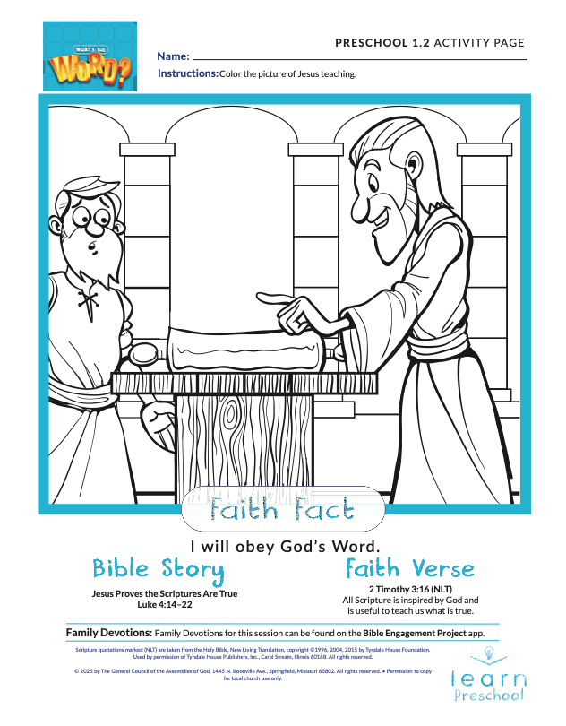
Because the Bible is true, we should obey everything it says. What are some things in the Bible that God wants us to obey? (Allow responses.)
- During the activity, interrupt and practice the Faith Fact: I will obey God’s Word.
- Play Faith Fact Sound video (bell ringing). Review the Faith Fact even if you can’t play the sound.

Circle 3

FEET-TO-FLOOR GAME TIME | Red Light, Green Light
You Will Need | Getting Ready
No supplies are needed for this activity. | No prep is needed for this activity.

Who remembers our Faith Fact? (Group response) Let’s say it together. I will obey God's Word.

One of the ways that we obey God's Word is by following what it says. The Bible tells us to love our neighbors. So when we’re nice to our friends, we’re obeying God's Word. God also tells us that we should obey our parents. So when we do what they tell us to do, like putting away our toys, we’re obeying God's Word.

Let's play a fun game that will help us practice following what someone else tells us to do. Who has played Red Light, Green Light? (Group response) In this game, when I say, “Green light,” you have to start moving around. When I say, “Red light,” you have to stop and freeze. If you don’t obey me and keep moving after I say, “Red light,” you miss the next turn. That means you have to sit down while everyone else plays again. Who wants to play? (Group response)
- Remind kids who move after you say, “Red Light,” to be seated until the next time.
- Let kids take turns being the leader.
- Play until you’re out of time.

That was a lot of fun. It’s important to obey the rules in that game. There’s an even more important person whose rules we should obey. Who is it? (Group response) You’re right! It’s God. I’m glad He gave us the Bible to help us know how to obey Him. Before we leave this circle, let’s practice our Faith Verse. Don't worry if you can’t remember it yet. We’ll all say it together.

2 Timothy 3:16 (NLT)
All Scripture is inspired by God and is useful to teach us what is true.

Circle 4

HANDS-ON LEARNING | Copy Cat Shapes
You Will Need | Getting Ready
- Play dough for each kid | No prep is needed for this activity.

Raise your hand if you know what a copycat is. (Group response) A copycat is someone who copies what someone else does. When we obey God, it’s kind of like we’re a copycat. We copy what He wants us to do.

We’re going to be a copycat with our play dough. I’m going to make a shape, and you’re going to copy what I make. Let’s get started.
- Give each kid some play dough.
- Make simple shapes that are easy for kids to copy (ball, Bible, snake, snail, pizza, letters made from rolled play dough, etc.).

You did a great job being a copycat and obeying what I told you to do. This week I hope you’ll obey what God wants you to do, too.

DISMISSAL

I enjoyed learning with you how we can know God’s Word is true. Let’s close in prayer.

Prayer

Dear God, thank You for teaching us the truth through Your Word. Help us to obey all the instructions found in it. Amen.

Faith Fact Recap
- Display the Faith Fact Slide or Motion Graphic as parents are coming into the room.

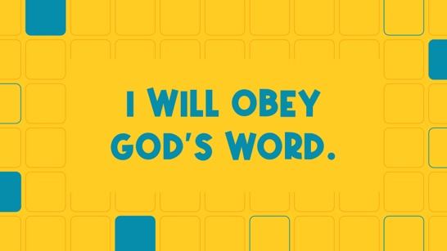

One important thing I want you to remember from today is our Faith Fact. Say it with me: I will obey God’s Word. I’m so glad you came today. See you next time.
- Send home the Activity Page.
- Remind parents that there are Family Devotions available on the app to do with their kid.
- Tell everyone the date and time for the next session.

