

LEADER OVERVIEW

Volume Overview—What’s the Word?
Our upbringing often influences our view of the Bible. In your home, was the Bible a dust-covered book that you thought kept people from having any fun? Was it honored as the living, breathing Word of God? Or did your childhood view of God’s Word fall somewhere in between? In this volume, we want kids to know that God speaks through His Word to those who will listen, giving guidance and correction for their lives (2 Timothy 3:16–17).

SESSION 1: The Bible Is God’s Word—Isaiah 7:14; Luke 1:26–38  Faith Fact: I will trust God’s Word. | SESSION 2: The Bible Is True—  Luke 4:14–22  Faith Fact: I will obey God’s Word.
SESSION 3: The Bible Is My Guide—  Luke 6:46–49  Faith Fact: I will follow God’s Word. | SESSION 4: The Bible Is My Weapon—  Luke 4:1–13  Faith Fact: I will use God’s Word.

SESSION OVERVIEW
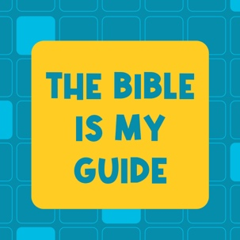

In this session, preschoolers will discover that they can follow God’s Word. Through Jesus’ teaching about the importance of building on a firm foundation, they’ll learn that their decisions affect so many things in their lives. Preschoolers will learn that when they follow God’s Word, their life will be built on the best thing.

Bible Lesson | Faith Fact
Jesus Teaches About a Firm Foundation  Luke 6:46–49 | I will follow God’s Word.
Faith Verse
2 Timothy 3:16 (NLT)
All Scripture is inspired by God and is useful to teach us what is true.

Learn Preschool is part of an entire kids’ discipleship strategy. Get access at KidminRoadmap.com.
PREPARING FOR THE SESSION
You Will Need | Getting Ready
Preservice Activities  - Toys for building (Jenga® game, wood blocks, Lego® bricks, etc.)  - Graham crackers or large flat crackers  - Cheese cubes or small crackers  Large Group  - Bible  - Worship songs (Song suggestions: “Only a Boy Named David” by Bible Songs for Kids; “The Lord Is My Rock” by freedomkids; “Nothing Is Impossible” by Planetshakers Kids)  - For groups not using a phone or tablet only, add:  - Projector or TV  - Laptop  - Countdown 5-Minute Video  - Theme Intro Video  - Faith Fact Sound video (bell ringing)  - Faith Fact Slide or Motion Graphic  - Faith Verse Slide or Motion Graphic  - Bible Lesson Video A  - Bible Lesson Video B  - Optional: Newsletter Template  Small Group  - Jenga® game, wood blocks, or Lego bricks, 10–15 blocks for each group  - Small Group Activity Page, one per kid  - Crayons or markers  - Small Group Feet-to-Floor Page, five per group  - 10 plastic bottles  - Tape  - Small soft ball  - Floor-safe tape (masking tape or painter’s tape)  - Clear bucket or storage container  - Water  - Items that will sink or float (rock, ball, pencil, feather, cotton ball, etc.) | Preservice Activities  - Set out toys and snacks.  Large Group  - Download videos and slides if needed.  - Select worship song(s) and have them ready to play.  - Optional: Download and customize the Newsletter Template, if using.  Small Group  - Print copies of the Small Group Activity Page, one per kid.  - Print copies of the Small Group Feet-to-Floor Page, five per group.  - Wrap five full bottles of water with the Rock Wraps and tape on the bottles.  - Wrap five empty bottles of water with the Sand Wraps and tape on the bottles.  - Create a standing line on the floor with the floor-safe tape.  - Fill the bucket with water.

Check out all the promotional and extra media files available for this theme. To access the Bible Engagement Project from a computer, visit App.BibleEngagementProject.com.

PRESERVICE ACTIVITIES (30 Minutes)
See what’s needed at the beginning of the session.

Bible Story Warm-Up
How many of you like to build things? (Group response) Let’s see what you can make.
- Give kids time to build.
- Ask questions that introduce the Bible story and theme:

Do you build things at home? What do you like to build with?
Have you ever had something you built fall over?
Did you know Jesus’ dad, Joseph, was a builder?

In the Bible, Jesus teaches us about building. Jesus talks about a very important part of a house. Do you think He talked about the roof on the top or the flat part along the ground? (Allow responses.) The roof is very important, but it’s not what Jesus talked about. He talked about the part low on the ground. A house needs the part on the ground to be strong and flat. We call that part the foundation. Can you say that after me? Foundation. (Group response) A good foundation makes the house strong and keeps it from falling over.

Building things can be a lot of fun. God loves us so much that He wants to help us build something very important—you and me. He wants to make sure we know how to build our lives. I can't wait to learn more about this together with you today.

Snack: Foods that Stack
As kids are eating the snack, share the following:

We have a fun snack for you today. Before you eat the snack, I want you to see how high you can stack your snacks. First, let’s start with the foundation. Remember that’s the flat part that goes next to the ground. That’s what builders do first. They make a strong foundation to build on.
- Hand out the larger crackers for the base.

Now let’s see who can build the highest tower with the rest of your snacks.
- Hand out the cheese cubes or smaller crackers.
- Give kids about a minute to build and then let them eat the snacks.

Good job trying to build with your snacks. Today, we’re going to find out why Jesus said it is important to build our life on something strong.

Free Play
Any extra time can be spent playing with toys.

LARGE GROUP (30 Minutes)
See what’s needed at the beginning of the session.

INTRODUCTION
- Optional: Play the Countdown 5-Minute Video.
- Use this time to pick up toys and transition to the large group area.

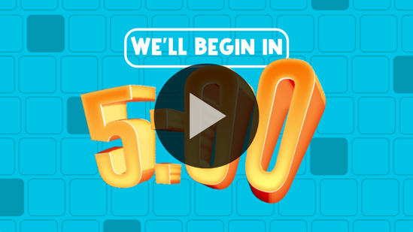

Welcome
Hey, friends. I’m so excited that you’re here today. If you’re excited to be here, raise your hand. (Group response) Today, we will learn more about following God’s Word, the Bible. You might be thinking that’s kind of a funny thing to say. How do you follow a book? When we say we’re going to follow God’s Word, we mean we’re going to do what it tells us to do. Wave your hands way up high if you want to follow God’s Word. (Group response) That’s awesome. I know I want to follow God’s Word, too.
- Play the Theme Intro Video.

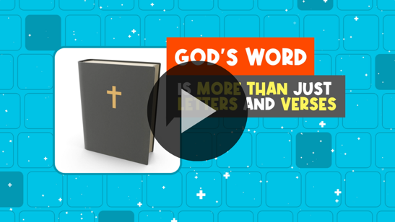

Faith Fact
What are some ways that you can follow God’s Word? (Allow responses.) Those are some great ideas, and they go with our Faith Fact today. I will follow God’s Word.
- Show the Faith Fact Slide or Motion Graphic.

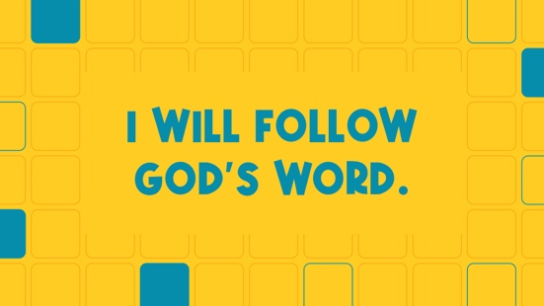

Let’s say our Faith Fact together. As we say the words, let’s use our hands like we’re building things. I’ll tell you what action to do each time. Ready?

I will follow God’s Word. (hammering motion)
I will follow God’s Word. (sawing motion)
I will follow God’s Word. (painting motion)

Great job, everyone. I think you’d be great builders. Let’s see what God wants us to know from His Word today.

BIBLE TIME | The Bible Is My Guide (Luke 6:46–49)

Bible Video A
I can't wait to check in with Lizzy to hear if she’s got a Bible story to share with us today. If you’re ready to listen, wave your hands in the air. (Group response)
- Play Bible Lesson Video A.

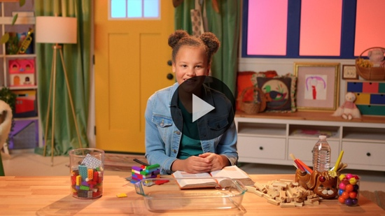

That was great. I’m so glad that Lizzy always shares the awesome stuff she learns from the Bible. Who liked watching Lizzy build things as she shared the Bible story? (Group response)

You helped Lizzy find the clues. What kind of foundation did Jesus say we needed to build on? (Group response) That’s right, the solid rock. God’s Word is a solid rock for us. When we follow it, we’re building our life on a great foundation.

WORSHIP
When we follow God’s Word, we’re showing Him how much we love Him. Another way we can show God how much we love Him is by telling Him. When we worship, we get to focus on God and tell Him how much we love Him.

Praise
Are you glad God gave us the Bible? Jump up high. (Group response)
Are you glad God loves you? Put your hands over your heart. (Group response)
Who wants to tell God you love Him? Wave your hands up high. (Group response)

Sing
Let’s spend some time telling God how much we love Him through these worship songs.
- Lead the kids in singing one or two songs. See suggestions at the beginning of the session.

Prayer
Singing to God is one of my favorite things to do. Another way we can talk to God is through prayer. Let’s bow our heads and pray.

Dear God, we love You so much. Thank You for giving us the Bible to build our life on. Help us to follow Your Word. Amen.

BIBLE TIME continued | The Bible Is My Guide (Luke 6:46–49)

Let’s check back with Lizzy. I think she’s going to help us practice our Faith Verse.
- Play Bible Lesson Video B.

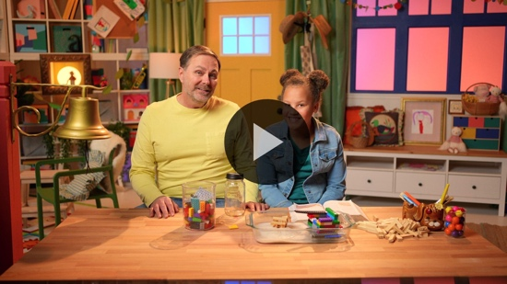

You’re doing a great job learning our Faith Verse. When we know God’s Word, it’s easier for us to follow God’s Word.

Response Time
Today, we’ve learned a lot about following God’s Word. God has given us an amazing gift—the Bible. When we read it and follow what it says, the Bible teaches us how to live our life. It shows us how to treat our friends and even how to treat people who aren’t that nice to us.

The more we do what the Bible says, the better our life will be. That’s why we’re building a foundation on it. We want to be able to stand strong no matter what comes our way, just like the house that was built on the rock. Let’s bow our heads and ask God to help us do that.
- Optional: Have the kids repeat phrases of the prayer after you.

Dear God, thank You for teaching us how to live. Thank You for giving us the Bible to follow. Help us to do our best to follow the words You have given us with happy hearts. We love You. Amen.

- Consider playing a worship song softly in the background while kids pray.

Faith Verse
Before we go, let’s practice our Faith Verse with actions. Say it with me.
- Show the Faith Verse Slide or Motion Graphic.

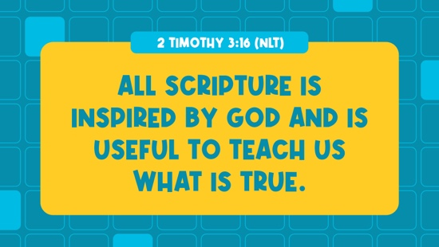

2 Timothy 3:16 (NLT)
All Scripture is inspired by God and is useful to teach us what is true.

2 Timothy (hands at waist, spread apart, palms up and out)
3: (hands together like a clap)
16 (hands opened to “book”)

All Scripture is inspired (hold out hands in front, palms up)
by God (point up)
and is useful to teach us (roll hands over each other)
what is true. (two thumbs up)

Closing
That was great! We’ve learned so much today. Who can tell me one thing you learned? (Allow responses.) Wow! That’s awesome. I’m so glad you all were listening so well. Coming together to learn more about God with you is one of my favorite things to do. This week, let’s remember that we can follow God’s Word.
- Play the Faith Fact Sound video (bell ringing).

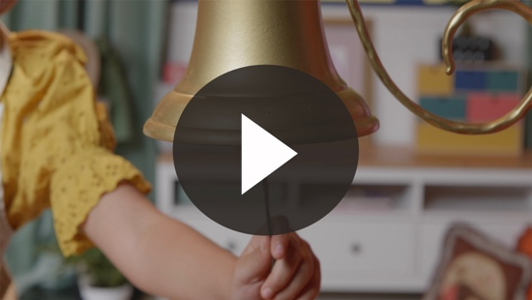

Hey! It’s time to practice our Faith Fact. I will follow God’s Word.
- Show the Faith Fact Slide or Motion Graphic.

Let’s march in place as we say it. Ready? I will follow God’s Word.

Dismissal to Small Groups
Awesome! Now let’s head to our circle times for some more fun.
- Dismiss the kids by groups.

Leader Tip: This can be done by assigning color teams or by age groups. Note that some young preschoolers may not know their age. Using a colored sticker, jersey, or wristband will help separate the kids and help identify their small groups.

SMALL GROUP (30 Minutes)
See the supplies and prep instructions at the beginning of the session or in each activity below.

Leader Tip: All groups can do each activity at the same time. If you choose to rotate, you will need at least one leader per group.

Circle 1

GROUP CONNECTION | Building a Strong Tower
You Will Need | Getting Ready
- Jenga game, wood blocks, or Lego bricks, 10–15 blocks for each group | No prep is needed for this activity.

If you’re ready to play a fun game, let me see you wiggle your ears. (Group response) That’s a hard one. Most people can’t do that. However, all of you can make sure your ears are listening while I tell you how to play our game. We’re going to sit in a circle and pass this block (Hold up block.) around very fast. While we’re passing, we’ll say our Faith Fact: I will follow God’s Word.
- Have kids sit in a circle.

Each time we say, “Word,” whoever has the block will add it to our tower in the middle of the circle. Add the block as quickly as you can and then come back to your place. Let’s see how tall we can build the tower before it falls.
- Hand a block to one kid and play the game.
- Continue until you run out of blocks or the tower falls.
- Optional: Ask kids to share the block with someone else if they’ve already had a turn to build.

Wow! What a great tower we built! (Pick up blocks as you say the following.) When we read our Bible, pray, worship God, and follow God’s Word, we’re building a strong foundation for our life. I want to do that. How about you? (Group response)

Circle 2

ACTIVITY PAGE TIME | The Right Path
You Will Need | Getting Ready
- Activity Page, one per kid  - Crayons or markers | - Print the Activity Page, one per kid.

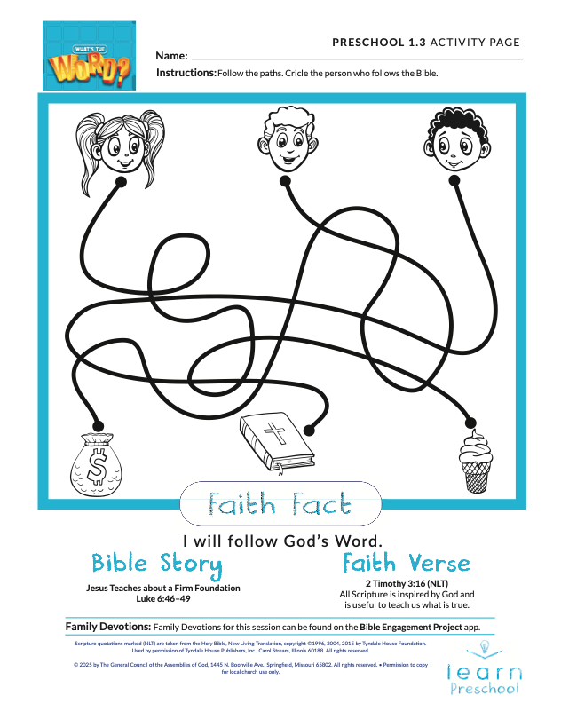
Today, we’re learning that we can follow God’s Word. In our Bible story, we learned that some things aren’t very strong and don’t stand very well like the sandy foundation. Some things are really strong like a rock. The Bible is a strong foundation. That’s why we should follow it.
- Give a copy of the Activity Page and crayons to each kid.

On your page there are a lot of different paths the kids can take, but only one leads to the Bible. Take your time and follow each one with your crayon. Then, circle the kid who made it all the way to the Bible.

Circle 3

FEET-TO-FLOOR GAME TIME | Bottle Bowling
You Will Need | Getting Ready
- Feet-to-Floor Page, five per group  - 10 plastic bottles  - Tape  - Small soft ball  - Floor-safe tape (masking tape or painter’s tape) | - Print copies of the Feet-to-Floor Page, five per group.  - Wrap five full bottles with the Rock Wraps and tape on the bottles.  - Wrap five empty bottles with the Sand Wraps and tape on the bottles.  - Create a standing line on the floor with the floor-safe tape.

Who wants to play a fun game? (Group response) Today, we’re going to bowl. That’s when we take turns rolling a ball toward these bottles to see how many we can knock down. We talked about how God’s Word is our strong foundation.
- Show the kids one Rock bottle and one Sand bottle.
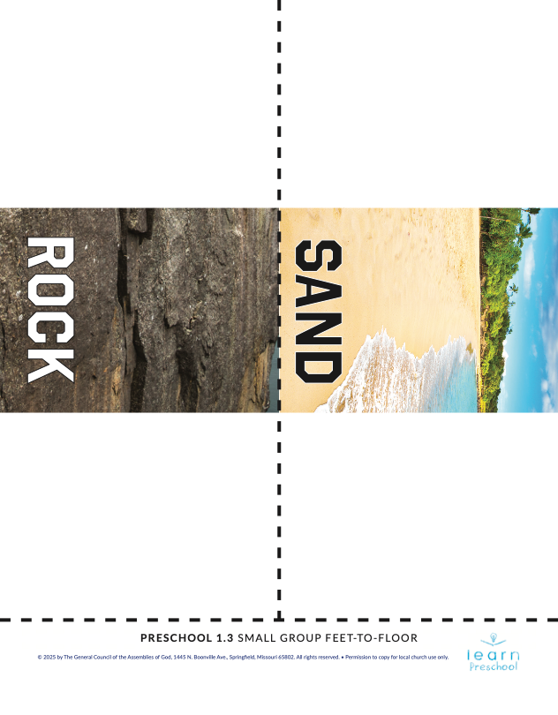
Some of these bottles have a strong foundation, and some have a weak foundation. Let’s see if you remember what Lizzy said in the Bible story. Do you think the ones with the strong foundation are the Rock or the Sand ones? (Allow responses.)
- Show the kids one Rock bottle and one Sand bottle.

The Rock one is stronger. When the waves come, do you think the bottles with the strong foundation or the weak foundation will fall over easier? (Group response) Let’s bowl and see.
- Allow kids to take turns bowling until all the bottles are knocked down.

Wow! You’re awesome at bowling. Did you know we’re a little like these bottles? The Bible is our strong foundation. Will we fall over when hard things happen? No. We’ve got a strong foundation in God’s Word.
- During the activity, interrupt and practice the Faith Fact: I will follow God’s Word.
- Play the Faith Fact Sound video. Review the Faith Fact even if you can’t play the sound.

Circle 4

HANDS-ON LEARNING | Sink or Float
You Will Need | Getting Ready
- Clear bucket or storage container  - Water  - Items that will sink or float (rock, ball, pencil, feather, cotton ball, etc.) | - Fill the bucket with water.

When we know God’s Word, we can follow God’s Word. Remember our Bible story? When the house was built on rock, the water couldn’t wash it away. When it was built on sand, the water washed it away. We’re going to put items into the water. Let’s see which ones sink and which ones float. If they float, the water can wash them away just like that house Jesus talked about. If they sink, they are strong against the water just like God wants us to be because we follow His Word.
- Have the kids guess what each item will do before it is put in the water.
- Allow the kids to help put the items into the water.

Isn’t it great that we have God’s Word to teach us? Before we leave this circle, let’s practice our Faith Verse. Don’t worry if you don’t remember it all right now. That’s why we practice. Say it with me.

2 Timothy 3:16 (NLT)
All Scripture is inspired by God and is useful to teach us what is true.

DISMISSAL

Thanks for joining me as we learned that God wants us to build the foundation of our lives on His Word, the Bible. Let’s close in prayer.

Prayer

Dear God, thank You for forgiving me when I get distracted by other things. Help me to focus on Your Word and follow it for the rest of my life. Amen.

Faith Fact Recap
- Display the Faith Fact Slide or Motion Graphic as parents are coming into the room.
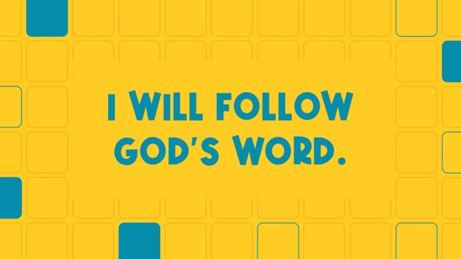

One very important thing to remember from today is our Faith Fact. Let’s say it together: I will follow God’s Word. See you next time.
- Send home the Activity Page.
- Remind parents that there are Family Devotions available on the app to do with their kid.
- Tell everyone the date and time for the next session.

